**SPRING FRAMEWORK**

**Framework:**

It is a combination of different technology and design pattern which is used for RAD process.

**RAD:**

RAD stand for Rapid Application Development i.e. Faster Application implementation.

**Technology:**

­A concept used for fixed type of coding in programming is called as technology.

**Design Pattern:**

It is a design provides better performance to application , by reducing code , execution time , memory taken by application.

**EXAMPLE:**

Design Pattern are singleton , Factory , FrontController , Template , Proxy , Abstract etc.

Performance 1/code , time , memory

**Spring**

**S**pring is a framework which is used to develop application in less line and faster way(RAD) , by using it’s in built technologies and Design Pattern.

1. Spring is a framework.
2. Compare to other technology and framework , Spring is faster in coding and execution.
3. Spring has in-built Design Pattern like Template , Factory , Proxy , MVC , Front Controller etc.
4. Spring supports end-to-end application development.
5. It support 4 layer coding
6. **Presentation Layer (PL):** Contain view logic , which is shown to end user.
7. **Service Layer(SL):** Contain business logic , like calculation , validation.

Ex. Balance = balance – withDrawAmt

1. **Data Access Layer (DAL):** It is used to perform database operation like , save , update , delete and select
2. **Integration Layer (IL):** Used to link different application Ex. Webservices , email , JMS etc.

**CHAPTER 1 SPRING CORE**

This Chapter provides rules and regulation to work with “Spring Container”

* Spring Container takes care of
* Creating Objects
* Providing data to object
* Link object to another objects
* Destroy Objects
* Spring Container needs two input from programmer.

1. Spring bean (Java Files / class )
2. Spring Config File (XML / JAVA / ANNOTATION)

By Taking these inputs , container will create object with data . then programmer has to read objects , use or print then using test class.

IMAGE HERE

1. **Spring Bean:**

* It is a class given by programmer which follows rules given by spring container.
* If we follow those rules and write class , then container will accept our class and create object to it , else class is rejected no object created.

**Spring Bean rules given as**

1. Class must have package statement.
2. Class must be public type.
3. Class can have variable , if exist type must be private.
4. Class must have default constructor with set/get method for every variable.

Or

Class can have parameterized constructor(Same time both also valid )

1. class can override method from object (java.lang) class given below.

toString() , hashCode() , equals()

1. class can have annotations , which are defined in spring API and also core annotation ( an annotation in java.lang.package ) are allowed
2. class can extends / implements only spring API ( classes / inerfaces ) and one special interface is allowed i.e. java.io.Serializable(I).

**DI ( Dependency Injection )**

It is a theory concept followed by (implemented by ) Spring framework this concept is used by spring container to create objects and providing data to variables.

**Dependency:**

It is a variable defined in a class (Spring Bean) based on data type used to create variable , It is divided into three

1. Primitive Type Dependency.
2. Collection Type Dependency
3. Reference Type Dependency
4. **Primitive Type Dependency (PTD) / Primitive Type (PT) [8+1] ::**

If a variable is created using one of below datatypes then it is called as PTD/PT

Data type are : byte , short , long , float , double , Boolean , char , String.

1. **Collection Type Dependency CTD / Primitive Type (CD) [4] :**

If a variable is created using List(I) , Set(I) , Map(I) or Properties( C ) then it is called as CTD / CD .

* All are from java.util package.

1. **Reference Type Dependency RTD / Reference Type (RT) [no count] ::**

Has a relation : Using one class or interface as a data type and creating variable in another class is called as HAS-A

** Every HAS-A variable is RTD/RT

Interface A{}

Interface B{}

Interface C{

Int a1; //Primitive type

String b1; //Primitive type

List c1; //Collection type

Map m1; //Collection type

A aob; //Reference type

B bob; //Reference type

}

**Injection (I) / Dependency Injection(DI) :**

Injection means “Provide data to variable (dependency) “

It is 4 types :

1. Setter Injection
2. Constructor Injection
3. LookUp method Injection
4. Interface Injection
5. **Injection(I) / Dependency Injection (DI) :**

Setter dependency injection (SDI) by using set method of variable container provides data. It uses default constructor and set method.

Ex: (Overview code)

Class A { int sid ;}

A a = new A();

a.setSid(25);

**2. Constructor Injection(CI) or Constructor Dependency(DDI) :**

Container provides data while creating object using “Parameter Constructor” It is called as (CI) / (CDI).

class A{int sid;}

A a1 = new A(55);

**Combination Table:**

Below table provides “different ways of coding in Spring”. Here mainly six(6) combination are given , these must be followed by spring configuration file (XML / java / Annotation).

**Spring Core Programming:**

Spring Container takes 2 inputs form programming those are:

1. Spring Bean (class + rules by container)
2. Spring config file (XML / Java / Annotation)

To Check “written code is valid or not ? “ we should write test class.

XML Configuration (Basic Syntax)

<bean class = “_____” name = “_______”>

<property name = “_________”>

<value> ________ </value>

<property>

</bean>

**Note:**

1. <bean> :: Indicate object , which will be created in Spring container.
2. <property> :: It will call set method of given variable to provide data.
3. <value> :: It indicates data to variable.
4. All above tags are case-sensetive must be written in lower-case only.

**Example #1**

* Consider below spring bean and container design write code only.

1. Spring Bean
2. Spring Config file

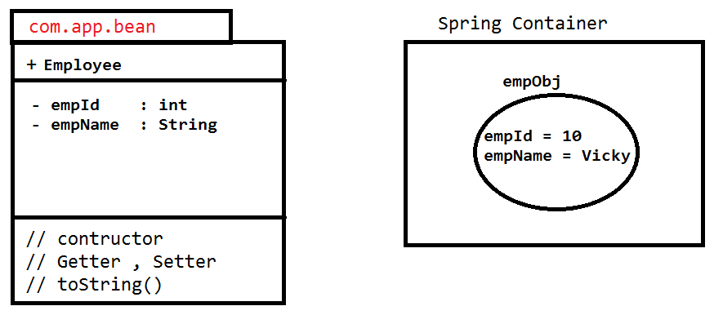**Code:**

1. Spring Bean (______.java)

Package com.app;

public class Employee{

private int empId;

private String empName;

//Default Constructor

//Set , Get

//toString..

}

1. Spring Configuration file (____.xml)

<bean class = “com.app.Employee” name = “emp”>

<property name = “empName”>

<value>A</value>

<property>

</bean>

**Example:**

<bean class = “com.app.Product” name = “pob”>

<property name = “prodId”>

<value> 100 </value>

</property>

<property name = “prodCode”>

<value> Mobile </value>

</property>

</bean>

Package com.app;

Public class Product {

Private int prodId;

Private String prodCode;

//default cons

//set , get

//toString..

}

Value can be represented in 3 syntaxes those are:

1. Value as tag
2. Value as attribute
3. P-namespace / p-schema

Value can be represented in 3 syntax those are ::

1. Value as tag
2. Value as attribute
3. P-namespace / p-schema

Example for employee object

1. **Value as tag:**

<bean class = “com.app.Employee” name = “emp”>

<property name = “empId”>

<value> 4 </value>

</property>

<property name = “empName”>

<value> ABC </value>

</property>

</bean>

1. **Value as attribute:**

<bean class = “com.app.Employee” name = “emp”>

<property name = “empId” value = “4” />

<property name = “empName” value = “ABC”/>

</bean>

1. **P-namespace / p-schema :**

<bean class = “com.app.Employee” name = “emp”

P:empId = “88”

P:empName = “ABC” />

**Syntax :** p:variableName = “data”…

**ADMIN EXAMPLE**

Test Class In Spring

This class is used to test our code “ is this container created object with data ? “ By using container interface and implementation class.

* Here we should write logic to read object (bean) from container and print it or use it.
* To indicate Spring container , framework has given interface(I) BeanFactory (old container ) and ApplicationContext (I) (new container).
* We should use any one implementation class of ApplicationContext (I) few are:
* ClassPathXmlApplication( C )
* FileSystemXmlApplicationContext( C )
* XmlWebApplicationContext( C )
* AnnotationConfigApplicationContext( C )
* AbstractApplicationContext( C ) etc..

Here class path = location of xml file (default is src(source) folder).

Xml = XML , configuration (file name can be any , but extension is xml)

ApplicationContext = means Spring Container ie. ClassPathXmlApplicationContext means “creating spring

**JAVA CONFIGURATION SPRING**

Spring Container can also take configuration in java format instead of xml. It is introduced in spring 3.x which works faster than XML and easy to write.

* Spring has provided two basic annotation for java configuration those are :

@Configuration (org.springframework.context.annotation)

@Bean (org.springframework.context.annotation)

WRITE JAVA CONFIGURATION

1. Write one public class with any name.
2. Apply @Configuration annotation at class level.
3. Define one method per one object which returns same class type of requested object method name behaves as object name by default.
4. Apply @Bean on method so that spring container create object

*** If method is written in java configuration but @Bean is not applied then container will not create object.

SYNTAX

Package com.app.config;

//ctrl + shift + 0 (imports)

@Configuration

Public class AppConfig{

//no of method = no of objects

@Bean

Public Type objName(){

//create object & set Data..

Return obj;

}

}

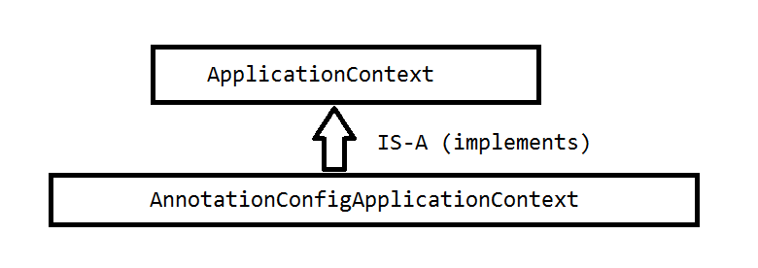

* For both java and annotation configuration we should use spring container class (Context) given as AnnotationConfigApplicationContext ( C ) (org.springframework.context.annotation) it takes java config class as input to create container with objects

**JAVA CONFIG EXAMPLE**

***Folder Structure***

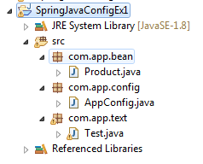

***UML DIAGRAM***

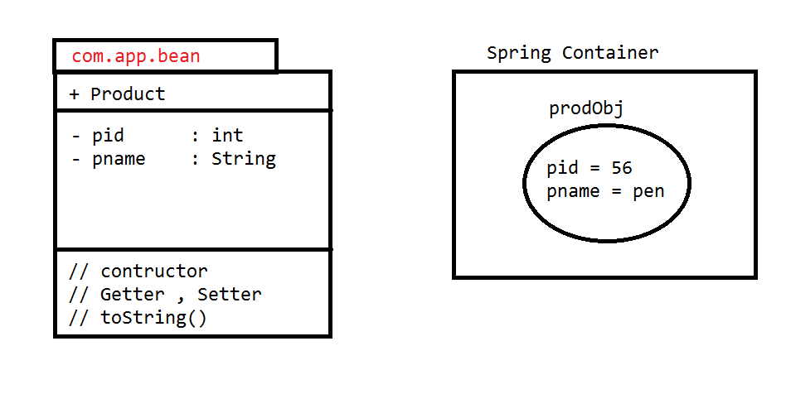

**CODE**

1. **Spring Bean**

**package** com.app.bean;

**publicclass** Product {

**privateint**pid;

**private** String pname;

**public** Product() {

**super**();

}

**publicint** getPid() {

**return**pid;

}

**publicvoid** setPid(**int**pid) {

**this**.pid = pid;

}

**public** String getPname() {

**return**pname;

}

**publicvoid** setPname(String pname) {

**this**.pname = pname;

}

@Override

**public** String toString() {

**return**"Product [pid=" + pid + ", pname=" + pname + "]";

}

}

1. **Spring Config File**

**package** com.app.config;

**import** org.springframework.context.annotation.Bean;

**import** org.springframework.context.annotation.Configuration;

**import** com.app.bean.Product;

@Configuration

**publicclass** AppConfig {

@Bean

**public** Product prodObj() {

Product p = **new** Product();

p.setPid(56);

p.setPname("Pen");

**return**p;

}

}

1. **Test Class**

**package** com.app.text;

**import** org.springframework.context.ApplicationContext;

**import** org.springframework.context.annotation.AnnotationConfigApplicationContext;

**import** com.app.bean.Product;

**import** com.app.config.AppConfig;

**publicclass** Test {

**publicstaticvoid** main(String[] args) {

ApplicationContext ac = **new** AnnotationConfigApplicationContext(AppConfig.**class**);

Product p = (Product)ac.getBean("prodObj");

System.***out***.println(p.toString());

}

}

**COLLECTION CONFIGURATION USING SPRING JAVA CONFIG CODE**

**Folder Structure**

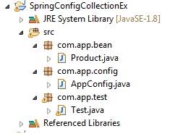

**UML DIAGRAM**

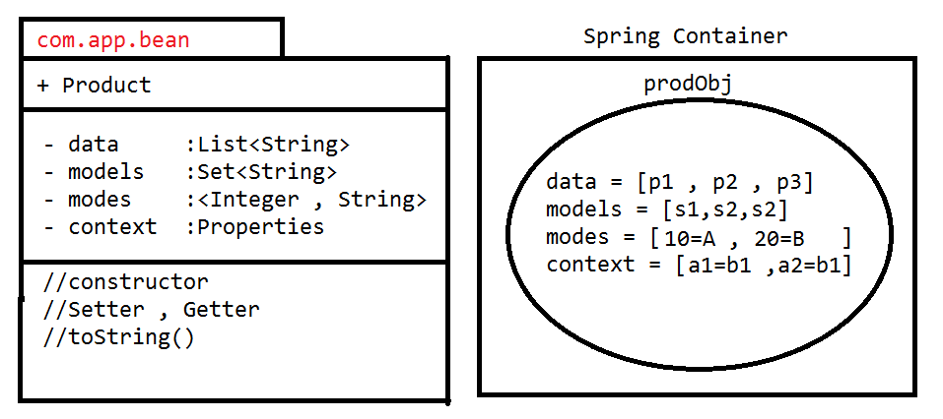

**CODE**

1. **Spring Bean**

**package** com.app.bean;

**import** java.util.List;

**import** java.util.Map;

**import** java.util.Properties;

**import** java.util.Set;

**publicclass** Product {

**private** List<String>data;

**private** Set<String>models;

**private** Map<Integer , String>modes;

**private** Properties context;

**public** Product() {

**super**();

}

**public** List<String> getData() {

**return**data;

}

**publicvoid** setData(List<String>data) {

**this**.data = data;

}

**public** Set<String> getModels() {

**return**models;

}

**publicvoid** setModels(Set<String>models) {

**this**.models = models;

}

**public** Map<Integer, String> getModes() {

**return**modes;

}

**publicvoid** setModes(Map<Integer, String>modes) {

**this**.modes = modes;

}

**public** Properties getContext() {

**return**context;

}

**publicvoid** setContext(Properties context) {

**this**.context = context;

}

@Override

**public** String toString() {

**return**"Product [data=" + data + ", models=" + models + ", modes=" + modes + ", context=" + context + "]";

}

}

1. **AppConfig.java**

**package** com.app.config;

**import** java.util.LinkedHashMap;

**import** java.util.LinkedHashSet;

**import** java.util.LinkedList;

**import** java.util.List;

**import** java.util.Map;

**import** java.util.Properties;

**import** java.util.Set;

**import** org.springframework.context.annotation.Bean;

**import** org.springframework.context.annotation.Configuration;

**import** com.app.bean.Product;

@Configuration

**publicclass** AppConfig {

@Bean

**public** Product prodObj() {

Product p = **new** Product();

p.setData(list());

p.setModels(set());

p.setModes(map());

p.setContext(prop());

**return**p;

}

**public** List<String> list(){

List<String>l = **new** LinkedList<String>();

l.add("p1");

l.add("P2");

l.add("P3");

**return**l;

}

**public** Set<String> set(){

Set<String>s = **new** LinkedHashSet<String>();

s.add("S1");

s.add("S2");

s.add("S3");

**return**s;

}

**public** Map<Integer , String> map(){

Map<Integer , String>m = **new** LinkedHashMap<Integer , String>();

m.put(10, "A");

m.put(20, "B");

m.put(30, "C");

**return**m;

}

**public** Properties prop() {

Properties p = **new** Properties();

p.put("A1", "B1");

p.put("A2", "B2");

p.put("A3", "B3");

**return**p;

}

}

1. **Test Class**

**package** com.app.test;

**import** org.springframework.context.ApplicationContext;

**import**org.springframework.context.annotation.AnnotationConfigApplicationContext;

**import** com.app.bean.Product;

**import** com.app.config.AppConfig;

**publicclass** Test {

**publicstaticvoid** main(String[] args) {

ApplicationContext ac = **new** AnnotationConfigApplicationContext(AppConfig.**class**);

Product p = (Product)ac.getBean("prodObj");

System.***out***.println(p);

}

}

JAVA CONFIG USING REFERENCE (HAS-A RELATION)

Folder Structure

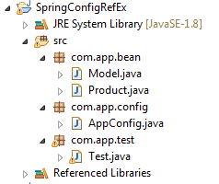

**UML DIAGRAM**

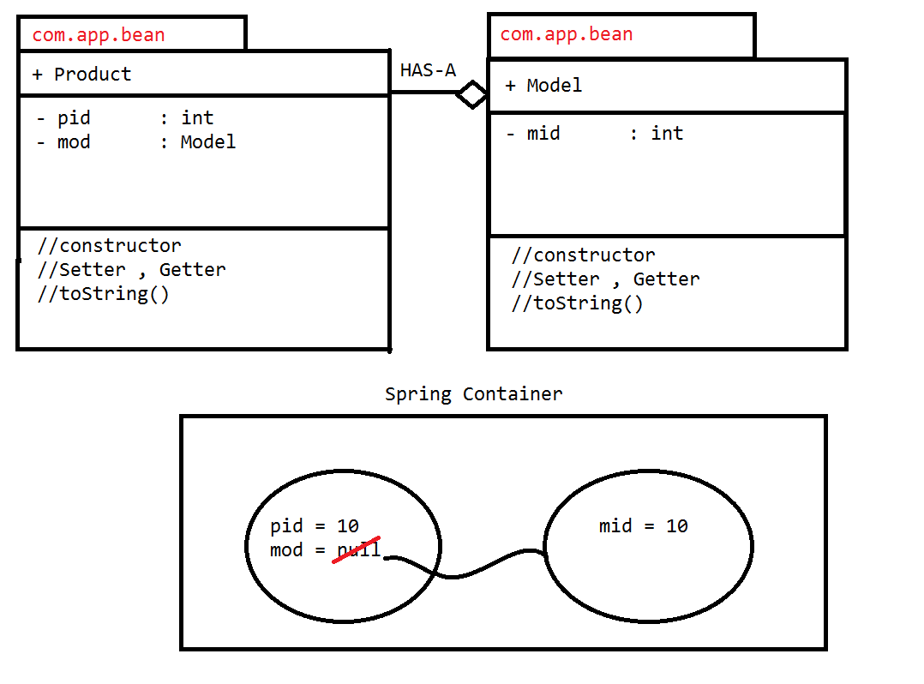

**Code**

1. **Spring Bean (Model.java)**

**package** com.app.bean;

**publicclass** Model {

**privateint**mid;

**public** Model() {

**super**();

}

**publicint** getMid() {

**return**mid;

}

**publicvoid** setMid(**int**mid) {

**this**.mid = mid;

}

@Override

**public** String toString() {

**return**"Model [mid=" + mid + "]";

}

}

**Product.java**

**package** com.app.bean;

**publicclass** Product {

**privateint**pid;

**private** Model mod;

**public** Product() {

**super**();

}

**publicint** getPid() {

**return**pid;

}

**publicvoid** setPid(**int**pid) {

**this**.pid = pid;

}

**public** Model getMod() {

**return**mod;

}

**publicvoid** setMod(Model mod) {

**this**.mod = mod;

}

@Override

**public** String toString() {

**return**"Product [pid=" + pid + ", mod=" + mod + "]";

}

}

1. **AppConfig.class**

**package** com.app.config;

**import** org.springframework.context.annotation.Bean;

**import** org.springframework.context.annotation.Configuration;

**import** com.app.bean.Model;

**import** com.app.bean.Product;

@Configuration

**publicclass** AppConfig {

@Bean

**public** Model modObj() {

Model m = **new** Model();

m.setMid(10);

**return**m;

}

@Bean

**public** Product prodObj() {

Product p = **new** Product();

p.setPid(10);

p.setMod(modObj());

**re**turn p;

}

}

1. **Test.java**

**package** com.app.test;

**import** org.springframework.context.ApplicationContext;

**import** org.springframework.context.annotation.AnnotationConfigApplicationContext;

**import** com.app.bean.Product;

**import** com.app.config.AppConfig;

**publicclass** Test {

**publicstaticvoid** main(String[] args) {

ApplicationContext ac = **new** AnnotationConfigApplicationContext(AppConfig.**class**);

Product p = (Product)ac.getBean("prodObj");

System.***out***.println(p);

}

}

**MULTIPLE HAS-A RELATION**

***Folder Structure***

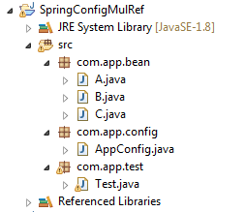

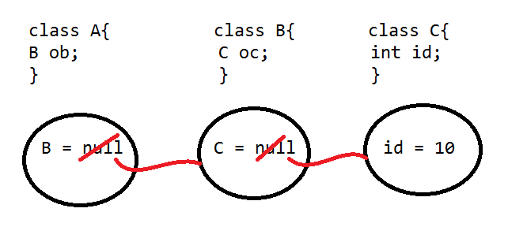

**CODE:**

1. **Spring Bean [A.class]**

**package** com.app.bean;

**publicclass** A {

**private** B ob;

**public** A() {

**super**();

}

**public** B getOb() {

**return**ob;

}

**publicvoid** setOb(B ob) {

**this**.ob = ob;

}

@Override

**public** String toString() {

**return**"A [ob=" + ob + "]";

}

}

**B.class**

**package** com.app.bean;

**publicclass** B {

**private** C oc;

**public** B() {

**super**();

}

**public** C getOc() {

**return**oc;

}

**publicvoid** setOc(C oc) {

**this**.oc = oc;

}

@Override

**public** String toString() {

**return**"B [oc=" + oc + "]";

}

}

**C.class**

**package** com.app.bean;

**publicclass** C {

**privateint**id;

**public** C() {

**super**();

}

**publicint** getId() {

**return**id;

}

**publicvoid** setId(**int**id) {

**this**.id = id;

}

@Override

**public** String toString() {

**return**"C [id=" + id + "]";

}

}

1. **AppConfig.class**

**package** com.app.config;

**import** org.springframework.context.annotation.Bean;

**import** org.springframework.context.annotation.Configuration;

**import** com.app.bean.A;

**import** com.app.bean.B;

**import** com.app.bean.C;

@Configuration

**publicclass** AppConfig {

@Bean

**public** C cObj() {

C c = **new** C();

c.setId(10);

**return**c;

}

@Bean

**public** B bObj() {

B b = **new** B();

b.setOc(cObj());

**return**b;

}

@Bean

**public** A aObj() {

A a = **new** A();

a.setOb(bObj());

**return**a;

}

}

1. **Test.class**

**package** com.app.test;

**import** org.springframework.context.ApplicationContext;

**import** org.springframework.context.annotation.AnnotationConfigApplicationContext;

**import** com.app.bean.A;

**import** com.app.config.AppConfig;

**publicclass** Test {

**publicstaticvoid** main(String[] args) {

ApplicationContext ac = **new** AnnotationConfigApplicationContext(AppConfig.**class**);

A a =(A)ac.getBean("aObj");

System.***out***.println(a);

}

}

**Output**

**A [ob=B [oc=C [id=10]]]**

**REF-TYPE CHILD AS INTERFACE**

In case of HAS-A relation (ref type) container create child object first and then parent.

* But if child type is interface then we should choose any one of its implementation classs and create object to it first. Then link with parent object.

SYNTAX FOR CHILD-TYPE-INTERFACE

@Bean

Public interface objName(){

//create obj to any implclass

return ob;

}

**CONSIDER BELOW DESIGN**

Product IModel(I)

ModelImpl ( C )

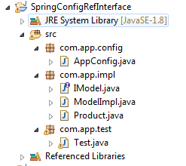

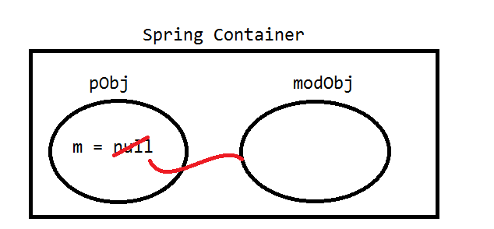

**CODE**

1. **Spring Bean [IModel.java]**

**package** com.app.impl;

**publicinterface** IModel { }

**ModelImpl.java**

**package** com.app.impl;

**publicclass** ModelImpl **implements** IModel{ }

Product.class

**package** com.app.impl;

**publicclass** Product {

**private** IModel mod;

**public** Product() {

**super**();

}

**public** IModel getMod() {

**return**mod;

}

**publicvoid** setMod(IModel mod) {

**this**.mod = mod;

}

}

1. **AppConfig.java**

**package** com.app.config;

**import** org.springframework.context.annotation.Bean;

**import** org.springframework.context.annotation.Configuration;

**import** com.app.impl.IModel;

**import** com.app.impl.ModelImpl;

**import** com.app.impl.Product;

@Configuration

**publicclass** AppConfig {

@Bean

**public** IModel modObj() {

ModelImpl m =**new** ModelImpl();

**return**m;

}

@Bean

**public** Product pObj() {

Product p =**new** Product();

p.setMod(modObj());

**return**p;

}

}

1. **Test.java**

**package** com.app.test;

**import** org.springframework.context.ApplicationContext;

**import** org.springframework.context.annotation.AnnotationConfigApplicationContext;

**import** com.app.config.AppConfig;

**import** com.app.impl.Product;

**publicclass** Test {

**publicstaticvoid** main(String[] args) {

ApplicationContext ac = **new** AnnotationConfigApplicationContext(AppConfig.**class**);

Product p = (Product)ac.getBean("pObj");

System.***out***.println(p);

}

}

**LOADING PROPERTIES FILE INTO JAVA CONFIG**

1. Create .properties files(one or more).
2. Load into spring container using @PropertySource ({..,..,..}).
3. Spring container create object to store all key and value object type is Environment(I).

* For stand alone application implementation class is MorkEnvironment(C).
* For Web application implementation class is StanderdServletEnvironment(C)
* These object are created and data loaded by Spring Container.

1. Link Environment object with save config class using @Autowired.
2. Read data using env.getProperty(“key”) or env.getProperty(“key” , T.class).

* getProperty(String key) : String
* getProperty(String key , T.class)

**CODE**

1. **Spring Bean [Product.java]**

**package** com.app.bean;

**publicclass** Product {

**privateint**pId;

**private** String pname;

**public** Product() {

**super**();

}

**publicint** getpId() {

**return**pId;

}

**publicvoid** setpId(**int**pId) {

**this**.pId = pId;

}

**public** String getPname() {

**return**pname;

}

**publicvoid** setPname(String pname) {

**this**.pname = pname;

}

@Override

**public** String toString() {

**return**"Product [pId=" + pId + ", pname=" + pname + "]";

}

}

1. **MyProp.propeties**

#This is properteis file

id = 10

name = Vicky

1. **AppConfig.java**

**package** com.app.config;

**import** org.springframework.beans.factory.annotation.Autowired;

**import** org.springframework.context.annotation.Bean;

**import** org.springframework.context.annotation.Configuration;

**import** org.springframework.context.annotation.PropertySource;

**import** org.springframework.core.env.Environment;

**import** com.app.bean.Product;

@Configuration

@PropertySource({"MyProp.properties"})

**publicclass** AppConfig {

@Autowired

**private** Environment env;

@Bean

**public** Product pdtObj() {

Product p = **new** Product();

p.setpId(env.getProperty("id" , Integer.**class**));

p.setPname(env.getProperty("name"));

**return**p;

}

}

1. **Test.java**

**package** com.app.test;

**import** org.springframework.context.ApplicationContext;

**import** org.springframework.context.annotation.AnnotationConfigApplicationContext;

**import** com.app.bean.Product;

**import** com.app.config.AppConfig;

**publicclass** Test {

**publicstaticvoid** main(String[] args) {

ApplicationContext ac = **new** AnnotationConfigApplicationContext(AppConfig.**class**);

Product p = (Product)ac.getBean("pdtObj");

System.***out***.println(p);

}

}

**Dependency Check In Spring**

In spring injection (providing data to variable ) is optional , to make it required use annotation @Required over set method of that variable.

** Making one dependency injection is required is called dependency check.

**Activate annotation using

<context:annotation-config/>

**Code**

**Spring Bean class**:--

Package com.app;

Public class Product

{

Private int productId;

Private String productName;

//constructor

@Required

Public void setProductId(int productId)

{

This.productId=productId;

}

//setters & getters, toString

}

1. **Spring configuration file:--**

<beans xmlns----------------------------->

<context:annotation-config/>

<bean class=”com.app.Product” name=”p”>

</bean>

1. **Test class**

read and print “p” object expected output:--

Exception: BeanCreationException…….

BeanInitializationException : Property “productId” is required for bean ‘p’.

**Solution**

write below code in <bean>

<property name=”productId” value=”66”/>

(set product id data to avoid exception)

**Stand Alone Collection (SAC)**

Creating one collection Object in Spring Container without using <bean> tag or outside to all <bean> tags is known as SAC.

1. Every SAC is independent.
2. SACs are re-usable (Create one time link with multiple <bean>s).
3. SACs can be created using our own specific Implementation class (for interface List, Set, Map only)
4. *** SACs can be created using util-schema.

**Creating SACs using Util-schema given by Spring Framework**

**Syntax#1**

***for List, Set and Map SACs.***

<util:cN cN-class=”_” id=”—“>

//data

</util:cN>

* Here , cN=Collection Name= list/set/map

1. **Ex: List Type:**

<util:list list-class=”java.util.LinkedList” id=”listObj”>

<value>A</value>

<value>B</value>

<value>C</value>

<util:list>

1. **Ex: Map Type:**

<util:map map-class=”java.util.LinkedHashMap” id=”mapObj”>

<entry key=”10” value=”AA”/>

<entry key=”11” value=”AB”/>

<entry key=”11” value=”AC”/>

<util:map>

**Example of SAC (Stand Alone Collection )**

**Code:**

1. **Spring Bean (Employee.java)**

**package** com.app.sathya;

**import** java.util.List;

**import** java.util.Map;

**import** java.util.Properties;

**publicclass** Employee {

**private** List<String>models;

**private** Map<Integer , String>codes;

**private** Properties data;

**public** Employee() {

**super**();

}

**public** List<String> getModels() {

**return**models;

}

**publicvoid** setModels(List<String>models) {

**this**.models = models;

}

**public** Map<Integer, String> getCodes() {

**return**codes;

}

**publicvoid** setCodes(Map<Integer, String>codes) {

**this**.codes = codes;

}

**public** Properties getData() {

**return**data;

}

**publicvoid** setData(Properties data) {

**this**.data = data;

}

@Override

**public** String toString() {

**return**"Employee [models=" + models + ", codes=" + codes + ", data=" + data + "]";

}

}

1. **Spring Configuration File**

<?xmlversion=*"1.0"*encoding=*"UTF-8"*?>

<beansxmlns=*"http://www.springframework.org/schema/beans"*

xmlns:p=*"http://www.springframework.org/schema/p"*

xmlns:util=*"http://www.springframework.org/schema/util"*

xmlns:xsi=*"http://www.w3.org/2001/XMLSchema-instance"*xsi:schemaLocation=*"http://www.springframework.org/schema/beans*

*http://www.springframework.org/schema/beans/spring-beans.xsd*

*http://www.springframework.org/schema/util*

*http://www.springframework.org/schema/util/spring-util.xs "*>

<util:listlist-class=*"java.util.LinkedList"*id=*"lstObj"*>

<value>10</value>

<value>vicky</value>

<value>5.5</value>

</util:list>

<util:mapmap-class=*"java.util.LinkedHashMap"*id=*"mapObj"*>

<entry>

<key>

<value>10</value>

</key>

<value>AA</value>

</entry>

<entrykey=*"20"*>

<value>BB</value>

</entry>

<entryvalue=*"CC"*>

<key>

<value>30</value>

</key>

</entry>

<entrykey=*"40"*value=*"DD"*/>

</util:map>

<util:propertiesid=*"setObj"*>

<propkey=*"10"*>AAA</prop>

<propkey=*"20"*>BBB</prop>

<propkey=*"30"*>CCC</prop>

</util:properties>

<beanclass=*"com.app.sathya.Employee"*name=*"empObj"*

p:data-ref=*"setObj"*>

<propertyname=*"models"*>

<refbean=*"lstObj"*/>

</property>

<propertyname=*"codes"*ref=*"mapObj"*/>

</bean>

</beans>

1. **Test Class**

**package** com.app.sathya;

**import** org.springframework.context.ApplicationContext;

**import** org.springframework.context.support.ClassPathXmlApplicationContext;

**publicclass** Test {

**publicstaticvoid** main(String[] args) {

ApplicationContext ac = **new** ClassPathXmlApplicationContext("config.xml");

Employee emp = ac.getBean("empObj" , Employee.**class**);

System.***out***.println(emp);

}

}

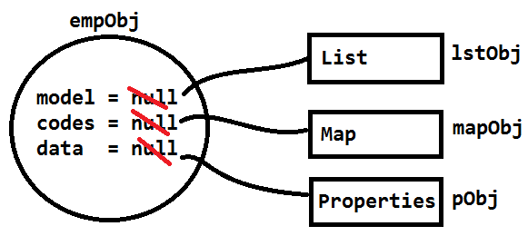

**Bean Scope In Spring**

It indicates “how long bean (Object) should be in Spring Container”

**Possible Bean Scope Are Given as:**

1. **Singleton (default scope)**
2. **Prototype**
3. **Request (Spring WEB-MVC servlets)**
4. **Session (Spring WEB-MVC servlets)**
5. **Global context(String WEB-MVC portlets)**
6. **Singleton**

It is only default scope given to every <bean> in Spring Container. It indicates one object is created by container when it is started. Maintains same object end container is destroyed.

** One object per one configuration.

1. **Prototype**

It create new object in Spring container on every access by Application / Programmer.

1. **Request**

Container creates new object for every request , same maintained until response is commited. Works only in web application (using servlet) in spring.

1. **Session**

Container creates new object for every new session it is maintained until session invalidated. Work only in web application (using servlet) in spring.

1. **Global context/session**

It works in portlets based web application. It creates one object for all portlet access.

**Code**

Read one bean using getBean() method in test class multiple time.

If same hashcode is returned every time means scope is singleton , else if every time new hashcode scope is prototype.

1. **Spring Bean(Employee.java)**

**package** com.app.core;

**publicclass** Employee {

**privateint**empId;

**public** Employee() {

**super**();

}

**publicint** getEmpId() {

**return**empId;

}

**publicvoid** setEmpId(**int**empId) {

**this**.empId = empId;

}

@Override

**public** String toString() {

**return**"Employee [empId=" + empId + "]";

}

}

1. **Configuration File (config.xml)**

<?xmlversion=*"1.0"*encoding=*"UTF-8"*?>

<beansxmlns=*"http://www.springframework.org/schema/beans"*

xmlns:p=*"http://www.springframework.org/schema/p"*

xmlns:util=*"http://www.springframework.org/schema/util"*

xmlns:xsi=*"http://www.w3.org/2001/XMLSchema-instance"*

xsi:schemaLocation=*"http://www.springframework.org/schema/beans*

*http://www.springframework.org/schema/beans/spring-beans.xsd*

*http://www.springframework.org/schema/util*

*http://www.springframework.org/schema/util/spring-util.xsd*

*"*>

<beanclass=*"com.app.core.Employee"*name=*"empObj" scope = “singleton”*

p:empId=*"10"*

/>

</beans>

1. **Test.java**

**package** com.app.core;

**import** org.springframework.context.ApplicationContext;

**import** org.springframework.context.support.ClassPathXmlApplicationContext;

**publicclass** Test {

**publicstaticvoid** main(String[] args) {

ApplicationContext ac = **new** ClassPathXmlApplicationContext("config.xml");

Employee e1 = ac.getBean("empObj" , Employee.**class**);

System.***out***.println(e1.hashCode());

Employee e2 = ac.getBean("empObj" , Employee.**class**);

System.***out***.println(e2.hashCode());

Employee e3 = ac.getBean("empObj" , Employee.**class**);

System.***out***.println(e3.hashCode());

}

}

**OUTPUT**

**30832607**

**30832607**

**30832607**

**Scope is prototype**

**28224929**

**8991183**

**10594517**

**LMI Problem statement:**

* If two classs are connected with HAS-A relation then possible combinations fro Bean score are
* **given as.**

|  |  |  |  |
| --- | --- | --- | --- |
| Sno. | Parent | Child | Status |
| 1. | Singlton | Singlton | Working Fine |
| 2. | Singlton | Prototype | Working Fine |
| 3. | Prototype | Singlton | Working Fine |
| 4. | Prototype | Prototype | Not Working |

* Here if parent bean having scope “Singlton” and child bean having scope “Prototype” in spring container.
* Container creating parent and child objects and linked then(Injected) first time, but second time onwards new child object is created but link Is not updated, so expected output not matched with actual output.

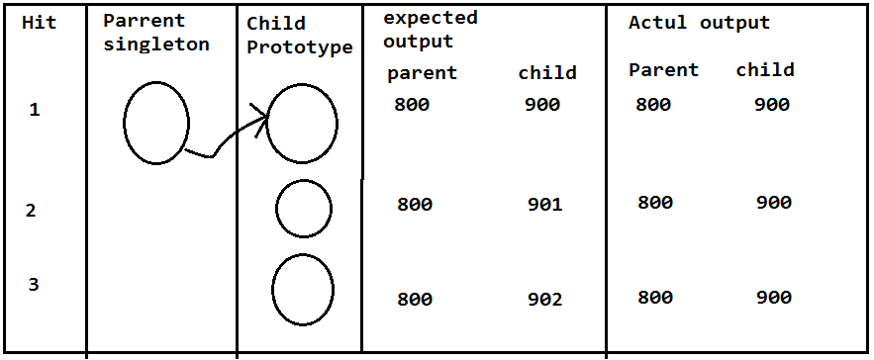

**Lookup method Injection (LMI):**

* Spring container provides a logic to method which will check “is new child created or not?” if it is created then this method will update the links it means new child object is injected to parent object on every access.

Steps to modify code in Parent class and Parent config (no code change child class or child)

**Parent class:**

1. remove set method of child type.
2. write one abstract method that must return child type with any methodName.

Public abstract ChildType methodName()

1. Make Parent class also abstract.
2. call abstract method in getChild(…)

**(Parent bean code change)**

1. Remove <property> tag for ref injection.
2. write new tag <lookup-method/>

Having method =” “ (abstract method name)

Bean=” “ (child objectName)

**Code**

1. **Spring Bean (Address.java)**

**package** com.app;

**publicclass** Address {

**privateint**addrId;

**private** String loc;

Address() {

**super**();

}

**publicint** getAddrId() {

**return**addrId;

}

**publicvoid** setAddrId(**int**addrId) {

**this**.addrId = addrId;

}

**public** String getLoc() {

**return**loc;

}

**publicvoid** setLoc(String loc) {

**this**.loc = loc;

}

@Override

**public** String toString() {

**return**"Address [addrId=" + addrId + ", loc=" + loc + "]";

}

}

1. **Spring Bean (Employee.java)**

**package** com.app;

**publicabstractclass** Employee {

**privateint**empId;

**private** String empName;

**privatedouble**empSal;

**private** Address addr;

Employee() {

**super**();

}

**publicint** getEmpId() {

**return**empId;

}

**publicvoid** setEmpId(**int**empId) {

**this**.empId = empId;

}

**public** String getEmpName() {

**return**empName;

}

**publicvoid** setEmpName(String empName) {

**this**.empName = empName;

}

**publicdouble** getEmpSal() {

**return**empSal;

}

**publicvoid** setEmpSal(**double**empSal) {

**this**.empSal = empSal;

}

**public** Address getAddr() {

**return** getAddress();

}

**publicabstract** Address getAddress();

@Override

**public** String toString() {

**return**"Employee [empId=" + empId + ", empName=" + empName + ", empSal=" + empSal + ", addr=" + addr + "]";

}

}

1. **config.xml**

<?xmlversion=*"1.0"*encoding=*"UTF-8"*?>

<beansxmlns=*"http://www.springframework.org/schema/beans"*

xmlns:util=*"http://www.springframework.org/schema/util"*

xmlns:p=*"http://www.springframework.org/schema/p"*

xmlns:xsi=*"http://www.w3.org/2001/XMLSchema-instance"*

xsi:schemaLocation=*"http://www.springframework.org/schema/beans*

*http://www.springframework.org/schema/beans/spring-beans.xsd"*>

<beanclass=*"com.vicky.Address"*name=*"addrObj"*scope=*"prototype"*>

<propertyname=*"addrId"*value=*"10"*/>

<propertyname=*"loc"*value=*"Patna"*

/>

</bean>

<beanclass=*"com.vicky.Employee"*name=*"empObj"*scope=*"singleton"*

p:empId=*"101"*

p:empName=*"Vicky Raj"*

>

<lookup-methodname=*"getAddr"*bean=*"addrObj"*/>

</bean>

</beans>

1. **Test.java**

**package** com.vicky;

**import** org.springframework.context.ApplicationContext;

**import** org.springframework.context.support.ClassPathXmlApplicationContext;

**publicclass** Test {

**publicstaticvoid** main(String[] args) {

ApplicationContext ac = **new** ClassPathXmlApplicationContext("config.xml");

Employee e1 = (Employee)ac.getBean("empObj");

System.***out***.println(e1.hashCode());

System.***out***.println(e1.getAddr().hashCode());

Employee e2 = (Employee)ac.getBean("empObj");

System.***out***.println(e2.hashCode());

System.***out***.println(e2.getAddr().hashCode());

Employee e3 = (Employee)ac.getBean("empObj");

System.***out***.println(e3.hashCode());

System.***out***.println(e1.getAddr().hashCode());

}

}

**OUTPUT**

10443789

31694959

10443789

11601748

10443789

32135860

**Execution of LMI:**

* Spring container provides logic to abstract method I below format.

1. Create one List of child type.
2. If new object is created then add new child to List.
3. Parent should be linked to last index child object of above list using setChild(list.get(size-1)) logic internally. It looks like.

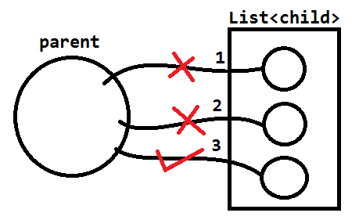

**Java Configuration in spring:**

Spring container can also take configuration in java format instead of XML.It is introduced in spring 3.x which works faster than XML and easy to write.

* Spring has provided two basic annotations for java configuration. Those are
* @Configuration (org.springframework.context.annotation)
* @Bean (org.springframework.context.annotation).

**Steps to write java configurations:**

1. Write one public class with any name.
2. Apply @Configuration annotation on class level.
3. Define one method for one object which returns same classType of requested Object. Method name behaves as Object name by default.
4. Apply @Bean over on method show that Spring Container creates object.

**If method is written in java configuration but @Bean is not applied then container will not create object

**Syntax:**

package com.app.config;

@Configuration

Public class AppConfig()

{

*//no of methods = no of Objects*

@Bean

Public classType objName()

{

*//create obj & set data..*

Return obj;

}

}

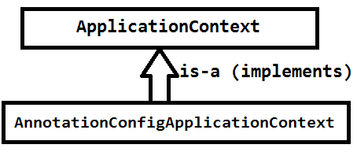

* For both java and Annotation configuration we should use Spring container class (context) given as “AnnotationConfigApplicationContext” (org.springframework.context.annotation).
* It takes java config class as input to create Container with Object.



**CODE**

1. **Spring Bean**

**package** com.app.bean;

**publicclass** Product {

**privateint**pid;

**private** String pname;

**public** Product() {

**super**();

}

**publicint** getPid() {

**return**pid;

}

**publicvoid** setPid(**int**pid) {

**this**.pid = pid;

}

**public** String getPname() {

**return**pname;

}

**publicvoid** setPname(String pname) {

**this**.pname = pname;

}

@Override

**public** String toString() {

**return**"Product [pid=" + pid + ", pname=" + pname + "]";

}

}

1. **Spring Config Flie (config.java)**

**package** com.app.config;

**import** org.springframework.context.annotation.Bean;

**import** org.springframework.context.annotation.Configuration;

**import** com.app.bean.Product;

@Configuration

**publicclass** AppConfig {

@Bean

**public** Product pdtObj() {

Product p =**new** Product();

p.setPid(100);

p.setPname("PEN");

**return**p;

}

}

1. **Test.java**

**package** com.app.test;

**import** org.springframework.context.ApplicationContext;

**import** org.springframework.context.annotation.AnnotationConfigApplicationContext;

**import** com.app.bean.Product;

**import** com.app.config.AppConfig;

**publicclass** Test {

**publicstaticvoid** main(String[] args) {

ApplicationContext ac = **new** AnnotationConfigApplicationContext(AppConfig.**class**);

Product p = ac.getBean("pdtObj" , Product.**class**);

System.***out***.println(p);

}

}

**OUTPUT**

**Product [pid=100, pname=PEN]**

**Collection Configuration Using Spring Java Config Code**

1. **Java Bean (Product.java)**

**package** com.app.bean;

**import** java.util.List;

**import** java.util.Map;

**import** java.util.Properties;

**import** java.util.Set;

**publicclass** Product {

**private** List<String>data;

**private** Set<String>models;

**private** Map<Integer , String>modes;

**private** Properties context;

**public** Product() {

**super**();

}

**public** List<String> getData() {

**return**data;

}

**publicvoid** setData(List<String>data) {

**this**.data = data;

}

**public** Set<String> getModels() {

**return**models;

}

**publicvoid** setModels(Set<String>models) {

**this**.models = models;

}

**public** Map<Integer, String> getModes() {

**return**modes;

}

**publicvoid** setModes(Map<Integer, String>modes) {

**this**.modes = modes;

}

**public** Properties getContext() {

**return**context;

}

**publicvoid** setContext(Properties context) {

**this**.context = context;

}

@Override

**public** String toString() {

**return**"Product [data=" + data + ", models=" + models + ", modes=" + modes + ", context=" + context + "]";

}

}

1. **Config File (AppConfig.java)**

**package** com.app.config;

**import** java.util.HashSet;

**import** java.util.LinkedHashMap;

**import** java.util.LinkedList;

**import** java.util.List;

**import** java.util.Map;

**import** java.util.Properties;

**import** java.util.Set;

**import** org.springframework.context.annotation.Bean;

**import** org.springframework.context.annotation.Configuration;

**import** com.app.bean.Product;

@Configuration

**publicclass** AppConfig {

@Bean

**public** Product pdtObj() {

Product p = **new** Product();

p.setData(lstData());

p.setModels(setData());

p.setModes(mapData());

p.setContext(propsData());

**return**p;

}

**public** List<String> lstData(){

List<String>lst = **new** LinkedList<>();

lst.add("PEN");

lst.add("PENCIL");

**return**lst;

}

**public** Set<String> setData(){

Set<String>set = **new** HashSet<>();

set.add("CAR");

set.add("BYKE");

**return**set;

}

**public** Map<Integer , String> mapData(){

Map<Integer , String>map = **new** LinkedHashMap<>();

map.put(10, "TV");

map.put(20, "LACTOP");

map.put(30, "MOBILE");

**return**map;

}

**public** Properties propsData() {

Properties p = **new** Properties();

p.put(1 , "AC");

p.put(2, "COOLER");

**return**p;

}

}

1. **Test.java**

**package** com.app.test;

**import** org.springframework.context.ApplicationContext;

**import** org.springframework.context.annotation.AnnotationConfigApplicationContext;

**import** com.app.bean.Product;

**import** com.app.config.AppConfig;

**publicclass** Test {

**publicstaticvoid** main(String[] args) {

ApplicationContext ac =**new** AnnotationConfigApplicationContext(AppConfig.**class**);

Product p = ac.getBean("pdtObj" , Product.**class**);

System.***out***.println(p);

}

}

**OUTPUT**

Product [data=[PEN, PENCIL], models=[CAR, BYKE], modes={10=TV, 20=LACTOP, 30=MOBILE}, context={2=COOLER, 1=AC}]

**Reference Type Dependency Configuration using Spring java Config code:**

**Syntax:**

parentObj.setVariable(childObj())

* To link child object with parent object follow above syntax, if not used value will be null.

**Configure child first and parent next.



1. **Spring Bean (Model.java)**

**package** com.app.bean;

**publicclass** Model {

**privateint**mid;

**public** Model() {

**super**();

}

**publicint** getMid() {

**return**mid;

}

**publicvoid** setMid(**int**mid) {

**this**.mid = mid;

}

@Override

**public** String toString() {

**return**"Model [mid=" + mid + "]";

}

}

1. **Spring Bean (Product.java)**

**package** com.app.bean;

**publicclass** Product {

**privateint**pid;

**private** Model mod;

**public** Product() {

**super**();

}

**publicint** getPid() {

**return**pid;

}

**publicvoid** setPid(**int**pid) {

**this**.pid = pid;

}

**public** Model getMod() {

**return**mod;

}

**publicvoid** setMod(Model mod) {

**this**.mod = mod;

}

@Override

**public** String toString() {

**return**"Product [pid=" + pid + ", mod=" + mod + "]";

}

}

1. **Config File (AppConfig.class)**

**package** com.app.config;

**import** org.springframework.context.annotation.Bean;

**import** org.springframework.context.annotation.Configuration;

**import** com.app.bean.Model;

**import** com.app.bean.Product;

@Configuration

**publicclass** AppConfig {

@Bean

**public** Model modObj() {

Model mod = **new** Model();

mod.setMid(10);

**return**mod;

}

@Bean

**public** Product pdtObj() {

Product p = **new** Product();

p.setPid(10);

p.setMod(modObj());

**ret**urn p;

}

}

1. **Test.java**

**package** com.app.test;

**import** org.springframework.context.ApplicationContext;

**import** org.springframework.context.annotation.AnnotationConfigApplicationContext;

**import** com.app.bean.Product;

**import** com.app.config.AppConfig;

**publicclass** Test {

**publicstaticvoid** main(String[] args) {

ApplicationContext ac =**new** AnnotationConfigApplicationContext(AppConfig.**class**);

Product p = ac.getBean("pdtObj" , Product.**class**);

System.***out***.println(p);

}

}

**OUTPUT**

Product [pid=10, mod=Model [mid=10]]

**Java ConfigurationRef-Type –child as Interface:**

* In case of HAS-A Relation (Ref-Type) container creates child object first and then parent.
* But if child type is interface then we should choose any one of it’s impl class and create object to it first.

**Syntax: for child-type-interface**

@Bean

public interfaceName objName () {

//create obj to any impl class

return b;

}

`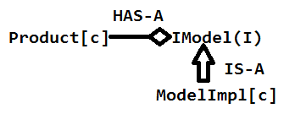



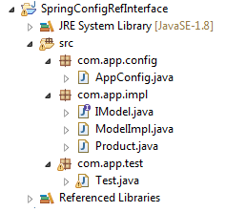

1. **IModel.java**

**package** com.app.bean;

**publicinterface** IModel { }

1. **Spring Bean (ModelImpl.java)**

**package** com.app.bean;

**publicclass** ModelImpl **implements** IModel{

**privateint**mid;

**public** ModelImpl() {

**super**();

}

**publicint** getMid() {

**return**mid;

}

**publicvoid** setMid(**int**mid) {

**this**.mid = mid;

}

@Override

**public** String toString() {

**return**"ModelImpl [mid=" + mid + "]";

}

}

1. **Spring Bean (Product.java)**

**package** com.app.bean;

**publicclass** Product {

**privateint**pid;

**private** IModel mod;

**public** Product() {

**super**();

}

**publicint** getPid() {

**return**pid;

}

**publicvoid** setPid(**int**pid) {

**this**.pid = pid;

}

**public** IModel getMod() {

**return**mod;

}

**publicvoid** setMod(IModel mod) {

**this**.mod = mod;

}

@Override

**public** String toString() {

**return**"Product [pid=" + pid + ", mod=" + mod + "]";

}

}

1. **AppConfig.java**

**package** com.app.config;

**import** org.springframework.context.annotation.Bean;

**import** org.springframework.context.annotation.Configuration;

**import** com.app.bean.IModel;

**import** com.app.bean.ModelImpl;

**import** com.app.bean.Product;

**import**com.app.bean.Product;

@Configuration

**publicclass** AppConfig {

@Bean

**public** IModel modObj() {

ModelImpl mi = **new** ModelImpl();

**return**mi;

}

@Bean

**public** Product pdtObj() {

Product p = **new** Product();

p.setPid(10);

p.setMod(modObj());

**return**p;

}

}

1. **Test.java**

**package** com.app.test;

**import** org.springframework.context.ApplicationContext;

**import** org.springframework.context.annotation.AnnotationConfigApplicationContext;

**import** com.app.bean.Product;

**import** com.app.config.AppConfig;

**publicclass** Test {

**publicstaticvoid** main(String[] args) {

ApplicationContext ac = **new** AnnotationConfigApplicationContext(AppConfig.**class**);

Product p = (Product)ac.getBean("pdtObj");

System.***out***.println(p);

}

}

**OUTPUT**

Product [pid=10, mod=ModelImpl [mid=0]]

**Loading Properties file into Java Config:--**

1. Create .properties files (one or more).
2. Load into Spring Container using @PropertySource ({.. , … , …})

3. Spring Container create object to store all key and values. Obj type is Environment (I).

* For standalone Apps impl class is: MockEnvironment (C).
* for web apps impls class is : StandardServletEnvironment (C)
* These objects are created and data loaded by Spring container..

1. Link Environemnt object with Java Config class using @Autowired.

5. Read data using env.getProperty (“key”) or env.getProperty(“key”, T.class).

* getProperty (String key) : String
* getProperty (String key, T clazz) : T

**Annotation configuration in Spring :**

Compared with other configurations this is very faster in coding and execution also. But not applicable for pre-defined classes configuration. We can configure only programmer defined (having .java code) classes only.

**Types of Annotations for configuration:**

***1.>StereoType Annotations (Bean creation)***

***2>Data Annotations (Injection)***

1. **StereoType Annotation:**

There are 5 types , list given as:

@Component

@Controller

@Service

@Repository

@RestController

1. **Data Annotation**

@Value

@Autowired (for scope concept : @Scope)

1. **StereoType Annotations :**

* An annotation which detects the class and creates the object is known as StereoType Annotation.

1. Activate Annotation with base-package.
2. Provide @Component on top of the class.

**\*\*\* code to activate Annotations:**

<context :component-scan base-package=”----“/>

**Q. What is base-package.**

Ans. It is a package name given by programmer to search and its sub packages.

Ex: if base-package=”com.app” then meaning is “app” package classes and all its sub package classes are selected for object creation.

**Example:**

<context:component-sacn base-package=”com.app”/> classes detected (scan) :C, F, H, J.

1. **@Component:**

It must be applied on class (not applicable for interface and abstract class). It will inform Container to create object of current class.

* If no object name is provided then class name (first letter small) is taken as object name (camel-case-conversion).

**Ex:** package com.app;

@Component

public class Employee{ }

// Here object name is :employee

package com.app;

@Component (“empObj”)

public class Employee{ }

//Here object name is :empObj

1. @Component : Create Object
2. @Controller : Create object +Http Req
3. @Service : Create Object +Transaction Management +Link Layers (Integration).
4. @Repository : Create Object +DB Operations.
5. @RestController:Create object +RestFul WebServices

**Stereo Type Annotation Example**

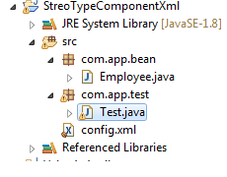

1. **Using Xml process**
2. **Sptring bean (Employee.java)**

**package** com.app.bean;

**import** org.springframework.stereotype.Component;

@Component("empObj")

**publicclass** Employee {

**privateint**empId;

**private** String empName;

**public** Employee() {

**super**();

}

**publicint** getEmpId() {

**return**empId;

}

**publicvoid** setEmpId(**int**empId) {

**this**.empId = empId;

}

**public** String getEmpName() {

**return**empName;

}

**publicvoid** setEmpName(String empName) {

**this**.empName = empName;

}

@Override

**public** String toString() {

**return**"Employee [empId=" +empId+",empName="+ empName + "]";

}

}

1. **Config File (config.xml)**

<?xmlversion=*"1.0"*encoding=*"UTF-8"*?>

<beansxmlns=*"http://www.springframework.org/schema/beans"*

xmlns:p=*"http://www.springframework.org/schema/p"*

xmlns:context=*"http://www.springframework.org/schema/context"*

xmlns:xsi=*"http://www.w3.org/2001/XMLSchema-instance"*

xsi:schemaLocation=*"*

*http://www.springframework.org/schema/beans*

*http://www.springframework.org/schema/beans/spring-beans.xsd*

*http://www.springframework.org/schema/context*

*http://www.springframework.org/schema/context/spring-context.xsd*

*"*>

<context:component-scanbase-package=*"com.app"*/>

</beans>

1. **Test.java**

**package** com.app.test;

**import** org.springframework.context.ApplicationContext;

**import** org.springframework.context.support.ClassPathXmlApplicationContext;

**import** com.app.bean.Employee;

**publicclass** Test {

**publicstaticvoid** main(String[] args) {

ApplicationContext ac = **new** ClassPathXmlApplicationContext("config.xml");

Employee e = ac.getBean("empObj" , Employee.**class**);

e.setEmpId(10);

e.setEmpName("Vicky Raj");

System.***out***.println(e);

}

}

1. **Using Java Config Process. (no Xml file)**
2. **Spring Bean (Employee.java)**

**package** com.app.bean;

**import** org.springframework.stereotype.Component;

@Component("empObj")

**publicclass** Employee {

**privateint**empId;

**private** String empName;

**public** Employee() {

**super**();

}

**publicint** getEmpId() {

**return**empId;

}

**publicvoid** setEmpId(**int**empId) {

**this**.empId = empId;

}

**public** String getEmpName() {

**return**empName;

}

**publicvoid** setEmpName(String empName) {

**this**.empName = empName;

}

@Override

**public** String toString() {

**return**"Employee [empId=" + empId+",empName="+empName+ "]";

}

}

1. **AppConfig.java**

**package** com.app.config;

**import**org.springframework.context.annotation.Bean;

**import** org.springframework.context.annotation.ComponentScan;

**import** org.springframework.context.annotation.Configuration;

**import**com.app.bean.Employee;

@Configuration

@ComponentScan(basePackages = "com.app")

**publicclass** AppConfig { }

1. **Test.java**

**package** com.app.config;

**import** org.springframework.context.ApplicationContext;

**import** org.springframework.context.annotation.AnnotationConfigApplicationContext;

**import** com.app.bean.Employee;

**publicclass** Test {

**publicstaticvoid** main(String[] args) {

ApplicationContext ac = **new** AnnotationConfigApplicationContext(AppConfig.**class**);

Employee emp = ac.getBean("empObj" , Employee.**class**);

System.***out***.println(emp);

}

}

1. **Using Annotation Process (* Only For Stand Alone Applications)**

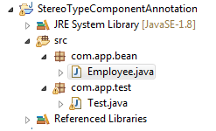

1. **Spring Bean (Employee.java)**

**package** com.app.bean;

**import** org.springframework.beans.factory.annotation.Value;

**import** org.springframework.stereotype.Component;

@Component

**publicclass** Employee {

@Value("10")

**privateint**empId;

@Value("vicky raj")

**private** String empName;

**public** Employee() {

**super**();

}

**publicint** getEmpId() {

**return**empId;

}

**publicvoid** setEmpId(**int**empId) {

**this**.empId = empId;

}

**public** String getEmpName() {

**return**empName;

}

**publicvoid** setEmpName(String empName) {

**this**.empName = empName;

}

@Override

**public** String toString() {

**return**"Employee [empId="+empId+",empName=" + empName + "]";

}

}

1. **Test.xml**

**package** com.app.test;

**import** org.springframework.context.annotation.AnnotationConfigApplicationContext;

**import** com.app.bean.Employee;

**publicclass** Test {

**publicstaticvoid** main(String[] args) {

AnnotationConfigApplicationContext ac =

**new** AnnotationConfigApplicationContext();

ac.scan("com.app");

ac.refresh();

Employee e = ac.getBean("employee" , Employee.**class**);

System.***out***.println(e);

}

}

* In above case container created with no objects (i.e ACAC a =new ACAC()).
* ***After creating container, we are providing package name to search for classes to create objects using code.

scan(basePackages).

* Now we should inform to container Re-search for all classes and create object using code.

refresh()

**Providing scope in Annotation Configuration:**

* use @Scope in annotation Config to define bean scope.

**Ex:**

Package com.app;

@Component

@Scope(“prototype”)

Public class Employee { }

**\*\* Test class :same as before**

** @Scope can be written along with even @Controller, @Service, @Repository and @RestController also.

**@Value (Basic data Annotation):**

* This annotation is used to inject data to bean (object) in case of Annotation configuration (used along with stereo type Annotation Configuration).
* It is applicable for Primitive Type, Collection and Reference Type.
* Data can be injected using simple value, expression, standalone Collection, Object reference, Object reference data.
* Supports Data reading from properties file also.
* Here # indicates object-id (obj ref) $ indicates property key.

**Annotation : Dependency**

@Value : Primitive Type

@Value + SAC : Collection Type

@Value + Child obj-id : Reference Type

Or

**@Autowired

**Example for primitive and collection configuration using annotation config in spring framework:**

**SETUP**

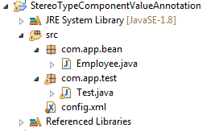

1. **Spring Bean (Employee.java)**

**package** com.app.bean;

**import** java.util.List;

**import** java.util.Map;

**import** java.util.Properties;

**import** org.springframework.beans.factory.annotation.Value;

**import** org.springframework.stereotype.Component;

@Component("empObj")

**publicclass** Employee {

@Value("100")

**privateint**empId;

@Value("Vicky raj")

**private** String empName;

@Value("5.5")

**privatedouble**empSal;

@Value("#{lstObj}")

**private** List<String>cords;

@Value("#{mapObj}")

**private** Map<Integer , String>stands;

@Value("#{propObj}")

**private** Properties props;

**public** Employee() {

**super**();

}

**publicint** getEmpId() {

**return**empId;

}

**publicvoid** setEmpId(**int**empId) {

**this**.empId = empId;

}

**public** String getEmpName() {

**return**empName;

}

**publicvoid** setEmpName(String empName) {

**this**.empName = empName;

}

**publicdouble** getEmpSal() {

**return**empSal;

}

**publicvoid** setEmpSal(**double**empSal) {

**this**.empSal = empSal;

}

**public** List<String> getCords() {

**return**cords;

}

**publicvoid** setCords(List<String>cords) {

**this**.cords = cords;

}

**public** Map<Integer, String> getStands() {

**return**stands;

}

**publicvoid** setStands(Map<Integer, String>stands) {

**this**.stands = stands;

}

**public** Properties getProps() {

**return**props;

}

**publicvoid** setProps(Properties props) {

**this**.props = props;

}

@Override

**public** String toString() {

**return**"Employee [empId=" + empId + ", empName=" + empName + ", empSal=" + empSal + ", cords=" + cords

+ ", stands=" + stands + ", props=" + props + "]";

}

}

1. **config.xml**

<?xmlversion="1.0"encoding="UTF-8"?>

<beansxmlns="http://www.springframework.org/schema/beans"

xmlns:p="http://www.springframework.org/schema/p"

xmlns:util="http://www.springframework.org/schema/util"

xmlns:context="http://www.springframework.org/schema/context"

xmlns:xsi="http://www.w3.org/2001/XMLSchema-instance"

xsi:schemaLocation="

http://www.springframework.org/schema/beans

http://www.springframework.org/schema/beans/spring-beans.xsd

http://www.springframework.org/schema/context

http://www.springframework.org/schema/context/spring-context.xsd

http://www.springframework.org/schema/util

http://www.springframework.org/schema/util/spring-util.xsd

">

<context:component-scanbase-package="com.app"/><util:listlist-class="java.util.LinkedList"id=lstObj">

<value>10</value>

<value>AAA</value>

</util:list>

<util:mapmap-class="java.util.LinkedHashMap" id="mapObj">

<entry>

<key>

<value>10</value>

</key>

<value>BBB</value>

</entry>

</util:map>

<util:propertiesid="propObj">

<propkey="20">CCC</prop>

<propkey="30">DDD</prop>

</util:properties>

</beans>

1. **Test.java**

**package** com.app.test;

**import** org.springframework.context.ApplicationContext;

**import** org.springframework.context.support.ClassPathXmlApplicationContext;

**import** com.app.bean.Employee;

**publicclass** Test {

**publicstaticvoid** main(String[] args) {

ApplicationContext ac = **new** ClassPathXmlApplicationContext("config.xml");

Employee e = ac.getBean("empObj" , Employee.**class**);

System.***out***.println(e);

}

}

**OUTPUT**

Employee [empId=100, empName=Vicky raj, empSal=5.5, cords=[10, AAA], .stands={10=BBB}, props={20=CCC, 30=DDD}]

**\*\***@Value auto-detect the required object (done by container) and link if fournd

[so , no setter required]

**Expression Language in Spring (SpEL=Spring Expression Language):**

In expression is a combination of different components in java that returns finally one value (Value can be primitive, Collection or Object).

Spring uses components like

1. variables (ex: a, b, sid)
2. symbols (#, . (? | <> + = - *)
3. classes (String, Math, Random , Date , ….)
4. methods (both static and non-static)
5. Objects (strObj, addrObj, listObj)
6. numerics (1, 2, 3,4 , …..)

**Int type expressions:**

1. @Value (“#{6+6}”) ==>12
2. @Value (#{new java.util.Random().nextInt(1000)}”) =>Random Number
3. @Value(“#{T(java.lang.Math).max(11,55)}”) =>55 output
4. @Value (“#{new java.util.Random().nextDouble()*1000}”) =>Generates double and converted to int.
5. @Value (“#{“Hello”.length()}”) =>Hello is String , its length =5
6. @Value (“#{7>7?9:-99}”) =>output -99
7. @Value (“#{6/6}”) =>output :1
8. @Value (“#{new java.util.Random().hashCode()}”) =>Output 564456

**NOTE:--**

1. To write expression use format @Value(“#{expression}”).
2. It returns a value, must be applied on same type (or nearest dataType, which can be convertible) variable.

**Ex:**

@Value (“#{6+3}”) returns int type, so apply on int type variable in code.

1. Call instance method using @Value{“#{new pack.className().method()}”)
2. Call static method using @Value(“#T(pack.className).method()}”)

** Here t =Type=Class

1. To indicate String object use single quotes .

**Ex:** ‘abc’

**String DataType expressions:**

1. @Value(“#{‘Welcome’.toUperCase()}”) =>WELCOME
2. @Value (“#(new java,lang.String (‘abcd’).length()}”) =>output 4
3. @Value (“#{new java.util.Date().toString()}”) =>Same Data and Time
4. @Value ({“(T (java.util.Calender).MILLISECOND}”) =>Milli seond in int data
5. @Value (“{‘Hello’ + ‘Welcome’}”) =>No
6. @Value (“#{3>8?’Yes’:’No’}”) =>No

**Note:**

1. Any value can be stored in String.

**Ex:** int, byte, Boolean, double… can be stored in string.

1. To convert any object to String data, use toString() method over Object.

** see above examples (3)

1. Use String objects are valid with ‘ ‘ Symbols. We can even call String methods.

**Constructor Dependency Injection (CDI)/Constructor Injection (CI) :**

* Spring container uses parameterized constructor to create object and to provide data. In this case programmer must write parameterized constructor in spring bean.
* To Specify one parameter tag is “<constructor-arg></constructor-arg>”.
* This one never going to depend on default constructor and setters and getters.
* Writing bean tag without <constructor-arg> indicates using default constructor.

**Ex:** no <constructor-arg> tag

<bean class=”com.app.bean.Employee”name=”emp”></bean>

**Means**: Employee emp = new Empoyee();

* If no constructor is written in class then Java Compiler will add default constructor.

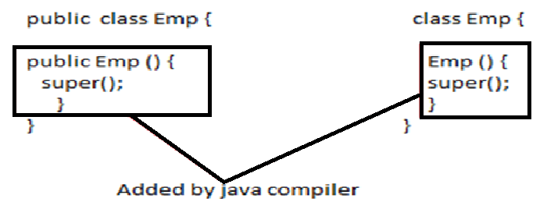

* A valid overloading checks data types

1. Order
2. count
3. Type

* one of this must be different.

**NOTE:**

It never checks param-name (arg-name)

**Overloading priority order:**

1. Primitive type
2. wrapper class
3. super class
4. var-args

**Emample Code:**

**package** com.vicky;

**publicclass** Employees {

**public** Employees( **int**a ) {

System.***out***.println("#int - 1"); //First Priority

}

**public** Employees(Integer a) {

System.***out***.println("#Integer - 2"); //second Priority

}

**public** Employees(Number n) {

System.***out***.println("#Number - 3"); //Third Priority

}

**public** Employees(Object o) {

System.***out***.println("#Object - 4"); // Fourth Priority

}

**public** Employees(**int**... a) {

System.***out***.println("#Var args - 5"); //Last Priority

}

}

**Ex1: CDI using Primitive Type**

We can provide value for primitive using

1. value as tag (<value></value>)
2. value as attribute (<constructor-arg value=” “/>
3. c-schema/c-namespace (<bean class =”com.app.Employee” name=”emp” c:variable=”data” …/>

**CODE**

**SETUP**

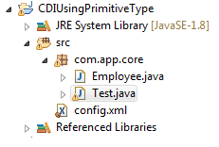

1. **Employee.java**

**package** com.app.core;

**publicclass** Employee {

**privateint**empId;

**private** String empName;

**public** Employee() {

**super**();

}

**public** Employee(**int**empId, String empName) {

**super**();

**this**.empId = empId;

**this**.empName = empName;

}

**publicint** getEmpId() {

**return**empId;

}

**publicvoid** setEmpId(**int**empId) {

**this**.empId = empId;

}

**public** String getEmpName() {

**return**empName;

}

**publicvoid** setEmpName(String empName) {

**this**.empName = empName;

}

@Override

**public** String toString() {

**return**"Employee [empId=" +empId+",empName="+ empName + "]";

}

}

1. **config.xml**

<?xmlversion=*"1.0"*encoding=*"UTF-8"*?>

<beansxmlns=*"http://www.springframework.org/schema/beans"*

xmlns:p=*"http://www.springframework.org/schema/p"*

xmlns:c=*"http://www.springframework.org/schema/c"*

xmlns:context=*"http://www.springframework.org/schema/context"*

xmlns:xsi=*"http://www.w3.org/2001/XMLSchema-instance"*

xsi:schemaLocation=*"*

*http://www.springframework.org/schema/beans*

*http://www.springframework.org/schema/beans/spring-beans.xsd*

*http://www.springframework.org/schema/context*

*http://www.springframework.org/schema/context/spring-context.xsd*

*"*>

<!-- Value As Tag

<bean class = "com.app.core.Employee" name = "empObj">

<constructor-arg>

<value>10</value>

</constructor-arg>

<constructor-arg>

<value>Vicky</value>

</constructor-arg>

</bean> -->

<!-- Value as attribute

<bean class = "com.app.core.Employee" name = "empObj">

<constructor-arg value = "10"/>

<constructor-arg value = "vickyraj"/>

</bean> -->

<!-- Value As C-Schema -->

<beanclass=*"com.app.core.Employee"*name=*"empObj"*

c:empId=*"10"*

c:empName=*"Vicky Raj"*/>

</beans>

1. **Test.java**

**package** com.app.core;

**import** org.springframework.context.ApplicationContext;

**import** org.springframework.context.support.ClassPathXmlApplicationContext;

**publicclass** Test {

**publicstaticvoid** main(String[] args) {

ApplicationContext ac = **new** ClassPathXmlApplicationContext("config.xml");

Employee emp = (Employee)ac.getBean("empObj");

System.***out***.println(emp);

}

}

**Primitives and Collection XML Configuration using Constructor Dependency Injection:**

* For Collection Type config code using CDI.

**Syntax is :**

1. **without SAC (Stand alone configuration):**

<constructor-arg>

<list> | <set> | <map> |<props>

</constructor-arg>

1. **Using SACs:**

<util:cncn-class=*"---"*id=*"objName"*>

</util:cn>

<constructor-argref=*"empObj"*/>

**or**

<bean.... c:varName-ref=*"objName"*.....></bean>

**or**

<constructor-arg>

<refbean=*"objName"*/>

</constructor-arg>

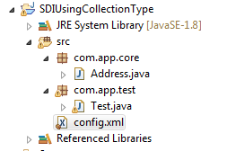

1. **Spring Bean (Address.java)**

**package** com.app.core;

**import** java.util.List;

**import** java.util.Map;

**publicclass** Address{

**privateint**empId;

**private** String loc;

**private** List<String>cords;

**private** Map<Integer , String>details;

**public** Address(**int**empId, String loc, List<String>cords, Map<Integer, String>details) {

**super**();

**this**.empId = empId;

**this**.loc = loc;

**this**.cords = cords;

**this**.details = details;

}

@Override

**public** String toString() {

**return**"Address [empId=" + empId + ", loc=" + loc + ", cords=" + cords + ", details=" + details + "]";

}

}

1. **config.xml**

<?xmlversion=*"1.0"*encoding=*"UTF-8"*?>

<beansxmlns=*"http://www.springframework.org/schema/beans"*

xmlns:p=*"http://www.springframework.org/schema/p"*

xmlns:c=*"http://www.springframework.org/schema/c"*

xmlns:util=*"http://www.springframework.org/schema/util"*

xmlns:context=*"http://www.springframework.org/schema/context"*

xmlns:xsi=*"http://www.w3.org/2001/XMLSchema-instance"*

xsi:schemaLocation=*"*

*http://www.springframework.org/schema/beans*

*http://www.springframework.org/schema/beans/spring-beans.xsd*

*http://www.springframework.org/schema/context*

*http://www.springframework.org/schema/context/spring-context.xsd*

*http://www.springframework.org/schema/util*

*http://www.springframework.org/schema/util/spring-util.xsd*

*"*>

**<!-- SAC Data List and Map -->**

<util:listlist-class=*"java.util.LinkedList"*id=*"lstObj"*>

<value>10</value>

<value>20</value>

</util:list>

<util:mapmap-class=*"java.util.LinkedHashMap"*id=*"mapObj"*>

<entry>

<key>

<value>10</value>

</key>

<value>AAA</value>

</entry>

<entrykey=*"20"*value=*"BBB"*/>

</util:map>

**<!-- Store Collection Value Using SAC (Stand Alone Class) -->**

<beanclass=*"com.app.core.Address"*name=*"addrObj"*>

<constructor-arg>

<value>10</value>

</constructor-arg>

<constructor-argvalue=*"CCC"*/>

<constructor-arg>

<refbean=*"lstObj"*/>

</constructor-arg>

<constructor-argref=*"mapObj"*/>

</bean>

**<!-- Without SAC -->**

<!--

<bean class="com.app.core.Address" name="addrObj">

<constructor-arg>

<value>10</value>

</constructor-arg>

<constructor-arg value="patna" />

<constructor-arg>

<list>

<value>10</value>

<value>20</value>

<value>30</value>

</list>

</constructor-arg>

<constructor-arg>

<map>

<entry>

<key>

<value>10</value>

</key>

<value>AAA</value>

</entry>

<entry>

<key>

<value>20</value>

</key>

<value>BBB</value>

</entry>

</map>

</constructor-arg>

</bean>

-->

**<!-- String Collection Data in Parameter Using SAC (Stand Alone Collection) -->**

<!-- <bean class = "com.app.core.Address" name = "addrObj"

c:empId = "10"

c:loc = "patna"

c:cords-ref = "lstObj"

c:details-ref = "mapObj" /> -->

</beans>

1. **Test.java**

**package** com.app.test;

**import** org.springframework.context.ApplicationContext;

**import** org.springframework.context.support.ClassPathXmlApplicationContext;

**import** com.app.core.Address;

**publicclass** Test {

**publicstaticvoid** main(String[] args) {

ApplicationContext ac = **new** ClassPathXmlApplicationContext("config.xml");

Address a = (Address)ac.getBean("addrObj");

System.***out***.println(a);

}

}

**Ref Type Using CDI With XML Config**

**Setup**

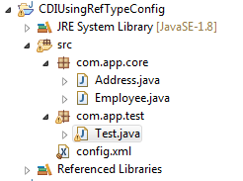

1. **Spring Bean (Address.java)**

**package** com.app.core;

**publicclass** Address {

**private** String addr;

**public** Address() {

**super**();

}

**public** Address(String addr) {

**super**();

**this**.addr = addr;

}

@Override

**public** String toString() {

**return**"Address [addr=" + addr + "]";

}

}

1. **Spring Bean (Employee.java)**

**package** com.app.core;

**publicclass** Employee {

**privateint**empId;

**private** String empName;

**private** Address addr;

**public** Employee() {

**super**();

}

**public** Employee(**int**empId, String empName, Address addr) {

**super**();

**this**.empId = empId;

**this**.empName = empName;

**this**.addr = addr;

}

@Override

**public** String toString() {

**return**"Employee [empId=" + empId + ", empName=" + empName + ", addr=" + addr + "]";

}

}

1. **config.xml**

<?xmlversion=*"1.0"*encoding=*"UTF-8"*?>

<beansxmlns=*"http://www.springframework.org/schema/beans"*

xmlns:p=*"http://www.springframework.org/schema/p"*

xmlns:c=*"http://www.springframework.org/schema/c"*

xmlns:util=*"http://www.springframework.org/schema/util"*

xmlns:context=*"http://www.springframework.org/schema/context"*

xmlns:xsi=*"http://www.w3.org/2001/XMLSchema-instance"*

xsi:schemaLocation=*"*

*http://www.springframework.org/schema/beans*

*http://www.springframework.org/schema/beans/spring-beans.xsd*

*http://www.springframework.org/schema/context*

*http://www.springframework.org/schema/context/spring-context.xsd*

*http://www.springframework.org/schema/util*

*http://www.springframework.org/schema/util/spring-util.xsd*

*"*>

**<!-- Address Object -->**

<!—

<bean class = "com.app.core.Address" name = "addrObj" c:addr = "patna"/>

-->

**<!-- Ref As Tag -->**

<!—

<bean class = "com.app.core.Employee" name = "empObj">

<constructor-arg>

<value>11</value>

</constructor-arg>

<constructor-arg>

<value>VickyRaj</value>

</constructor-arg>

<constructor-arg>

<ref bean = "addrObj"/>

</constructor-arg>

</bean>

-->

**<!-- Ref As Attribute -->**

<!—-

<bean class = "com.app.core.Employee" name = "empObj">

<constructor-arg value = "10"/>

<constructor-arg value = "VickyRaj"/>

<constructor-argref = "addrObj"/>

</bean>

-->

**<!--Ref As Using C-Schema / C:Name-Space -->**

<!—-

<bean class = "com.app.core.Employee" name = "empObj"

c:empId = "10"

c:empName = "VickyRaj"

c:addr-ref = "addrObj"/>

-->

**<!-- Using Inner Bean -->**

<beanclass=*"com.app.core.Employee"*name=*"empObj"*

c:empId=*"12"*

c:empName=*"Vicky raj"*>

<constructor-arg>

<beanclass=*"com.app.core.Address"*c:addr=*"patna"*/>

</constructor-arg>

</bean>

</beans>

1. **Test.java**

**package** com.app.test;

**import** org.springframework.context.ApplicationContext;

**import** org.springframework.context.support.ClassPathXmlApplicationContext;

**import** com.app.core.Employee;

**publicclass** Test {

**publicstaticvoid** main(String[] args) {

ApplicationContext ac = **new** ClassPathXmlApplicationContext("config.xml");

Employee e = ac.getBean("empObj" , Employee.**class**);

System.***out***.println(e);

}

}

**CDI Important Point**

1. Writing <bean> tag without any <constructor-arg> tag, indicates “creating object using default constructor”.
2. If <bean> tag having <constructor-arg> tag then, it indicates “creating object using param constructor”.
3. If Spring Bean has only one param Constructor (no default constructor is provided), then writing only <bean> tag without <constructor-arg> throws Exception: *BeanInstantiationException:* No default constructor found; NoSuch MethodException: com.app.Employee.<init>()

**Ex:**

public class Employee {

Public Employee (int a) {……}

}

**XML:** <bean class=”Employee” name=”oa”></bean>

**NOTE:** Java Compiler will never provide default constructor. If class has one or more constructor in it.

1. If class (Spring bean) has no matching const. for XML Configuration, then Spring Container throws Exception:

*BeanCreationException:* could not resolve matching constructor

**Ex:**

public class Employee {

Public Employee (int a ) {….}

}

**XML:**

<beanclass=*"com.app.core.Employee"*name=*"empObj"*>

<constructor-arg>

<value>10</value>

</constructor-arg>

<constructor-arg>

<value>20</value>

</constructor-arg>

</bean>

**Output: above type Exception.**

1. By default <value> tag data is String type , So calling constructor given priority is String#param constructor. If it is not available then Container checked in order (1st, 2nd, 3rd,….const) else Exception (no matching const. found).

**Case#1 Having (no String type const.)**

**publicclass** Employee {

**public** Employee (**int**a , **int**b) {

System.***out***.println("#int-1");

}

**public** Employee(**double**a , **double**b) {

System.***out***.println("#double-2");

}

}

**XML:Same As Above Code**

**OUTPUT :#int-1**

**Case#2 Change In Order (no String type)**

**publicclass** Employee {

**public** Employee(**double**a , **double**b) {

System.***out***.println("#double-2");

}

**public** Employee (**int**a , **int**b) {

System.***out***.println("#int-1");

}

}

**XML: Same As Above Code.**

**OUTPUT: #double-2**

**Case#1 Having String param const.**

**publicclass** Employee {

**public** Employee(**double**a , **double**b) {

System.***out***.println("#double-2");

}

**public** Employee(String a , String b) {

System.***out***.println("#String-3");

}

**public** Employee (**int**a , **int**b) {

System.***out***.println("#int-1");

}

}

**XML: Same As Above Code.**

**Output: #String-3**

**NOTE:**

In above class, Spring Container is trying to select nearest matching const. to avoid exception. But it leads to wrong output. To solve this use constructor argument “type, index and name”

1. **type attribute :**

it indicates data type. For <value> tag default type is provided as java.lang.String. So, search priority is given to String#Param const 1st.

**\*\***  Use this attribute to provide const-arg data Type, to choose a valid param const.

**CODE**

**publicclass** Employee {

**public** Employee(**double**a , **double**b) {

System.***out***.println("#double-2");

}

**public** Employee(String a , String b) {

System.***out***.println("#String-3");

}

**public** Employee (**int**a , **int**b) {

System.***out***.println("#int-1");

}

}

**XML CODE #1**

<beanclass=*"com.app.core.Employee"*name=*"empObj"*>

<constructor-argtype=*"int"*>

<value>10</value>

</constructor-arg>

<constructor-argtype=*"int"*>

<value>20</value>

</constructor-arg>

</bean>

**OUTPUT: #int-1**

**XML CODE #2**

<beanclass=*"com.app.core.Employee"*name=*"empObj"*>

<constructor-argtype=*"double"*>

<value>10.5</value>

</constructor-arg>

<constructor-argtype=*"double"*>

<value>20.5</value>

</constructor-arg>

</bean>

**OUTPUT: #double-2**

**b. Index for Constructor-argument:**

* Every argument of param Constructor gets assigned with one position number [starts from zero (0)] is known as index.
* Index can be provided by programmer else assigned by Spring Container.
* Index number starts from zero (0, 1, 2, 3….).
* Providing index is optional.
* Index may be provided for few <constructor-arg> tags by programmer, remaining can be provided by Spring container, it is also called as partial indexing.
* If no index is provided then, Spring Container applies “Index Swapping”. It means.

1. First search for const with given order of args.
2. Else if not found any matching const then it will change index positions to get a nearest matching const. which avoid exception.
3. **Spring Bean**

**publicclass** Employee {

**public** Employee(**int**a , **double**b) {

System.***out***.println("#Const");

}

}

1. **Spring Config File (.xml)**

<beanclass=*"com.app.core.Employee"*name=*"empObj"*>

<constructor-argtype=*"double"*>

<value>10.5</value>

</constructor-arg>

<constructor-argtype=*"int"*>

<value>20.5</value>

</constructor-arg>

</bean>

1. **Test Class**

**OUTPUT : #CONST#**

**Q. How above code is executed?**

**Ans.** First Spring Container is trying to Search Employee constructor with index=0 as double and index=1 as int i.e. Employee (88, 66);

So, this is not found in Spring Bean, Container did swapping index i.e. index=0 to int and index=1 to double i.e. Employee (66, 88) // Employee (int, double)

**Q. Why Spring Container is swapping index?**

**Ans.**Spring container is trying to avoid exception by choosing nearest matching data type constructor using index swapping.

**Q. How to avoid index swapping in Spring?**

**Ans.**Programmer should provide index to all arguments in Spring config file.

<beanclass=*"com.app.core.Employee"*name=*"empObj"*>

<constructor-argtype=*"double" index = “0”*>

<value>10.5</value>

</constructor-arg>

<constructor-argtype=*"int" index = “1”*>

<value>20.5</value>

</constructor-arg>

</bean>

**\*\***If Employee (double, int) const. is not found, then Spring container throws **UnsatisfiedDependencyException.**

**Partial indexing:**

Providing index to arguments are optional. We can provide index to all or few args.

If only few indexes are provided by programmer then it is called as Partial indexing. In this case Spring Container provides remaining indexes.

Consider below example:--

|  |  |  |
| --- | --- | --- |
|  | Programmer | Spring Container |
| <c-arg> | **Index=”4”** | **Index=”4”** |
| <c-arg> |  | **Index=”1”** |
| <c-arg> |  | **Index=”2”** |
| <c-arg> | **Index=”0”** | **Index=”0”** |
| <c-arg> |  | **Index=”3”** |
| <c-arg> |  | **Index=”5”** |

* In above case index swapping is done if no matching constructor if found. But Container can swap only index numbers 1, 2, 3, 5 (assigned by Container)

**C. Name attribute in CDI:**

* This attribute is used to specify parameter name in Constructor (not the instance variable name like setter injection).

**Ex:**

class Employee {

int empId;

Employee (int a) {

empId=a;

}

}

<constructor-arg name=”a” …. (valid)

<constructor-arg name=”empId” ….(Invalid)

* This name is provided in Spring 3.x version.

**Code**

1. **Spring Bean (Employee.java)**

**package** com.app.core;

**publicclass** Employee {

**public** Employee(**double**a , **double**b) {

System.***out***.println("#double");

}

}

1. **Spring Config (config.xml)**

<beanclass=*"com.app.core.Employee"*name=*"empObj"*>

<constructor-argname=*"a"*>

<value>10</value>

</constructor-arg>

<constructor-argname=*"b"*>

<value>20</value>

</constructor-arg>

</bean>

**OUTPUT: #double**

**EXAMPLE#2**

1. **Spring Bean (Employee.java)**

**package** com.app.core;

**publicclass** Employee {

**public** Employee(**double**a , **double**b) {

System.***out***.println("#double Type");

}

**public** Employee(String a , String b) {

System.***out***.println("#String Type");

}

}

1. **Config File (config.xml)**

<beanclass=*"com.app.core.Employee"*name=*"empObj"*>

<constructor-argname=*"a"*type=*"double"*>

<value>10</value>

</constructor-arg>

<constructor-argname=*"b"*type=*"double"*>

<value>20</value>

</constructor-arg>

</bean>

**OUTPUT: #double Type**

**Difference between CDI and SBI:**

|  |  |
| --- | --- |
| CDI | SDI |
| 1. Tag used here is <constructor-arg> above tag indicates one parameter of constructor | 1. **Tag used here is <property> above tag indicates one set method** |
| 1. attributes are : type, index and name | 1. **Attribute are: only name** |
| 1. It uses param. Const. to create object | 1. **It uses default const with set method to create obj.** |
| 4. Faster compared to setter Injection. | **4. Slower compared to Const. Injection.** |
| 5. Creates Immutable object (which can’t be changed once created. | **5. Creates mutable object.** |
| 6. It may choose invalid constructor, based on Spring execution control flow. | **6.It always chooses 100% valid set method.** |
| 7. It supports c-schema/c-namespace | **7. It supports p-schema/p-namespace** |
| 8.Inner Bean Syntax is:  <bean ….  <constructor-arg….  <bean…… | **8. Inner Bean Syntax is :**  **<bean….**  **<property……**  **<bean….** |
| 9. we should provide all param to choose one param. Const. (at least default values). | **9. Setter injection. Is optional, we can pass few or zero value (use @Required to make it mandatory)** |
| 10. All attributes (type, index, name are optional) | **10. name attribute is required.** |

**Q. When should we use Constructor Dependency Injection (CDI) and Setter Dependency Injection (SDI)?**

**Ans1**: If class has less param const. with few arguments then better to choose CDI. If class has more overloaded const. and has more params, better choose SDI.

**Ans2:** To set all values (full object data) use CDI, To get few value (partial object data ) use SDI.

**Ans3:** CDI args follows order (index based) like 1st param, 2nd param etc… SDI never follows order. We can set eid 1st ename next or ename 1st and eid next.

**Ans4:** If class has both default constructor with set/get and param const. then using combination is allowed, Even better to follow this, compared with all other cases.

**Ex code:**

publicclass Employee {

privateintempId;

private String empName;

public Employee(int empId, String empName)

{

System.out.println("in param constructor");

}

publicvoid setEmpId(intempId)

{

//code...

System.*out*.println("in empId Set method");

}

//toString

}

**XML Code:**

<bean class=”com.appEMployee” name=”e”>

<constructor-arg value=”66”/>

<property name=”empId” value=”88”/>

<constructor-arg value=”AA”/>

</bean>

**Wiring:**

It is a process of linking parent object with child object. By writing<ref> tag code written by programmer.

**Autowiring:**

Parent-child object are linked by Spring Container only. Programmer not required to write <property with <ref (SI code) or <constructor-arg with <ref (CI code).

* Autowiring is applicable for Reference Type Dependency Only.
* Autowiring can be done in two ways.

1. XML 2. Annotation

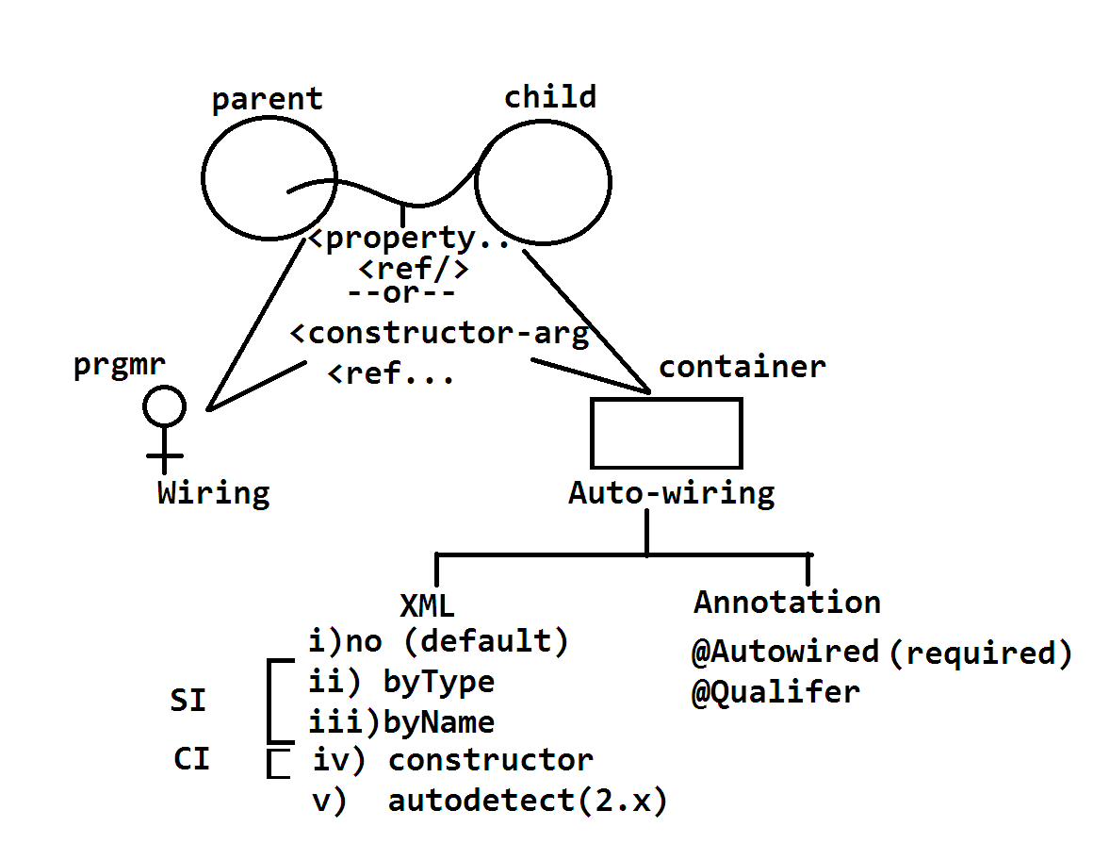

**byType autowiring example:**

* This one compares <bean class=”” in XML with DataType of HAS-A variable in parent class.
* If matched then spring container will inject child into parent object.

**Syntax:** at parent <bean> tag level

<bean class=”” name=”” autowired=”byType”…

**Matching Result Table**

|  |  |
| --- | --- |
| No.of Matching | Result |
| =0 | Null |
| =1 | Injected |
| =2 | NoUniqueBeanDefEx |

* byType uses setter Injection.
* byType means DataType
* byType case container generates code like: <property… with <ref..

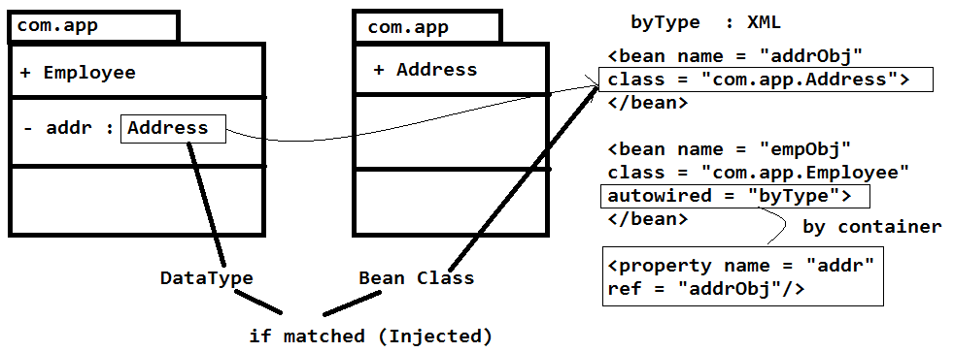

**SETUP**

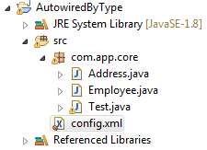

**CODE:**

1. **Spring Bean (Address.java)**

**package** com.app.core;

**publicclass** Address {

**private** String loc;

**public** Address() {

**super**();

}

**public** Address(String loc) {

**super**();

**this**.loc = loc;

}

**public** String getLoc() {

**return**loc;

}

**publicvoid** setLoc(String loc) {

**this**.loc = loc;

}

@Override

**public** String toString() {

**return**"Address [loc=" + loc + "]";

}

}

1. **Spring Bean (Employee.java)**

**package** com.app.core;

**publicclass** Employee {

**privateint**empId;

**private** Address addr;

**public** Employee() {

**super**();

}

**public** Employee(**int**empId, Address addr) {

**super**();

**this**.empId = empId;

**this**.addr = addr;

}

**publicint** getEmpId() {

**return**empId;

}

**publicvoid** setEmpId(**int**empId) {

**this**.empId = empId;

}

**public** Address getAddr() {

**return**addr;

}

**publicvoid** setAddr(Address addr) {

**this**.addr = addr;

}

@Override

**public** String toString() {

**return**"Employee [empId=" + empId + ", addr=" + addr + "]";

}

}

1. **config.xml**

**CASE#1: (Zero Child Bean Matching Found)**

<beanclass=*"com.app.core.Employee"*name=*"empObj"*

p:empId=*"10"*

autowire=*"byType"*/>

**OUTPUT:** Employee [empId=10, addr=null]

**CASE#2: (One Child Bean Matching Found)**

<beanclass=*"com.app.core.Address"*name=*"addr"*

p:loc=*"patna"*/>

<beanclass=*"com.app.core.Employee"*name=*"empObj"*

p:empId=*"10"*

autowire=*"byType"*/>

**OUTPUT:** Employee [empId=10, addr=Address [loc=patna]]

**CASE#3 (Multiple Bean Matching Bean Found)**

<beanclass=*"com.app.core.Address"*name=*"addr"*

p:loc=*"patna"*/>

<beanclass=*"com.app.core.Address"*name=*"addr1"*

p:loc=*"patna"*/>

<beanclass=*"com.app.core.Employee"*name=*"empObj"*

p:empId=*"10"*

autowire=*"byType"*/>

**OUTPUT:**

org.springframework.beans.factory.

***NoUniqueBeanDefinitionException:***

**byName Autowiring:**

At parent <bean> tag level provide autowire=”byname” then Spring Container compares HAS-A “variable name” with <bean name=” “ in XML.

* If both are matched then spring container injects child with parent.

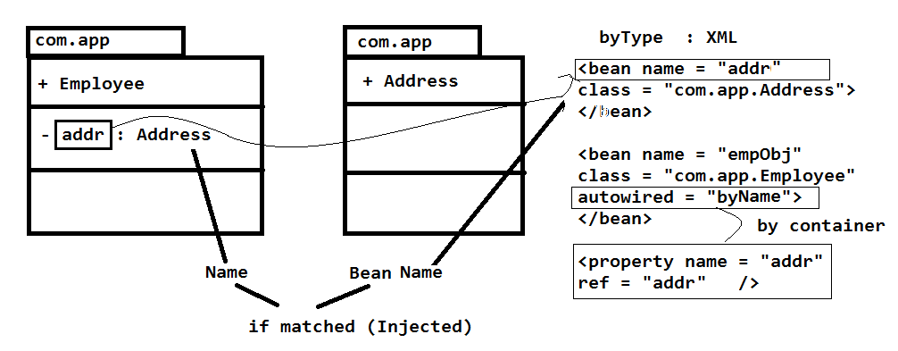

**SETUP (Same as above)**

**CODE:**

1. **Spring Bean**

**package** com.app.core;

**publicclass** Address {

**private** String loc;

**public** Address() {

**super**();

}

**public** Address(String loc) {

**super**();

**this**.loc = loc;

}

**public** String getLoc() {

**return**loc;

}

**publicvoid** setLoc(String loc) {

**this**.loc = loc;

}

@Override

**public** String toString() {

**return**"Address [loc=" + loc + "]";

}

}

1. **Spring Bean (Employee.java)**

**package** com.app.core;

**publicclass** Employee {

**privateint**empId;

**private** Address addr;

**public** Employee() {

**super**();

}

**public** Employee(**int**empId, Address addr) {

**super**();

**this**.empId = empId;

**this**.addr = addr;

}

**publicint** getEmpId() {

**return**empId;

}

**publicvoid** setEmpId(**int**empId) {

**this**.empId = empId;

}

**public** Address getAddr() {

**return**addr;

}

**publicvoid** setAddr(Address addr) {

**this**.addr = addr;

}

@Override

**public** String toString() {

**return**"Employee [empId=" + empId + ", addr=" + addr + "]";

}

}

1. **Config File (config.xml)**

**CASE#1: (For Zero Bean Matching Found )**

<beanclass=*"com.app.core.Employee"*name=*"empObj"*

p:empId=*"10"*

autowire=*"byName"*/>

**OUTPUT:**Employee [empId=10, addr=null]

**CASE#2: (For One Bean Matching Found)**

<beanclass=*"com.app.core.Address"*name=*"addr"*

p:loc=*"hyd"*/>

<beanclass=*"com.app.core.Employee"*name=*"empObj"*

p:empId=*"10"*

autowire=*"byName"*/>

**OUTPUT:** Employee [empId=10, addr=Address [loc=hyd]]

**CASE#3: (For Multiple Matching Found)**

<beanclass=*"com.app.core.Address"*name=*"addr"*

p:loc=*"patna"*/>

<beanclass=*"com.app.core.Address"*name=*"addr"*

p:loc=*"patna"*/>

<beanclass=*"com.app.core.Employee"*name=*"empObj"*

p:empId=*"10"*

autowire=*"byName"*/>

**OUTPUT:**

org.springframework.beans.factory.parsing.

BeanDefinitionParsingException:

**Matching Result Table:**

|  |  |
| --- | --- |
| No. of matchings | Result |
| =0 | null |
| =1 | Injected |
| >1 | Exception |

**Constructor Autowiring:**

If we provide autowire=”constructor” at parent bean tag level then Spring container links child and parent objects using const. Dependency Injection (CDI) (It will call param. const.)

**Code:**

1. **Spring Beans:**

package com.app;

public class Address {

private int addrId;

//const, set/get, ..toString

}

Package com.app;

public class Employee {

Private Address addr; //HAS-A

//parameter constructor

Public Employee(Address addr) {

System.out.println(“in param const”);

this.addr = addr;

}

//toString

}

**Spring Config File(XML):---**

<bean class”com.app.Address” name=”a1” p:addrId=”99”/>

<bean class=”com.app.Employee” name=empObj” autowire=”constructor”/>

**no(default):**

This is only default value it indicates no-autowiring, program should do wiring(manually, write code).

**autodetect (2.x):**

It is removed in new versions of Spring. It is not a type of autowiring.

* If parent class has default const. then byType is choosen
* else constructor is choosen by autodetect.

**@Autowired :**

This is used to do autowiring using Annotation concept, Which works faster (and better) compared with XML config.

1. It must be activated before using it with **<context:annotation-config/>** or **<context:component-scan base-package=”com.app”/>**
2. It internally follows required annotation by default. So, Injecting child is not optional.
3. To make injection optional use @Autowired(required=false). By default it is true.
4. If zero matchings found then Spring container throws

**NoSuchBeanDefenationException. (=0 and @Qualifier with zero matchings).**

1. If multiple matching found but even name is not matching then **NoUniqueBeanException (for >1 matchings &<bean name not matched).**

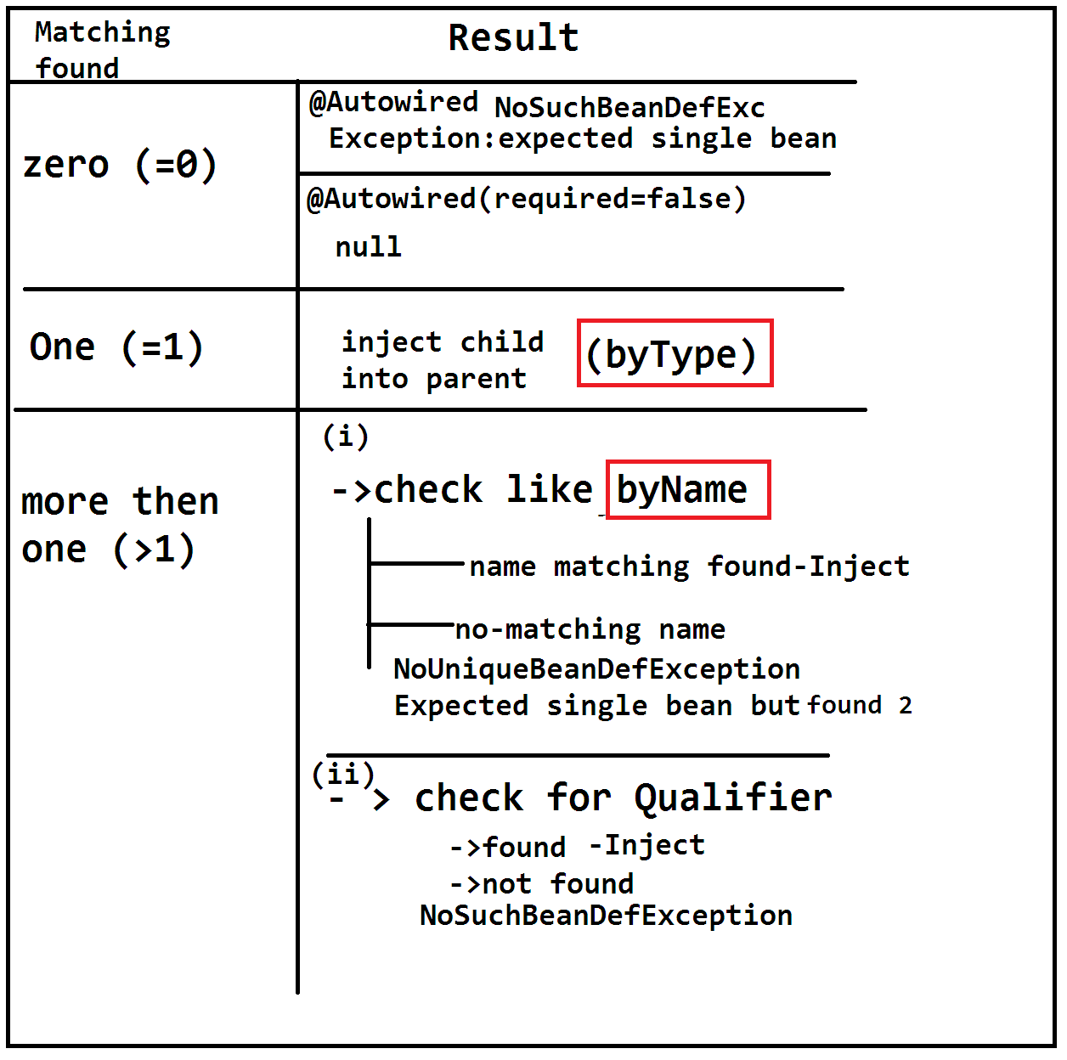

**SETUP**

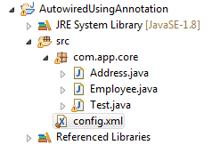

**CODE:**

1. **Spring Bean (Address.java)**

**package** com.app.core;

**publicclass** Address {

**private** String loc;

**public** Address() {

**super**();

}

**public** Address(String loc) {

**super**();

**this**.loc = loc;

}

**public** String getLoc() {

**return**loc;

}

**publicvoid** setLoc(String loc) {

**this**.loc = loc;

}

@Override

**public** String toString() {

**return**"Address [loc=" + loc + "]";

}

}

1. **Spring Bean (Employee.java)**

**package** com.app.core;

**import** org.springframework.beans.factory.annotation.Autowired;

**publicclass** Employee {

**privateint**empId;

@Autowired

**private** Address addr;

**public** Employee() {

**super**();

}

**public** Employee(**int**empId, Address addr) {

**super**();

**this**.empId = empId;

**this**.addr = addr;

}

**publicint** getEmpId() {

**return**empId;

}

**publicvoid** setEmpId(**int**empId) {

**this**.empId = empId;

}

**public** Address getAddr() {

**return**addr;

}

**publicvoid** setAddr(Address addr) {

**this**.addr = addr;

}

@Override

**public** String toString() {

**return**"Employee [empId=" + empId + ", addr=" + addr + "]";

}

}

1. **Config File (config.xml)**

**CASE#1: (Zero Child Object Found)**

<context:annotation-config/>

<beanclass=*"com.app.core.Employee"*name=*"empObj"*

p:empId=*"10"*/>

**OUTPUT:**

Caused by: org.springframework.beans.factory.***NoSuchBeanDefinitionException:***

**CASE#2: (Zero Matching Avoid Exception )**

**Replace Above Employee Class Address variable with required = false;**

@Autowired( required = **false**)

**private** Address addr;

**XML:**

<context:annotation-config/>

<beanclass=*"com.app.core.Employee"*name=*"empObj"*

p:empId=*"10"*/>

**OUPUT:** Employee [empId=10, addr=null]

**CASE#3: (One Matching Found [work like byType] )**

<beanclass=*"com.app.core.Address"*name=*"aob"*  p:loc=*"hyd"*/>

<context:annotation-config/>

<beanclass=*"com.app.core.Employee"*name=*"empObj"*

p:empId=*"10"*/>

**OUTPUT:** Employee [empId=10, addr=Address [loc=hyd]]

**CASE#4:**

**(Multiple Child Bean Found And One <bean name = “” matched)**

<beanclass=*"com.app.core.Address"* name=*"aob"*

p:loc=*"hyd"*/>

<beanclass=*"com.app.core.Address"*name=*"addr"* p:loc=*"hyd"*/>

<context:annotation-config/>

<beanclass=*"com.app.core.Employee"*name=*"empObj"*

p:empId=*"10"*/>

**OUPUT:**Employee [empId=10, addr=Address [loc=hyd]]

**CASE#5:**

**(Choosing One Child Bean From Multiple By Programmer [@Qualifier])**

**Bean CODE**

@Qualifier("aob")

**private** Address addr;

**XML:**

<beanclass=*"com.app.core.Address"* name=*"aob"*

p:loc=*"hyd"*/>

<beanclass=*"com.app.core.Address"*name=*"addr"*

p:loc=*"hyd"*/>

<context:annotation-config/>

<beanclass=*"com.app.core.Employee"*name=*"empObj"*

p:empId=*"10"*/>

**OUTPUT:**Employee [empId=10, addr=Address [loc=hyd]]

**Chapter#2 Spring JDBC**

**# Spring-JDBC:-**

This is used to perform database operations in less lines by removing common lines of code (redundant code/boilerplate) .

That is, if we consider two (2) JDBC programs common lines are connection, Driver class loading, statement etc… known as duplicate code.

These lines can be written one time and used multiple time done using Template Design Pattern.

|  |
| --- |
| **Jdbc + Template = JdbcTemplate**  **Technology Design Pattern (class)** |

* JdbcTemplate (c) created by Spring Framework reduces common lines of code, by writing then only one time and use multiple times.
* Here Spring Container performs common operation steps, Programmer should write SQL, set data, get result and print code.

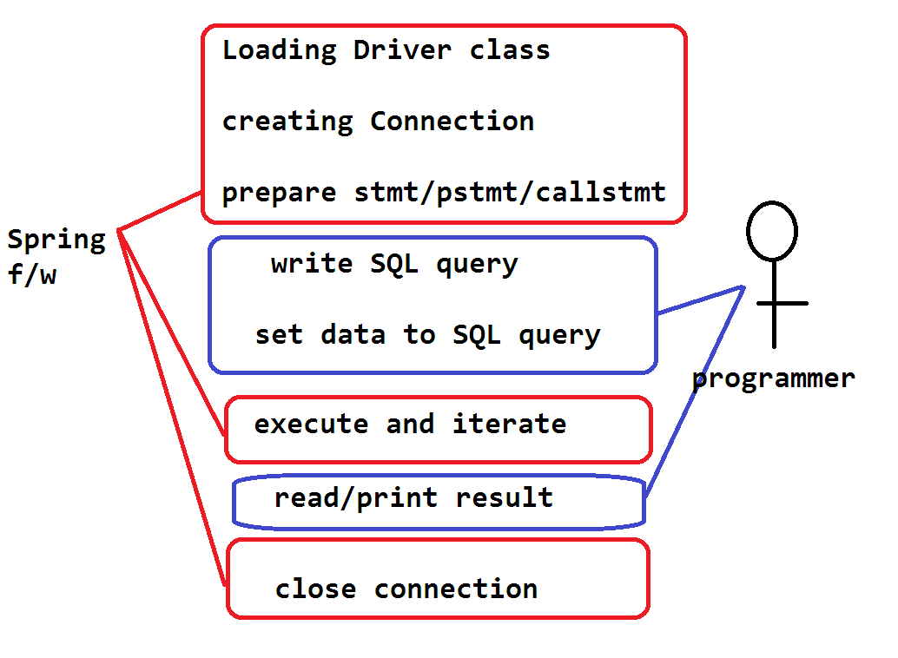

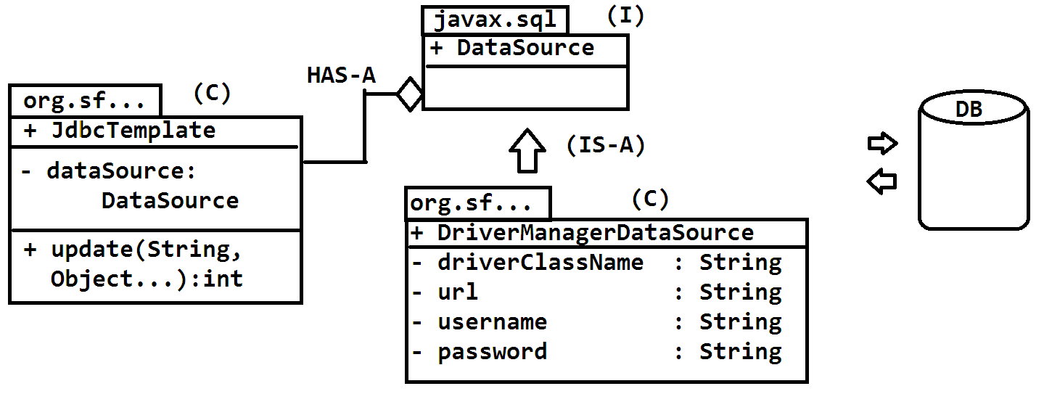

**#JdbcTemplate (c) :- (org.springframework.jdbc.core)**

* This class is given by Spring Framework, to perform database operations **(CURD).**
* For this we need to provide DataSource (I) (javax.sql) object. Here DataSource is an interface. So,we have to pass it’s any one implementation class object.

Ex: DriverManagerDataSource, BasicDataSource etc…

* JdbcTemplate provide method “update” which is used to perform insert, update and delete operations.

**API:-**

**update(String sql, Object… args) : int**

**# Var-args : Varing length argument:-**

* This concept also similar to Array. we can pass multiple values comma seprated in mrthod call instead of creating Array and providing data.
* Var-args applicable to any datatype.
* It is introduced in JDK 1.5 version.
* Var-args must be last parameter of a method that is after var-args parameter no other parameter is allowed.

Syntex is DataType… VariableName

**Ex:**

**Int…marks**

**String…subject**

**Double…avegs**

**Example: Array and var-args**

class A {

void m1(int[] a) { }

void m2(int… b) { } // JDK1.5 v

}

A oa = new A();

// Method call -- for Array input

Int[] arr = new int[3];

arr[0] = 10;

arr[1] = 20;

arr[2] = 30;

oa.m1(arr);

// Method call – using var-args.

oa.m2(10,20,30,40);

**# Code -- Spring JDBC Using XML Configuration:-**

* JdbcTemplate class having update() method which perform “insert, update and delete” operation by taking two inputs.

**String -- SQL Query**

**Object… -- inputs to SQL Query**

**Example Code #1 Using Spring XML Configuration:---**

**Folder Structure:**

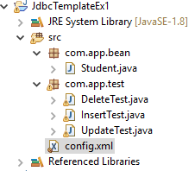

**## Insert Operation**

1. **Config.xml file code**

<?xml version=*"1.0"* encoding=*"UTF-8"*?>

<beans xmlns=[*http://www.springframework.org/schema/beans*](http://www.springframework.org/schema/beans)

xmlns:context=*"http://www.springframework.org/schema/context"* xmlns:util=*"http://www.springframework.org/schema/util"*

xmlns:xsi=*"http://www.w3.org/2001/XMLSchema-instance"*

xmlns:p=*"http://www.springframework.org/schema/p"*

xsi:schemaLocation=*"http://www.springframework.org/schema/beans http://www.springframework.org/schema/beans/spring-beans.xsd*

*http://www.springframework.org/schema/context*

*http://www.springframework.org/schema/context/spring-context.xsd http://www.springframework.org/schema/util http://www.springframework.org/schema/util/spring-util.xsd "*>

<bean class=*"org.springframework.jdbc.datasource.DriverManagerDataSource"*

name=*"dmdsObj"*

p:driverClassName=*"oracle.jdbc.driver.OracleDriver"*

p:url=*"jdbc:oracle:thin:@localhost:1521:xe"*

p:username=*"system"*

p:password=*"root"*

/>

<bean class=*"org.springframework.jdbc.core.JdbcTemplate"*

name=*"jtObj"*

p:dataSource-ref=*"dmdsObj"*

/>

</beans>

1. **Spring Bean Code:**

**package** com.app.bean;

**publicclass** Student {

**privateint**stdId;

**private** String stdName;

**private** String course;

**privatedouble**stdFee;

**public** Student() {

**super**();

}

**publicint** getStdId() {

**return**stdId;

}

**publicvoid** setStdId(**int**stdId) {

**this**.stdId = stdId;

}

**public** String getStdName() {

**return**stdName;

}

**publicvoid** setStdName(String stdName) {

**this**.stdName = stdName;

}

**public** String getCourse() {

**return**course;

}

**publicvoid** setCourse(String course) {

**this**.course = course;

}

**publicdouble** getStdFee() {

**return**stdFee;

}

**publicvoid** setStdFee(**double**stdFee) {

**this**.stdFee = stdFee;

}

@Override

**public** String toString() {

**return**"Student [stdId=" + stdId + ", stdName=" + stdName + ", course=" + course + ", stdFee=" + stdFee + "]";

}

}

1. **Test class code:**

**package** com.app.test;

**import** org.springframework.context.ApplicationContext;

**import** org.springframework.context.support.ClassPathXmlApplicationContext;

**import** org.springframework.jdbc.core.JdbcTemplate;

**publicclass** InsertTest {

**publicstaticvoid** main(String[] args) {

ApplicationContext c = **new** ClassPathXmlApplicationContext("config.xml");

JdbcTemplate jt = (JdbcTemplate) c.getBean("jtObj");

String sql = "insert into student1 values(?,?,?,?)";

**int**count = jt.update(sql, 1005,"Ashutosh","Spring",49999);

// DriverManagerDataSource ds= null;

// ds.setDriverClassName(arg0);

// ds.setUrl(url);

// ds.setUsername(username);

// ds.setPassword(password);

System.***out***.println(“Student saved successfully **::** ”+count);

}

}

**OUTPUT:**

**Student saved successfully :: 1**

**## Update Operation**

**Spring Config File Code and Spring Bean Code Same as before**

**Test class:**

**package** com.app.test;

**import** org.springframework.context.ApplicationContext;

**import** org.springframework.context.support.ClassPathXmlApplicationContext;

**import** org.springframework.jdbc.core.JdbcTemplate;

**publicclass** UpdateTest {

**publicstaticvoid** main(String[] args) {

ApplicationContext ac = **new** ClassPathXmlApplicationContext("config.xml");

JdbcTemplate jt = (JdbcTemplate) ac.getBean("jtObj");

String sql = "update student1 set stdname=?, stdcourse=?, stdfee=? where stdid=?";

**int**count = jt.update(sql, "Pooja","Adv.ja",8000, 111 );

System.***out***.println("Student Updated Successfully :: "+count);

}

}

**OUTPUT:**

**Student Updated Successfully :: 1**

**## Delete Operation**

**Spring Config File Code and Spring Bean Code Same as before**

**Test class:**

**package** com.app.test;

**import** org.springframework.context.ApplicationContext;

**import** org.springframework.context.support.ClassPathXmlApplicationContext;

**import** org.springframework.jdbc.core.JdbcTemplate;

**publicclass** DeleteTest {

**publicstaticvoid** main(String[] args) {

ApplicationContext ac = **new** ClassPathXmlApplicationContext("config.xml");

JdbcTemplate jt = (JdbcTemplate) ac.getBean("jtObj");

String sql = "delete from student1 where stdid=?";

**int**count = jt.update(sql,113);

System.***out***.println("Student deleted Successfully :: "+count);

}

}

**OUTPUT:**

**Student deleted Successfully :: 1**

**Spring JDBC Using Java Configuration and Maven Tool**

**Folder Structure- Maven Tool**

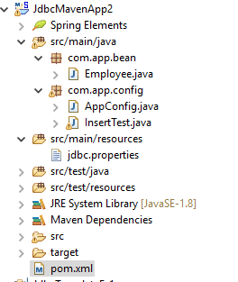

**Steps To Create Maven Project For Core Application:**

**Step#1**: Create Maven Project in Eclipse or STS.

* File > New > Maven Project > Click Check Box
* L√Ꞁ create simple maven project (skip………)
* Next button > Enter Details like

groupId : org.sathyatech

artifactId : SpringJDBCMavenApp

Version : 1.0

* Click on finish button.

**Step#2:** open pom.xml and add below dependencies(jar details) and build plugins (compiler details)

**<dependencies>**

**<dependency>**

**<groupId>org.springframework</groupId>**

**<artifactId>spring-jdbc</artifactId>**

**<version>5.0.6.RELEASE</version>**

**</dependency>**

**<dependency>**

**<groupId>org.springframework</groupId>**

**<artifactId>spring-context</artifactId>**

**<version>5.0.6.RELEASE</version>**

**</dependency>**

**<dependency>**

**<groupId>mysql</groupId>**

**<artifactId>mysql-connector-java</artifactId>**

**<version>5.1.6</version>**

**</dependency>**

**</dependencies>**

**step#3:** Update Maven Project

* Right click on project > Maven > update project > apply/ok/finish.

**step#4:**Write code in below format.

1. Spring Bean : src/main/java

2. Spring Config : src/main/resource

3. Test Class : src/main/java

**step#5:** Run Test class to see output.

* .java files must be placed under src/main/java folder.
* Non-java files like xml/properties etc…

Must be placed under src/main/resource folder.

**Example:**

**1. Pom.xml file code:-**

<projectxmlns=*"http://maven.apache.org/POM/4.0.0"*xmlns:xsi=*"http://www.w3.org/2001/XMLSchema-instance"*xsi:schemaLocation=*"http://maven.apache.org/POM/4.0.0 http://maven.apache.org/xsd/maven-4.0.0.xsd"*>

<modelVersion>4.0.0</modelVersion>

<groupId>org.sathyatech</groupId>

<artifactId>SpringMavenApp2</artifactId>

<version>1.0</version>

<dependencies>

<dependency>

<groupId>org.springframework</groupId>

<artifactId>spring-jdbc</artifactId>

<version>5.0.6.RELEASE</version>

</dependency>

<dependency>

<groupId>org.springframework</groupId>

<artifactId>spring-context</artifactId>

<version>5.0.6.RELEASE</version>

</dependency>

<dependency>

<groupId>mysql</groupId>

<artifactId>mysql-connector-java</artifactId>

<version>5.1.6</version>

</dependency>

</dependencies>

<build>

<plugins>

<plugin>

<groupId>org.apache.maven.plugins</groupId>

<artifactId>maven-compiler-plugin</artifactId>

<version>3.8.0</version>

<configuration>

<source>1.8</source>

<target>1.8</target>

</configuration>

</plugin>

</plugins>

</build>

</project>

**2.Java config code:**

**package** com.app.config;

**import** org.springframework.beans.factory.annotation.Autowired;

**import** org.springframework.context.annotation.Bean;

**import** org.springframework.context.annotation.Configuration;

**import** org.springframework.context.annotation.PropertySource;

**import** org.springframework.core.env.Environment;

**import** org.springframework.jdbc.core.JdbcTemplate;

**import** org.springframework.jdbc.datasource.DriverManagerDataSource;

@PropertySource("jdbc.properties")

@Configuration

**publicclass** AppConfig {

@Autowired

**private** Environment env;

@Bean

**public** DriverManagerDataSource dsObj() {

DriverManagerDataSource ds = **new** DriverManagerDataSource();

ds.setDriverClassName(env.getProperty("dc"));

ds.setUrl(env.getProperty("url"));

ds.setUsername(env.getProperty("un"));

ds.setPassword(env.getProperty("pwd"));

**return**ds;

}

@Bean

**public** JdbcTemplate jtObj() {

JdbcTemplate jt = **new** JdbcTemplate();

jt.setDataSource(dsObj());

**return**jt;

}

}

**3.Test class code:**

**package** com.app.config;

**import** org.springframework.context.ApplicationContext;

**import** org.springframework.context.annotation.AnnotationConfigApplicationContext;

**import** org.springframework.jdbc.core.JdbcTemplate;

**publicclass** InsertTest {

**publicstaticvoid** main(String[] args) {

ApplicationContext ac = **new** AnnotationConfigApplicationContext(AppConfig.**class**);

JdbcTemplate jt = (JdbcTemplate) ac.getBean("jtObj");

String sql = "insert into emptab2 values(?,?,?,?)";

**int**count = jt.update(sql, 11,"Ashu","JS",999);

System.***out***.println("Data Inserted :: "+count);

}

}

**4.db.properties file code:**

dc=com.mysql.jdbc.Driver

url=jdbc:mysql://localhost:3306/test

un=root

pwd=root

**5.Spring Bean code:**

**package** com.app.bean;

**publicclass** Employee {

**privateint**empId;

**private** String empName;

**private** String desig;

**privatedouble**empSal;

**public** Employee() {

**super**();

}

**publicint** getEmpId() {

**return**empId;

}

**publicvoid** setEmpId(**int**empId) {

**this**.empId = empId;

}

**public** String getEmpName() {

**return**empName;

}

**publicvoid** setEmpName(String empName) {

**this**.empName = empName;

}

**public** String getDesig() {

**return**desig;

}

**publicvoid** setDesig(String desig) {

**this**.desig = desig;

}

**publicdouble** getEmpSal() {

**return**empSal;

}

**publicvoid** setEmpSal(**double**empSal) {

**this**.empSal = empSal;

}

@Override

**public** String toString() {

**return**"Employee [empId=" + empId + ", empName=" + empName + ", desig=" + desig + ", empSal=" + empSal + "]";

}

}

**Output:**

Data Inserted :: 1

**RowMapperin Spring JDBC:**

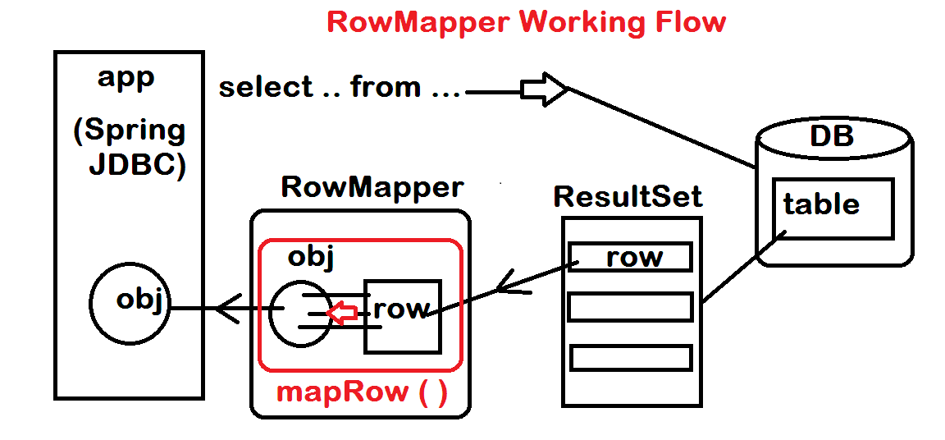

**#RowMapper(I) in Spring JDBC:- (package: org.springframework.jdbc.core)**

* To fetch data from database using select query, JdbcTemplate has provided special method like:

1. queryForObject (Single row)
2. query(Multiple row)

both methods perform select operations

But these methods will fetch data from database table in ResultSet format (having rows) after excuting SQL query.

* This ResultSet data cab be converted to Objects format using RowMapper(I).
* RowMapper will not get data form database. If only converts ResultSet rows to model class Objects.
* It is having MapRow() method which contains conversion logic (row -> object).

**Example of RowMapper:**

**Folder Structure:**

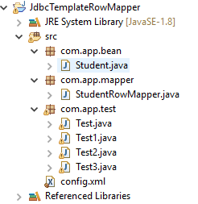

1. **Spring Bean**

**package** com.app.bean;

**publicclass** Student {

**privateint**stdId;

**private** String stdName;

**privatedouble**stdFee;

**public** Student() {

}

**publicint** getStdId() {

**return**stdId;

}

**publicvoid** setStdId(**int**stdId) {

**this**.stdId = stdId;

}

**public** String getStdName() {

**return**stdName;

}

**publicvoid** setStdName(String stdName) {

**this**.stdName = stdName;

}

**publicdouble** getStdFee() {

**return**stdFee;

}

**publicvoid** setStdFee(**double**stdFee) {

**this**.stdFee = stdFee;

}

@Override

**public** String toString() {

**return**"Student [stdId=" + stdId + ", stdName=" + stdName + ", stdFee=" + stdFee + "]";

}

}

1. **RowMapper Code:**

**package** com.app.mapper;

**import** java.sql.ResultSet;

**import** java.sql.SQLException;

**import** org.springframework.jdbc.core.RowMapper;

**import** com.app.bean.Student;

**publicclass** StudentRowMapper **implements** RowMapper<Student> {

**public** Student mapRow(ResultSet rs, **int**count) **throws** SQLException {

Student s = **new** Student();

s.setStdId(rs.getInt(1));

s.setStdName(rs.getString(2));

s.setStdFee(rs.getDouble(3));

**return**s;

}

}

1. **Spring config file:**

<?xml version=*"1.0"* encoding=*"UTF-8"*?>

<beans xmlns=*"http://www.springframework.org/schema/beans"*

xmlns:context=*"http://www.springframework.org/schema/context"*

xmlns:util=*"http://www.springframework.org/schema/util"*

xmlns:xsi=*"http://www.w3.org/2001/XMLSchema-instance"*

xmlns:p=*"http://www.springframework.org/schema/p"*

xsi:schemaLocation=*"http://www.springframework.org/schema/beans*

*http://www.springframework.org/schema/beans/spring-beans.xsd*

*http://www.springframework.org/schema/context*

*http://www.springframework.org/schema/context/spring-context.xsd*

*http://www.springframework.org/schema/util*

*http://www.springframework.org/schema/util/spring-util.xsd"*>

<bean class=*"org.springframework.jdbc.datasource.DriverManagerDataSource"*

name=*"dmdsObj"*

p:driverClassName=*"oracle.jdbc.driver.OracleDriver"*

p:url=*"jdbc:oracle:thin:@localhost:1521:xe"*

p:username=*"system"*

p:password=*"root"*

/>

<bean class=*"org.springframework.jdbc.core.JdbcTemplate"*

name=*"jtObj"*

p:dataSource-ref=*"dmdsObj"*

/>

</beans>

1. **Test Class:**

**package** com.app.test;

**import** org.springframework.context.ApplicationContext;

**import** org.springframework.context.support.ClassPathXmlApplicationContext;

**import** org.springframework.jdbc.core.JdbcTemplate;

**import** com.app.bean.Student;

**import** com.app.mapper.StudentRowMapper;

**publicclass** Test {

**publicstaticvoid** main(String[] args) {

ApplicationContext c = **new** ClassPathXmlApplicationContext("config.xml");

JdbcTemplate jt = (JdbcTemplate) c.getBean("jtObj");

String sql = "select * from stdtab4 where sid=?";

StudentRowMapper srm = **new** StudentRowMapper();

Student s = jt.queryForObject(sql, srm, 8);

System.***out***.println(s);

}

}

**Output:**

**Student [stdId=6, stdName=AAA, stdFee=50.0]**

**Student [stdId=8, stdName=ASJK, stdFee=444.0]**

**Student [stdId=5, stdName=AAA, stdFee=50.0]**

**# query() method:-**

* This method is used to get multiple rows from database table using SQL and RowMapper(I).

API: query(String sql,RowMapper<T> rm) : List<T>

Final data is returned in List format.

**# queryForObject() method:-**

* This method is used to get one row data from database table using SQl and RowMapper(I).

**API:**

queryForObject(String sql, RowMapper<T> rm, Object… inputs) : T

Here Object… (var-args) are used to pass data to SQL at runtime in place of ‘?’ symbols (place holder).

**##**RowMapper<T> (I) is a functional interface, so we can write above code without writing StudentRowMapper class, directly using lambda expression.

**EX#1. (Test class code)**

String sql = “select * from student where sid=?”;

RowMapper<Student> rm = (rs, count)-> {

Student s = new Student();

s.setStdId(rs.getInt(“sid”))

s.setStdName(rs.getString(“sname”))

s.setStdFee(rs.getDouble(“sfee”))

return s;

};

Student s = jt.queryForObject(sql, rm, 45);

Sysout(s);

**EX#2:** Generate 3 param constructor in Student Then lambda expression is:

RowMapper<Student> rm = (rs, count) ->

new Student (rs.getInt(1),rs.getString(2),rs.getDouble(3));

**CHEPTER :: 3**

**ORM (Object Relational Mapping)**

It is theory concept used to perform DB operations in OOPS style.

* For this programmer has to follow Mapping concept between java class and DB table.
* Mapping is provided

:: ClassName must be mapped with table name.

:: VariableName must be mapped with column name.

* Mapping can be done using

1. XML coding (old style)
2. Annotation coding (new style)

(Also called as JPA = java persistency API annotation)

* If we follow mapping , then ORM converts objects to row and row to object without SQL written to programmer.
* Above java class is also called as model class/Entity class/POJO class etc.
* Table must have one primary key (behaves as unique + not null)

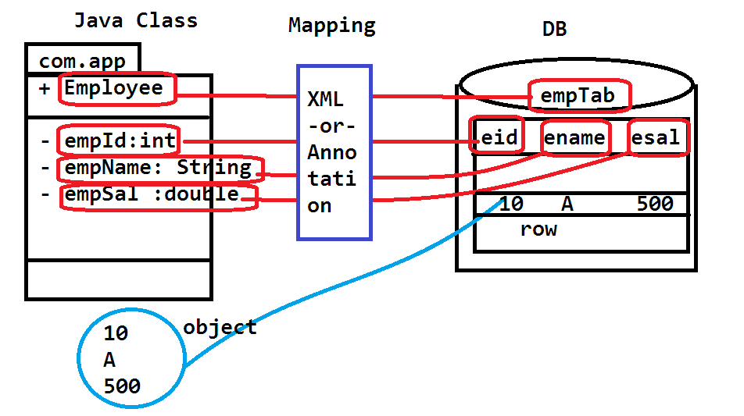

ORM USING SPRING

Here setup code is provided for DataSource ,SessionFactory and TransactionManager object and Module-Wise code is provided for Model class.

Model-class

IDao ------DaoImpl (POJI – POJO) : in Data Access Layer.

IService ------ ServiceImpl (POJI – POJO) : in Service Layer.

* POJI – POJO design pattern is used to link layer in loosely-coupled manner.
* Service Layer Contains :

Application logic and Transaction (tx) management code.

* Data Access Layer Contains:

DataBase Operation code.

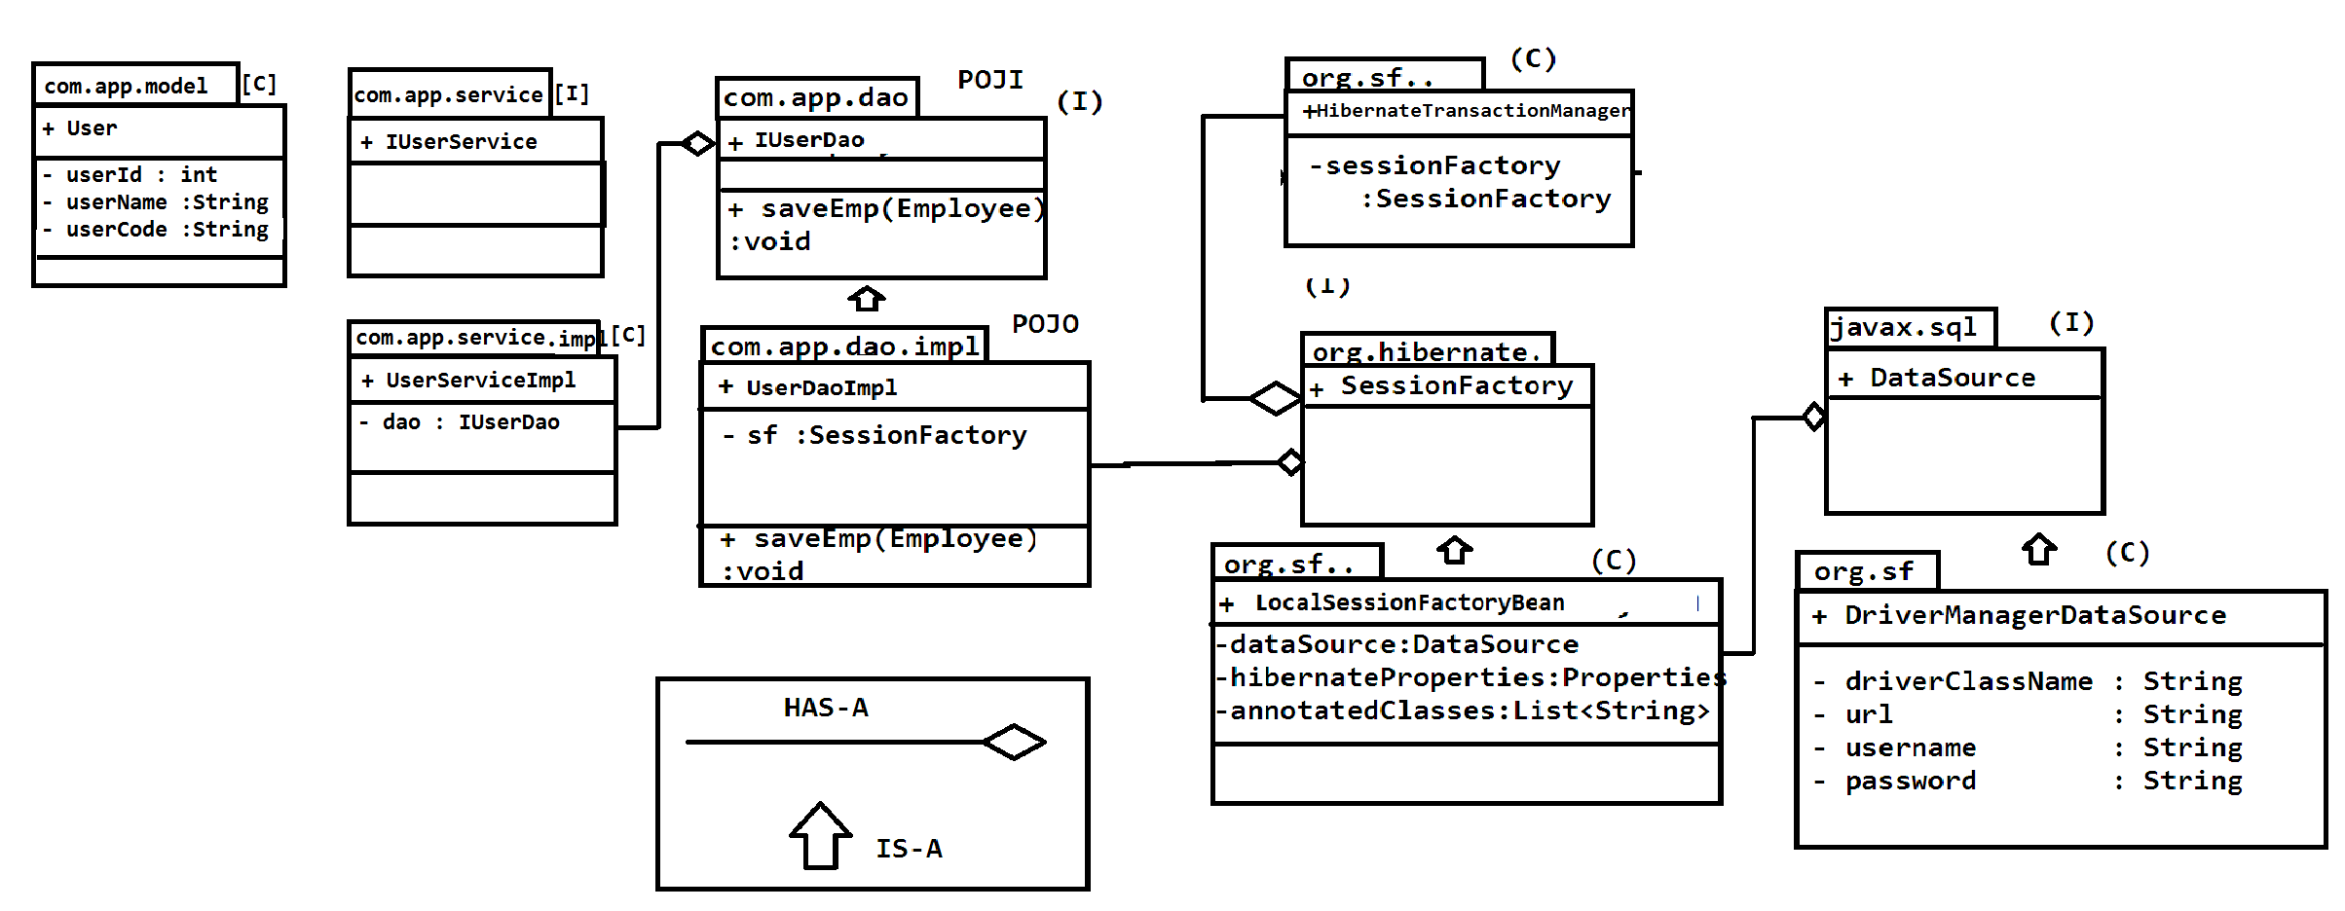

**ORM Example**

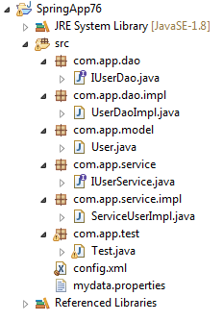

1. **Model class**

**package**com.app.model;

**import**javax.persistence.Column;

**import**javax.persistence.Entity;

**import**javax.persistence.Id;

**import**javax.persistence.Table;

@Entity

@Table(name = "user_tab1")

**publicclass** User {

@Id

@Column(name = "u_id")

**privateint**userId;

@Column(name = "uname")

**private** String userName;

@Column(name = "ucode")

**private** String userCode;

**public** User() {

**super**();

}

**public** User(**int**userId, String userName, String userCode) {

**super**();

**this**.userId = userId;

**this**.userName = userName;

**this**.userCode = userCode;

}

**publicint**getUserId() {

**return**userId;

}

**publicvoid**setUserId(**int**userId) {

**this**.userId = userId;

}

**public** String getUserName() {

**return**userName;

}

**publicvoid**setUserName(String userName) {

**this**.userName = userName;

}

**public** String getUserCode() {

**return**userCode;

}

**publicvoid**setUserCode(String userCode) {

**this**.userCode = userCode;

}

@Override

**public** String toString() {

**return**"User [userId=" + userId + ", userName=" + userName + ", userCode=" + userCode + "]";

}

}

1. **IUserDao.java**

**package**com.app.dao;

**import**java.util.List;

**import**com.app.model.User;

**publicinterface**IUserDao {

**publicabstractint** save(User user);

**publicabstractvoid** update(User user);

**publicabstractvoid** delete(**int**userId);

**publicabstract** User getUserById(**int**userId);

**publicabstract** List<User>getAllUsers();

}

1. **UserDaoImpl.java**

**package**com.app.dao.impl;

**import**java.util.List;

**import**org.springframework.beans.factory.annotation.Autowired;

**import** org.springframework.orm.hibernate5.HibernateTemplate;

**import**org.springframework.stereotype.Repository;

**import**com.app.dao.IUserDao;

**import**com.app.model.User;

@Repository

**publicclass**UserDaoImpl**implements**IUserDao{

@Autowired

**private**HibernateTemplateht;

@Override

**publicint** save(User user) {

**return** (Integer)ht.save(user);

}

@Override

**publicvoid** update(User user) {

ht.update(user);

}

@Override

**publicvoid** delete(**int**userId) {

User user = **new**User();

user.setUserId(userId);

ht.delete(user);

}

@Override

**public** User getUserById(**int**userId) {

User user = ht.get(User.**class**, userId);

**return**user;

}

@Override

**public** List<User>getAllUsers() {

List<User>user = ht.loadAll(User.**class**);

**return**user;

}

}

1. **IUserService.java**

**package**com.app.service;

**import**java.util.List;

**import**com.app.model.User;

**publicinterface**IUserService {

**publicabstractint** save(User user);

**publicabstractvoid** update(User user);

**publicabstractvoid** delete(**int**userId);

**publicabstract** User getUserById(**int**userId);

**publicabstract** List<User>getAllUsers();

}

1. **UserServiceImpl.java**

**package**com.app.service.impl;

**import**java.util.List;

**import**org.springframework.beans.factory.annotation.Autowired;

**import**org.springframework.stereotype.Service;

**import**org.springframework.transaction.annotation.Transactional;

**import**com.app.dao.IUserDao;

**import**com.app.model.User;

**import**com.app.service.IUserService;

@Service

**publicclass**ServiceUserImpl**implements**IUserService{

@Autowired

**private**IUserDaodao;

@Transactional

**publicint** save(User user) {

**return**dao.save(user);

}

@Transactional

**publicvoid** update(User user) {

dao.update(user);

}

@Transactional

**publicvoid** delete(**int**userId) {

dao.delete(userId);

}

@Transactional(readOnly = **true**)

**public** User getUserById(**int**userId) {

**return**dao.getUserById(userId);

}

@Transactional(readOnly = **true**)

**public** List<User>getAllUsers() {

**return**dao.getAllUsers();

}

}

1. Test.java

**package**com.app.test;

**import**java.util.List;

**import**org.springframework.context.ApplicationContext;

**import** org.springframework.context.support.ClassPathXmlApplicationContext;

**import**com.app.model.User;

**import**com.app.service.IUserService;

**publicclass** Test {

**publicstaticvoid** main(String[] args) {

ApplicationContextac = **new**ClassPathXmlApplicationContext("config.xml");

IUserServiceu = (IUserService)ac.getBean("serviceUserImpl");

/* User user = new User();

user.setUserId(3);

user.setUserName("RAVI SAM Sharma");

user.setUserCode("Uss5");

u.save(user);

System.out.println("Saved data successful");

*/

/*

User user = new User();

user.setUserId(3);

user.setUserName("VickyRajkumar");

user.setUserCode("psdf");

u.update(user);

System.out.println("update succesfull");

*/

/*

//Delete operation

User user = new User();

user.setUserId(3);

u.delete(3);

System.out.println(3+" user deleted");

*/

//retrive data in list<User>

List<User>list = u.getAllUsers();

**for**(User user:list)

System.***out***.println(user);

//retrive only one user data` /

/*User user = u.getUserById(2);

System.out.println(user);*/

//HibernateTransactionManagerhh;

// hh.setSessionFactory(sessionFactory);

}

}

1. **Config.xml**

<?xmlversion=*"1.0"*encoding=*"UTF-8"*?>

<beansxmlns=*"http://www.springframework.org/schema/beans"*

xmlns:p=*"http://www.springframework.org/schema/p"*

xmlns:tx=*"http://www.springframework.org/schema/tx"*

xmlns:aop=*"http://www.springframework.org/schema/aop"*

xmlns:context=*"http://www.springframework.org/schema/context"*

xmlns:xsi=*"http://www.w3.org/2001/XMLSchema-instance"*

xsi:schemaLocation=*"*

*http://www.springframework.org/schema/beans*

*http://www.springframework.org/schema/beans/spring-beans.xsd*

*http://www.springframework.org/schema/context*

*http://www.springframework.org/schema/context/spring-context.xsd*

*http://www.springframework.org/schema/tx*

*http://www.springframework.org/schema/tx/spring-tx.xsd*

*http://www.springframework.org/schema/aop*

*http://www.springframework.org/schema/aop/spring-aop.xsd*

*"*>

<!-- Activation of streotype annotation -->

<context:component-scanbase-package=*"com.app"*/>

<!-- Activation transection manager -->

<tx:annotation-driven/>

<!-- Link properties file -->

<context:property-placeholderlocation=*"mydata.properties"*/>

<!-- 1.DataSource object -->

<beanclass=*"org.springframework.jdbc.datasource.DriverManagerDataSource"*name=*"dsObj"*

p:driverClassName=*"${dcn}"*

p:url=*"${url}"*

p:username=*"${un}"*

p:password=*"${pwd}"*

/>

<!-- 2.LocalSessionFactoryBean object -->

<beanclass=*"org.springframework.orm.hibernate5.LocalSessionFactoryBean"*name=*"lsbObj"*>

<propertyname=*"dataSource"*ref=*"dsObj"*/>

<propertyname=*"hibernateProperties"*>

<props>

<propkey=*"hibernate.dialect"*>${dialects}</prop>

<propkey=*"hibernate.show_sql"*>${showsql}</prop>

<propkey=*"hibernate.format_sql"*>${formatsql}</prop>

<propkey=*"hibernate.hbm2ddl.auto"*>${hbmauto}</prop>

</props>

</property>

<propertyname=*"annotatedClasses"*>

<list>

<value>com.app.model.User</value>

</list>

</property>

</bean>

<beanclass=*"org.springframework.orm.hibernate5.HibernateTemplate"*name=*"htObj"*>

<propertyname=*"sessionFactory"*ref=*"lsbObj"*/>

</bean>

<beanclass=*"org.springframework.orm.hibernate5.HibernateTransactionManager"*name=*"transactionManager"*>

<propertyname=*"sessionFactory"*ref=*"lsbObj"*/>

</bean>

</beans>

1. **MyData.properties**

#This is properties data

dcn=oracle.jdbc.OracleDriver

url=jdbc:oracle:thin:@localhost:1521:xe

un=vicky

pwd=vicky

dialects=org.hibernate.dialect.OracleDialect

showsql=true

formatsql=true

hbmauto=update

OUTPUT

User [userId=1, userName=Vicky Raj, userCode=Uss1]

User [userId=2, userName=RAvi Sharma, userCode=Uss1]

**Mapping Code Using JPA Annotation**

Hibernate has been integrated with JPA for model class mapping with DB table. All these annotation are provided in package.

Javax.persistency(JPA)

1. **@Entity:**

This annotation must be applied over class. It maps class with table , variables with columns.

1. **@Id:**

It indicates primary key in table. Every table must have one primary key.

1. **@Table:**

It is used to provide table details. It is optional if not provided then class name is taken as table name.

1. **@Column:**

It is optional , used to provide column details if not provided then variable name is taken as column name.



**Equal Java Code Is**

**import**javax.persistence.*;

@Entity

@Table(name = "emptab")

**publicclass**Employee{

@Id

@Column(name = "eid")

**privateint**empId;

@Column(name = "ename")

**private** String empName;

@Column(name = "esal")

**privatedouble**empSal;

}

**Hibernate Properties**

In general properties means data in key = value format hibernate application need few key = value details to create SessionFactory object

Those are listed below with possible value.

1. **Dialect:**

It is a class in hibernate which generate SQL when we perform any operation (Save / Update / delete /select…).

* All dialect are in ***package org.hibernate.dialect***few dialect classes are:

OralceDialect ,MySQLDialect , SybaseDialect , DB2Dialect

**Ex: key = value**

**hibernate.dialect = org.hibernate.dialect.OracleDialect**

1. **Show_sql**

It is a Boolean property , default value : false. It will display SQL on console. If value is true.

**Ex: hibernate.show_sql = true**

1. **Format_sql:**

It is a Boolean property , default false. It will display SQL query in clause by clause.

**Ex: hibernate.format_sql = true**

1. **hbm2ddl.auto**

hbm = Hibernate Mapping

DDL = create/ alter / drop

This is optional key, ti is used to indicate about creating table (and DB component).

Possible value are : 4

1. **validate:**

(default value) It indicates programmer should handle table creation and modifications . Hibernate does nothing here.

1. **Create:**

This option says , “every time new table is created by hibernate “. It table exist then it will be dropped and new table is created.

1. **Update:**

it creates new table if no table exist else uses same and does modifications if required.

1. **Create-drop:**

Hibernate create new table every time and drop after operation done

**Ex: hibernate.hbm2ddl.auto = create**

**DataSource**

This interface is used to indicate connection object between java app (JDBC / Hibernate / Spring ) and DB.

* We need to configure (<bean> / @Bean) for any one implementation class of this interface

**Impl #1 DriverManagerDataSource (org.springframework.jdbc.datasource)**

This is given by spring framework to handle single connection object for application which is used for small application (no of user are less , ex max 150 user)

* We must configure this in application one time using XML or java configuration.

**Impl#2 BasicDataSource (org.apache.commons.dbcp2)**

This is given by Apache-commons-dbcp.2.x

**Types of memories in application**

**Connection Pool**

it is used to hold multiple connection object, which can be used to source. Database operation between java app and database.

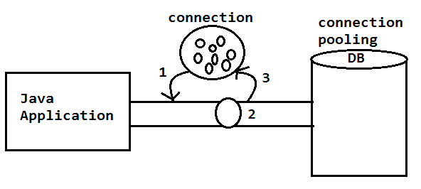

1 Read connection from pool. 2 use connection to execute database operation. 3 return back connection to pool (Do not close connection ) Basic properties for connection pooling. Driver class, url ,username, password, Initial size, max total, max idle, min idle- - - # Initial size –No of connection when app (server ) starts. Ex =1 # Max total – No of maximum connections to be created by application. # Min –Max idle – No of unused connections to be maintained in pool (min and max ).

# Session factory (I ) [org.hebernate ] =

* It is a interface given by hibernet framework which handle.
* Loading driver class
* Supporting for creating connection
* Creating statements
* Execute operations
* Handle memory for result storing and conversion.
* Spring has provided one impl class using factory bean < session factory > format. ( ie creating object at runtime based on input detail [ Database selected ]
* Input class is – Local session factory bean.

(org.springframework.orm.hibernate )

We should provide details like:

1. Data source (Inject basic data source obj)
2. Hibernate properties : provide date in key =value format.

Here keys are :

1. Hibernate. Dialect = -----
2. Hibernate. Show_sql =-----
3. Hibernate.format_sql = --
4. Hibernate.hbm2dd.auto =--
5. annotatedClasses:

Details of model entity classes [or a class mapped with DB table]

**JAVA CONFIG CODE**

@Bean

public LocalSessionFactoryBeansfObj(){

LocalSessionFactoryBeansf = new LocalSessionFactoryBean();

sf.setDataSource(dsObj());

sf.setHibernateProperties(props());

sf.setAnnotatedClasses(Employee.class);

returnsf;

}

private Properties props(){

Properties p = new Properties();

p.put(“hibernate.dialect” , “___”);

p.put(“hibernate.show_sql” , “___”);

p.put(“hibernate.format_sql” , “___”);

p.put(“hibernate.hbm2ddl.auto” , “___”);

return p;

}

**TransactionManagement in spring ORM:**

Before performing any DB operation we should start (begin) Transaction (tx)

* If operation is successfully executed then commit (Save changes in DB) else rollback (Cancle changes in database).
* To do this tx management spring has provided API (for ORM) as:

1. **TX Management Classes.**

HibernateTransactionManager (org.springframework.orm.hibernate5)

It does code execution like:

try{

begintx ….

//operation

Commit(if all done)

}catch (Exception e){

rollback…

}

1. **Enable Tx:** @EnableTransactionManagement

(org.springframework.transaction.annotation)

It will activate and de-activate txmanagement in spring application. It behaves like switch.

1. **Service method annotation.**

in service layer method apply annotation like @Transactional for non-select operation and also for select operation.

@Transactional (readOnly = true)

**Hibernate + Template**

Hibernate Template framework (ORM) Design pattern class (Spring)

* By using this “HibernateTemplate” (C) we can perform operation in one line remaining common line (7 setps) are done by Spring framework.

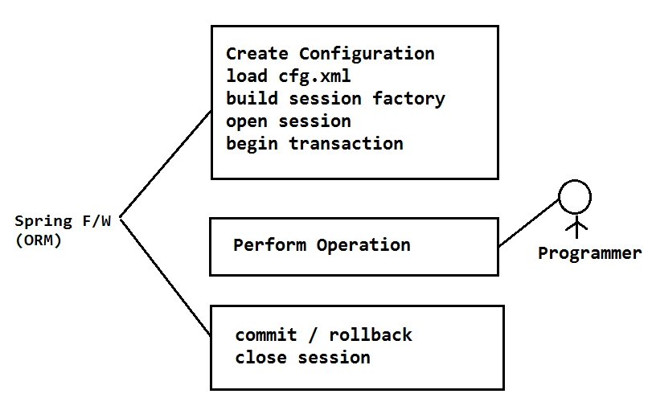

**HibernateTemplate[c] (org.springframework.orm.hibernate5)**

This class is used to perfrom operation in one line code , given example operations are save() , update() , delete() , get() and loadAll().

1. **save(obj):**

This method is used to convert model (entity / pojo) class object to database table row.

**EX: consider Employee(empId: int , empName :String , empSal : double)**

**As model class mapped with emptab (eid ,ename , esal).**

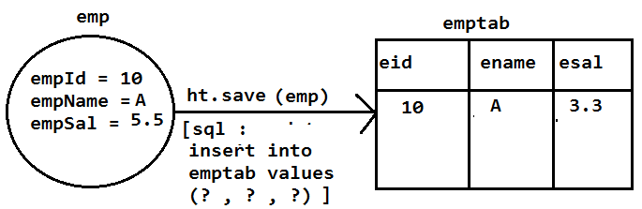

1. **update(obj):**

This method updates all columns data based on primary key value in database table.

Input is model class object and update row data column wise.

**Example**

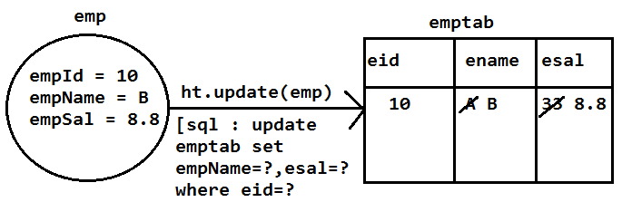

1. **delete(obj):**

This method takes one model class object having only primary key value (other values not required) based on primary key , row will be deleted from DB table.

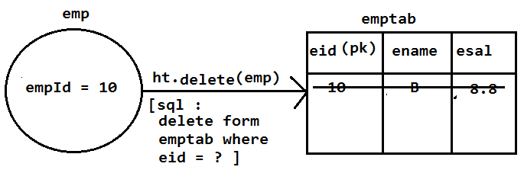

**FETCH RECORD**

1. **get(T.class , ID) : T Object**

This method is used to fetch one row using select query to application. This row will be converted to model class object.

Inputs T = Type = Model class name

ID = primary key data.

**Syntax:**

T obj = ht.get(T.class , ID);

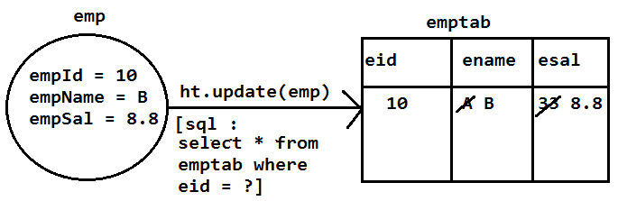

* if given id based row not exist in DB table then get() method returns null value.

1. **loadAll(T.class): List<T>**

This method will fetch all rows in DB table converts to list of objects (model class objects)

* list size is equals to number of rows in table.
* If table has no rows then empty list will be returned.

Here T = model class name

**Syntax:**

List<T>objs = ht.loadAll(T.class);

**Example**

List<Employee>emps = ht.loadAll(Employee.class);

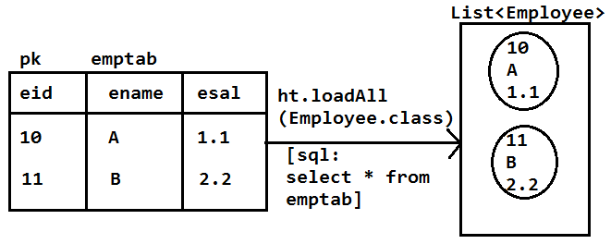

**Hibernate Design**

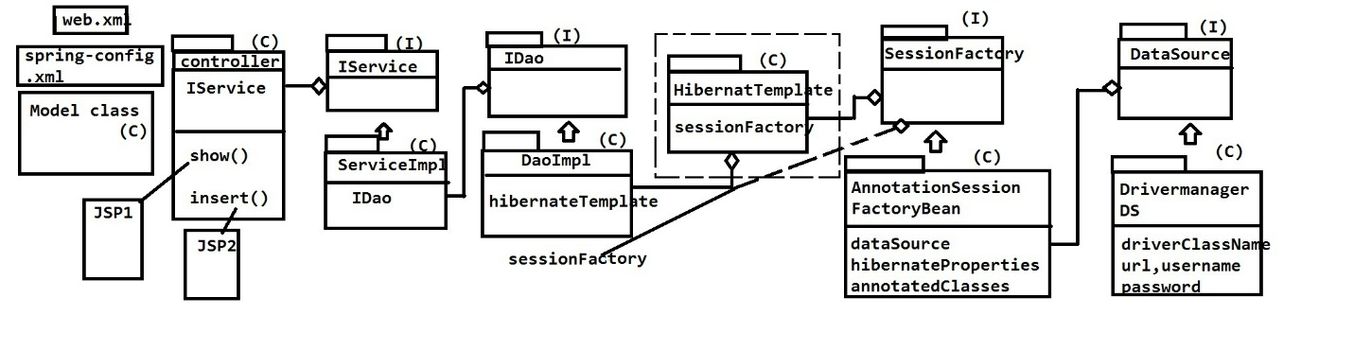

**CHEPTER # 4**

**Spring Web MVC**

To write one spring web application using MVC and FC pattern files are written in below order

1. XML File
2. **web.xml :** To configure FC (Dispatcher Servlet).
3. **Spring Configuration Files :** Activate annotation and provide view resolvers.
4. Java Fies : controller class[c] [String Bean] with request method.
5. UI Files : jsp/Html , css and java script.
6. ***web.xml***

<web-appxmlns:xsi="http://www.w3.org/2001/XMLSchema-instance"xmlns="http://java.sun.com/xml/ns/javaee"xsi:schemaLocation="http://java.sun.com/xml/ns/javaee http://java.sun.com/xml/ns/javaee/web-app_2_5.xsd"id="WebApp_ID"version="2.5">

<servlet>

<servlet-name>sample</servlet-name>

<servlet-class>

org.springframework.web.servlet.DispatcherServlet

</servlet-class>

</servlet>

<servlet-mapping>

<servlet-name>sample</servlet-name>

<url-pattern>/mvc/*</url-pattern>

</servlet-mapping>

</web-app>

1. ***Spring Config files (XML)***

It must be created under WEB-INF location file name should follow naming rule.

**[<servlet-name>]-servlet.xml**

Ex: sample-servlet.xml

**Code for annotation activations**

<context:component-scan base-package = “com.app”/>

**ViewResolver**

Here “InternalResourceViewResolver” is a class which can be used to provide prefix(location) and suffix(extension) of UI files.

**CODE(XML Configuration)**

<beanclass=*"org.springframework.web.servlet.view.InternalResourceViewResolver"*

p:prefix=*"/WEB-INF/views/"*

p:suffix=*".jsp"*/>

**Request can be made using browser in 3 different ways those are:**

1. Enter URL in address bar(GET)
2. HTML form submit(GET / POST)
3. Hiperlink <a> tag (GET)

** All internally generate URL only so request means URL only.

* To do request processing in spring define controller class given in below format.

@Controller

Public clas <class name> {

//request method can be written an:

@RequestMapping(“/url”) //GET type

Public ModelAndView methodName(){

//logic

request mav;

}

***// For post type request method***

@RequestMapping(value = "/url" ,

method = RequestMethod.POST)

public ModelAndView mehtodName(){

//logic

return mav;

}

**Note:**

1. URL is case-sensitive i.e /abc , /Abc , /ABC all are different.
2. If request URL is not matched with method URL then FC throws Http status 404 (not found).
3. If request URL is matched with method URL but type (GET/POST) is not matched then FC throws

Http status-405 method not allowed

1. If input data like empId , salary data type not matched then FC throws.

Http status-400 Bad Request

1. If secured URL is accessed without permission (login) then FC throws.

Http status-401 UNAuthorized

1. If request method executed logic and throws any exception then FC returns .

Http status-500 InternalServerError

1. If request processed successfully then FC returns Http status-200 ok.
2. Here request method is a enum [org.springframework.web.bind.annotation]
3. Browser to server only supported types are GET , POST.

10)Server to server all types are supported GET , POST , DELETE , TRACE , OPTIONS , HEAD , PUT.

11)Http status codes and types are :[https://en.wikipedia.org/wiki/listof http_status].

**CODE MESSAGE TYPE**

**________________________________________**

1XX Information

2XX Success Message

3XX Redirect Message

4XX Client Side Error

5XX Server Side Error

**Spring Web MVC**

Web application

It is a collection of web pages which runs in web server (Apache Tomcat) and accessed using web browser (Google Chrome) with the help of Http Request and Http Response.

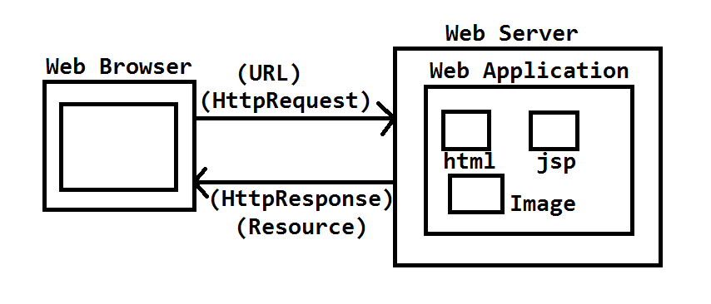

MVC + FC

* It is a combination design pattern used in dynamic web application development here Front Controller is a servlet. It will received request (HttpServlet) and dispatched to one controller (class) based on URL.
* Controller execute logic and it may communicate to DB and fetch data which will be stored in model memory.
* This model memory will be shared with view (Display Code).
* Data will be placed in views file (Data Rendering) and finally view returned back to FrontController.
* Front Controller sent this as HttpResponse

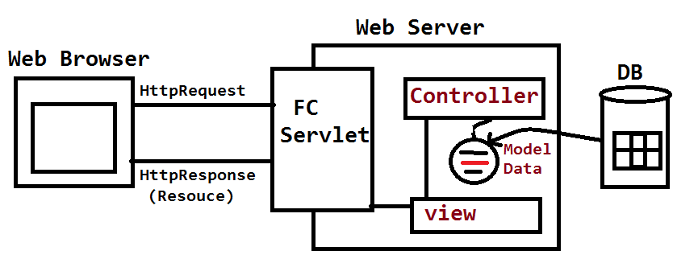

SPRING WEB-MVC AND FC DESIGN

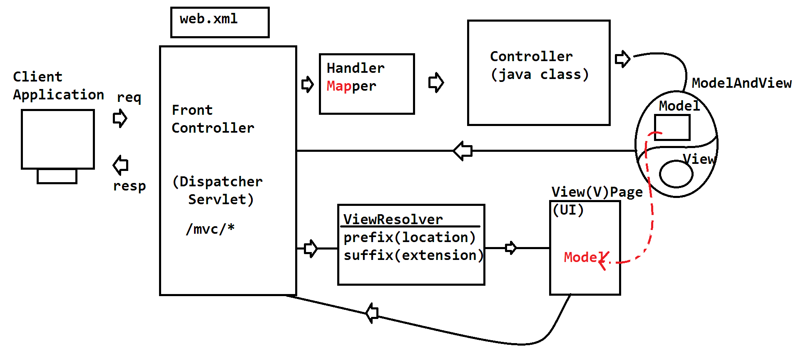

1. FrontController is a servlet which behaves like entry and exit gate to application running in servlet.
2. In Spring FC is a pre-define servlet named as DispatcherServlet.

package : org.springframework.web.servlet

1. FC will read HttpRequest (URL) and identifies one controller method based on HandlerMapper (MAP).
2. HandlerMapper will be created by FC at runtime it is a map holds URL (key) and connected controller method (value).
3. Controller is a class (Spring Bean) which can have multiple methods (known as request method).
4. Controller method returns finally ModelAndView class object. It holds ViewName(required) and Model (data) (optional)
5. FC reads ModelAndView(MAV) object and call ViewResolver class to identify UI(view page).
6. ViewResolver contains prefix (location of view page) and suffix (entension of view page). This is use to make controller independent of UI technology.

View Page = Prefix + view name + suffix

= /myfile/ home .jsp

1. ViewResolver finds view page nad view page reads data form model memory if exist using JSTL and EL (Data Rendering).

10)Finally view page as returned to FC and save returned as HttpResponse to client.

**NOTE:**

1. FC (Dispatcher Servlet) must be configured in web.xml file using directory match url pattern

Ex: /mvc/*

1. HandlerMapper is auto created object.
2. Controller class is a spring bean

no of modules = no of controller in project

1. ViewResolver are pre-defined in spring must be configured either using XML or using java configuration.
2. JSTL (Jsp Standard Tag Library) used to write java code in tag based format to apply CSS/JS easily and for flexible output.

**Spring Web MVC and FC Ex# 1**

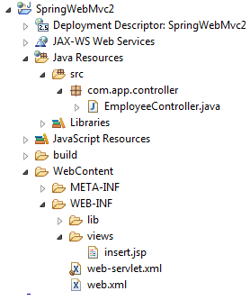

1. **Change STS/ECLIPSE to Java EE format**

Window > prespective > open prespective > other > choose “java ee”

1. **Configure Tomcat Server**

* Goto server tab shown in button
* Right click
* New
* Server
* Choose apache tomcat
* Next
* Click on browser for location

Ex:c:/program file /Apache Software Foundation /Tomcat 9.0

* Next
* Finish

1. **Create Dynamic web project**

* File > new > Dynamic web project
* Enter Details

Project name : SpringWebMvc2

Target Runtime : Apache Tomcat 9.0

Dynamic web module version : 2.5

* Next > Next > Choose checkbox> Finish

1. **Add jars to lib folder (do not use build path)**

* Copy jars from download location
* Right click on “lib” folder
* Paste

**CODING**

1. **Configure DispatcherServlet in web.xml.**

<?xmlversion=*"1.0"*encoding=*"UTF-8"*?>

<web-appxmlns:xsi=*"http://www.w3.org/2001/XMLSchema-instance"*xmlns=*"http://java.sun.com/xml/ns/javaee"*xsi:schemaLocation=*"http://java.sun.com/xml/ns/javaee http://java.sun.com/xml/ns/javaee/web-app_2_5.xsd"*id=*"WebApp_ID"*version=*"2.5"*>

<display-name>SpringWebMvc2</display-name>

<servlet>

<servlet-name>web</servlet-name>

<servlet-class>org.springframework.web.servlet.DispatcherServlet</servlet-class>

</servlet>

<servlet-mapping>

<servlet-name>web</servlet-name>

<url-pattern>/mvc/*</url-pattern>

</servlet-mapping>

</web-app>

1. **Create Spring Configuration file under WEB-INF with name.**

**(web-servlet.xml)**

<?xmlversion=*"1.0"*encoding=*"UTF-8"*?>

<beansxmlns=*"http://www.springframework.org/schema/beans"*

xmlns:p=*"http://www.springframework.org/schema/p"*

xmlns:context=*"http://www.springframework.org/schema/context"*

xmlns:xsi=*"http://www.w3.org/2001/XMLSchema-instance"*

xsi:schemaLocation=*"*

*http://www.springframework.org/schema/beans*

*http://www.springframework.org/schema/beans/spring-beans.xsd*

*http://www.springframework.org/schema/context http://www.springframework.org/schema/context/spring-context.xsd"*

>

<!-- Activation of annotation -->

<context:component-scanbase-package=*"com.app"*/>

<!-- View Resolver -->

<beanclass=*"org.springframework.web.servlet.view.InternalResourceViewResolver"*

p:prefix=*"/WEB-INF/views/"*

p:suffix=*".jsp"*/>

</beans>

1. Write controller class under src package com.app.controller.

(EmployeeController.java)

**package** com.app.controller;

**import** org.springframework.stereotype.Controller;

**import** org.springframework.web.bind.annotation.RequestMapping;

@Controller

**publicclass** EmployeeController {

@RequestMapping("/show")

**public** String showMsg() {

**return** ("insert");

}

}

1. **UI (Jsp) Files (Insert.jsp)**
   1. ***Create “views” folder under WEB-INF***

* Right Click on WEB-INF
* New
* Folder
* Enter Name : views
* Finish
  1. ***Create Insert.jsp file under views***
* Right click on view folder
* New
* Jsp file
* Enter name :: Insert.jsp
* Finish

<%@pagelanguage=*"java"*contentType=*"text/html; charset=ISO-8859-1"*

pageEncoding=*"ISO-8859-1"*%>

<!DOCTYPEhtmlPUBLIC"-//W3C//DTD HTML 4.01 Transitional//EN""http://www.w3.org/TR/html4/loose.dtd">

<html>

<head>

<metahttp-equiv=*"Content-Type"*content=*"text/html; charset=ISO-8859-1"*>

<title>Insert title here</title>

</head>

<body>

<h1> This is my first Spring web application....</h1>

</body>

</html>

1. **Run Application in server.**

* Right click on project > Run as
* Run on server
* Enter URL in browser

<http://localhost:8089/SpringWebMvc2/mvc/show>

OUTPUT:

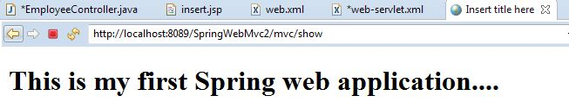

* In Java configuration web.xml file is written in java format using AppInit java .
* In Same way spring xml configuration is written in java formal using AppConfig.java
* Controller and UI(views) are same as before example.
* lib folder concept is replaced with pom.xml file in maven concept.

# Setup:-



1. **Create one Maven Project**

* File
* New
* Other
* search with Maven
* choose Maven project
* next
* enter filter word: webapp
* choose "maven-archtype-webapp"
* next
* Enter Details

Group Id : org.sathyatech

Artifact Id : SpringWebMvcMaven1

version : 1.1

**2) Configure server in workspace and add to maven project.**

* Finish
* Right click on Project
* build path
* Configure build path
* Add Library...
* choose "server runtime"
* next
* select "Apache Tomcat "
* apply
* Apply and close.

**3) Add dependencies and build plugins in pom.xml [copy from Document]**

<projectxmlns=*"http://maven.apache.org/POM/4.0.0"*

xmlns:xsi=*"http://www.w3.org/2001/XMLSchema-instance"*

xsi:schemaLocation=*"http://maven.apache.org/POM/4.0.0 http://maven.apache.org/maven-v4_0_0.xsd"*>

<modelVersion>4.0.0</modelVersion>

<groupId>org.sathyatech</groupId>

<artifactId>SpringWebMvcMaven</artifactId>

<packaging>war</packaging>

<version>1.0</version>

<name>SpringWebMvcMaven MavenWebapp</name>

<url>http://maven.apache.org</url>

<dependencies>

<dependency>

<groupId>org.springframework</groupId>

<artifactId>spring-webmvc</artifactId>

<version>5.0.3.RELEASE</version>

</dependency>

</dependencies>

<build>

<plugins>

<plugin>

<groupId>org.apache.maven.plugins</groupId>

<artifactId>maven-compiler-plugin</artifactId>

<version>3.7.0</version>

<configuration>

<source>1.8</source>

<target>1.8</target>

</configuration>

</plugin>

<plugin>

<artifactId>maven-war-plugin</artifactId>

<version>2.4</version>

<configuration>

<failOnMissingWebXml>false</failOnMissingWebXml>

</configuration>

</plugin>

</plugins>

</build>

</project>

1. **delete web.xml file and index.jsp file provided by default in Project**
2. **Chnage Dynamic web module version to : 3.1**

* Window
* show view
* navigator (then)
* Goto Project
* expand .settings (folder)
* open "org.eclipse.wst.common .project.facet.core.xml" File
* modify version="3.1" where facet="jst.web"
* come to Project/Package Explorer then update maven Project

1. **Update Maven Project**

* Right click on Project
* Maven
* Update Maven Project
* OK/Finish

**coding**

**1. create folder "views" under WEB-INF**

* right click on WEB-INF
* new
* Folder
* enter name : views > finish

**2. Create Home.jsp under views**

* Right click on views
* new
* JSP File
* Enter name : Home.jsp
* Finish

**3. Define Controller class under src/main/java**

**1) EmployeeController.java**

**package** com.app.controller;

**import** org.springframework.stereotype.Controller;

**import** org.springframework.web.bind.annotation.RequestMapping;

**import** org.springframework.web.servlet.ModelAndView;

@Controller

**publicclass** EmployeeController {

@RequestMapping("/show")

**public** ModelAndView showPage() {

ModelAndView mav = **new** ModelAndView();

mav.setViewName("Home");

**return**mav;

}

}

**2) AppConfig.java**

**package** com.app.config;

**import** org.springframework.context.annotation.Bean;

**import** org.springframework.context.annotation.ComponentScan;

**import** org.springframework.context.annotation.Configuration;

**import** org.springframework.web.servlet.config.annotation.EnableWebMvc;

**import** org.springframework.web.servlet.view.InternalResourceViewResolver;

@Configuration

@EnableWebMvc

@ComponentScan(basePackages = "com.app")

**publicclass** AppConfig {

@Bean

**public** InternalResourceViewResolver ivr() {

InternalResourceViewResolver ivr = **new** InternalResourceViewResolver();

ivr.setPrefix("/WEB-INF/views/");

ivr.setSuffix(".jsp");

**return**ivr;

}

}

**3) AppInit.java**

**package** com.app.init;

**import** org.springframework.web.servlet.support.AbstractAnnotationConfigDispatcherServletInitializer;

**import**com.app.config.AppConfig;

**publicclass** AppInit **extends** AbstractAnnotationConfigDispatcherServletInitializer{

@Override

**protected** Class<?>[] getRootConfigClasses() {

**returnnew** Class[]{AppConfig.**class**};

}

@Override

**protected** Class<?>[] getServletConfigClasses() {

// **TODO** Auto-generated method stub

**returnnull**;

}

@Override

**protected** String[] getServletMappings() {

**returnnew** String[] { "/mvc/*"};

}

}

**4)Home.jsp**

<%@pagelanguage=*"java"*contentType=*"text/html; charset=ISO-8859-1"*

pageEncoding=*"ISO-8859-1"*%>

<!DOCTYPEhtmlPUBLIC"-//W3C//DTD HTML 4.01 Transitional//EN""http://www.w3.org/TR/html4/loose.dtd">

<html>

<head>

<metahttp-equiv=*"Content-Type"*content=*"text/html; charset=ISO-8859-1"*>

<title>Insert title here</title>

</head>

<body>

<h1> This is the example of spring application using java configuration with maven</h1>

</body>

</html>

**5) Output**

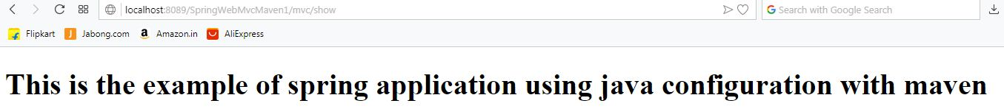

**Handler Mapper**

Controller class object created by Spring Container browser can understand only URLs (Request) and output (Response).

* Here DispatcherServlet cannot search all controller classes and their method so , FC creates one register which holds details like “For WHAT request , WHICH method ? “ will be executed.
* All methods and their URLs will be listed out and create as a map , known as HandlerMapper.
* Consider below code:

**package** com.app.controller;

**import** org.springframework.stereotype.Controller;

**import** org.springframework.web.bind.annotation.RequestMapping;

**import** org.springframework.web.servlet.ModelAndView;

@Controller

**publicclass**EmployeeController {

@RequestMapping("/show")

**public** ModelAndView showPage() {

ModelAndView mav = **new** ModelAndView();

mav.setViewName("Home");

**return**mav;

}

}

Execution flow will be:

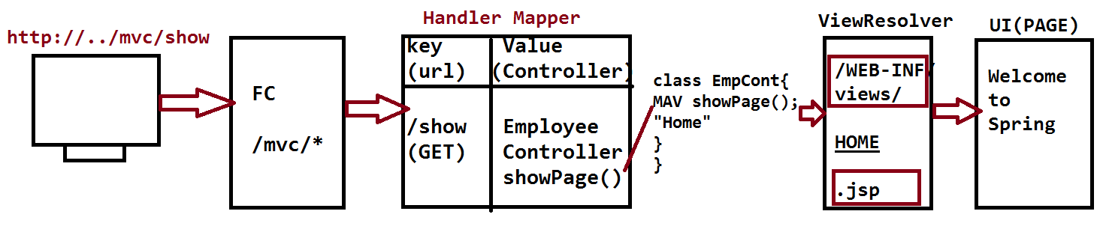

Data(MODEL) Exchange between controller and UI

1. **Sending data from controller to UI (JSP).**
2. **Sending data from UI to Controller.**
3. **Sending data from Controller to UI(JSP)**

Use Model and View (ModelAndView) (Model Memory) to store data from controller to UI(view) page.

ModelAndView will store data in key = value format key is String type and value is object (java.lang) type [value can store any data type , so super type object].

**Consider below example**

use ModelAndView object method i.e. addObject(String key , String value);

to add data to Model memory.

Read data at UI (View) using El (Expression Language) or Scriptlet-request (implicit Object) Object method getAttribute(“key”) : Object

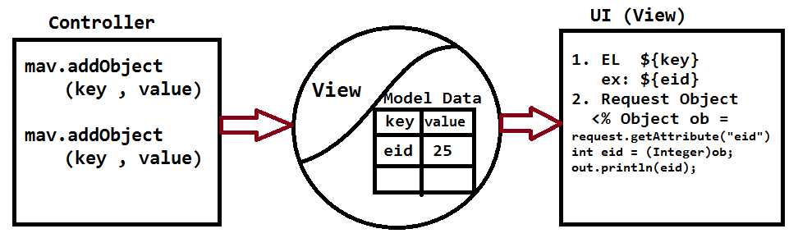

**Example Of Sending Data From Controller To UI Using XML** :

**Setup**

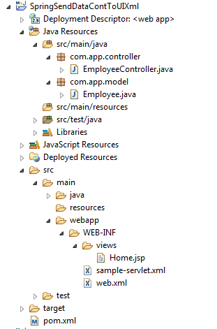

1. **pom.xml**

<projectxmlns=*"http://maven.apache.org/POM/4.0.0"*

xmlns:xsi=*"http://www.w3.org/2001/XMLSchema-instance"*

xsi:schemaLocation=*"http://maven.apache.org/POM/4.0.0 http://maven.apache.org/maven-v4_0_0.xsd"*>

<modelVersion>4.0.0</modelVersion>

<groupId>org.sathyatech</groupId>

<artifactId>SpringSendDataContToUIXml</artifactId>

<packaging>war</packaging>

<version>1.1</version>

<name>SpringSendDataContToUIXml MavenWebapp</name>

<url>http://maven.apache.org</url>

<dependencies>

<dependency>

<groupId>org.springframework</groupId>

<artifactId>spring-webmvc</artifactId>

<version>5.0.3.RELEASE</version>

</dependency>

</dependencies>

<build>

<plugins>

<plugin>

<groupId>org.apache.maven.plugins</groupId>

<artifactId>maven-compiler-plugin</artifactId>

<version>3.7.0</version>

<configuration>

<source>1.8</source>

<target>1.8</target>

</configuration>

</plugin>

<plugin>

<artifactId>maven-war-plugin</artifactId>

<version>2.4</version>

<configuration>

<failOnMissingWebXml>false</failOnMissingWebXml>

</configuration>

</plugin>

</plugins>

</build>

</project>

1. **web.xml**

<!DOCTYPEweb-appPUBLIC

"-//Sun Microsystems, Inc.//DTD Web Application 2.3//EN"

"http://java.sun.com/dtd/web-app_2_3.dtd">

<web-app>

<servlet>

<servlet-name>sample</servlet-name>

<servlet-class>org.springframework.web.servlet.DispatcherServlet</servlet-class>

</servlet>

<servlet-mapping>

<servlet-name>sample</servlet-name>

<url-pattern>/mvc/*</url-pattern>

</servlet-mapping>

</web-app>

1. **sample-servlet.xml**

<?xmlversion=*"1.0"*encoding=*"UTF-8"*?>

<beansxmlns=*"http://www.springframework.org/schema/beans"*

xmlns:p=*"http://www.springframework.org/schema/p"*

xmlns:context=*"http://www.springframework.org/schema/context"*

xmlns:xsi=*"http://www.w3.org/2001/XMLSchema-instance"*

xsi:schemaLocation=*"*

*http://www.springframework.org/schema/beans*

*http://www.springframework.org/schema/beans/spring-beans.xsd*

*http://www.springframework.org/schema/context*

*http://www.springframework.org/schema/context/spring-context.xsd*

*"*>

<!-- Activation Of Annotation -->

<context:component-scanbase-package=*"com.app"*/>

<!-- View Resolver -->

<beanclass=*"org.springframework.web.servlet.view.InternalResourceViewResolver"*

p:prefix=*"/WEB-INF/views/"*

p:suffix=*".jsp"*/>

</beans>

1. **Employee.java**

**package** com.app.model;

**publicclass** Employee {

**privateint**empId;

**private** String empName;

**privatedouble**empSal;

**public** Employee() {

**super**();

}

**publicint** getEmpId() {

**return**empId;

}

**publicvoid** setEmpId(**int**empId) {

**this**.empId = empId;

}

**public** String getEmpName() {

**return**empName;

}

**publicvoid** setEmpName(String empName) {

**this**.empName = empName;

}

**publicdouble** getEmpSal() {

**return**empSal;

}

**publicvoid** setEmpSal(**double**empSal) {

**this**.empSal = empSal;

}

@Override

**public** String toString() {

**return**"Employee [empId=" + empId + ", empName=" + empName + ", empSal=" + empSal + "]";

}

}

1. **EmployeeController.java**

**package** com.app.controller;

**import** org.springframework.stereotype.Controller;

**import** org.springframework.web.bind.annotation.RequestMapping;

**import** org.springframework.web.servlet.ModelAndView;

**import** com.app.model.Employee;

@Controller

**publicclass** EmployeeController {

@RequestMapping("/show")

**public**ModelAndView showMsg() {

ModelAndView mav = **new** ModelAndView();

mav.setViewName("Home");

Employee e = **new** Employee();

e.setEmpId(10);

e.setEmpName("Vicky Raj");

e.setEmpSal(6.5);

mav.addObject("emp" , e);

**return**mav;

}

}

1. **Output**

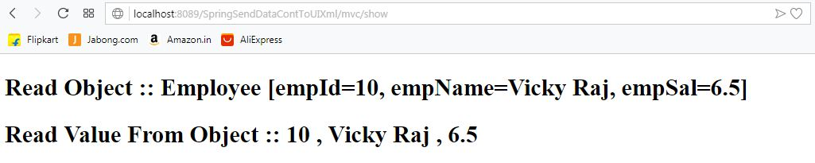

**Example Of Sending Data From Controller To UI (JSP) USING Java Config**

**Setup**

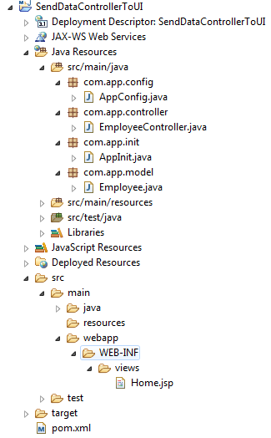

1. **pom.xml**

<projectxmlns=*"http://maven.apache.org/POM/4.0.0"*

xmlns:xsi=*"http://www.w3.org/2001/XMLSchema-instance"*

xsi:schemaLocation=*"http://maven.apache.org/POM/4.0.0 http://maven.apache.org/maven-v4_0_0.xsd"*>

<modelVersion>4.0.0</modelVersion>

<groupId>org.sathyatech</groupId>

<artifactId>SendDataControllerToUI</artifactId>

<packaging>war</packaging>

<version>1.1</version>

<name>SendDataControllerToUI MavenWebapp</name>

<url>http://maven.apache.org</url>

<dependencies>

<dependency>

<groupId>org.springframework</groupId>

<artifactId>spring-webmvc</artifactId>

<version>5.0.3.RELEASE</version>

</dependency>

<!-- https://mvnrepository.com/artifact/javax.servlet/jstl -->

<dependency>

<groupId>javax.servlet</groupId>

<artifactId>jstl</artifactId>

<version>1.2</version>

</dependency>

</dependencies>

<build>

<plugins>

<plugin>

<groupId>org.apache.maven.plugins</groupId>

<artifactId>maven-compiler-plugin</artifactId>

<version>3.7.0</version>

<configuration>

<source>1.8</source>

<target>1.8</target>

</configuration>

</plugin>

<plugin>

<artifactId>maven-war-plugin</artifactId>

<version>2.4</version>

<configuration>

<failOnMissingWebXml>false</failOnMissingWebXml>

</configuration>

</plugin>

</plugins>

</build>

</project>

1. **Employee.java**

**package** com.app.model;

**publicclass** Employee {

**privateint**empId;

**private** String empName;

**privatedouble**empSal;

**public** Employee() {

**super**();

}

**publicint** getEmpId() {

**return**empId;

}

**publicvoid** setEmpId(**int**empId) {

**this**.empId = empId;

}

**public** String getEmpName() {

**return**empName;

}

**publicvoid** setEmpName(String empName) {

**this**.empName = empName;

}

**publicdouble** getEmpSal() {

**return**empSal;

}

**publicvoid** setEmpSal(**double**empSal) {

**this**.empSal = empSal;

}

@Override

**public** String toString() {

**return**"Employee [empId=" + empId + ", empName=" + empName + ", empSal=" + empSal + "]";

}

}

1. **EmployeeController.java**

**package** com.app.controller;

**import** org.springframework.stereotype.Controller;

**import** org.springframework.web.bind.annotation.RequestMapping;

**import** org.springframework.web.servlet.ModelAndView;

**import** com.app.model.Employee;

@Controller

**publicclass** EmployeeController {

@RequestMapping("/show")

**public** ModelAndView showOutput() {

ModelAndView mav = **new** ModelAndView();

mav.setViewName("Home");

Employee e = **new** Employee();

e.setEmpId(10);

e.setEmpName("Vicky");

e.setEmpSal(5.5);

mav.addObject("data" , e);

**return**mav;

}

}

1. **AppConfig.java**

**package** com.app.config;

**import** org.springframework.context.annotation.Bean;

**import** org.springframework.context.annotation.ComponentScan;

**import** org.springframework.context.annotation.Configuration;

**import** org.springframework.web.servlet.config.annotation.EnableWebMvc;

**import** org.springframework.web.servlet.view.InternalResourceViewResolver;

@EnableWebMvc

@Configuration

@ComponentScan(basePackages = "com.app")

**publicclass** AppConfig {

@Bean

**public** InternalResourceViewResolver ivr() {

InternalResourceViewResolver ivr = **new** InternalResourceViewResolver();

ivr.setPrefix("/WEB-INF/views/");

ivr.setSuffix(".jsp");

**return**ivr;

}

}

1. **AppInit.java**

**package** com.app.init;

**import** org.springframework.web.servlet.support.AbstractAnnotationConfigDispatcherServletInitializer;

**import** com.app.config.AppConfig;

**publicclass** AppInit **extends** AbstractAnnotationConfigDispatcherServletInitializer{

@Override

**protected** Class<?>[] getRootConfigClasses() {

**returnnew** Class[] {AppConfig.**class**};

}

@Override

**protected** Class<?>[] getServletConfigClasses() {

// **TODO** Auto-generated method stub

**returnnull**;

}

@Override

**protected** String[] getServletMappings() {

**returnnew** String[] {"/mvc/*"};

}

}

1. **Home.jsp**

<%@pagelanguage=*"java"*contentType=*"text/html; charset=ISO-8859-1"*

pageEncoding=*"ISO-8859-1"*%>

<%@taglibprefix=*"c"*uri=*"http://java.sun.com/jsp/jstl/core"*%>

<!DOCTYPEhtmlPUBLIC"-//W3C//DTD HTML 4.01 Transitional//EN""http://www.w3.org/TR/html4/loose.dtd">

<html>

<head>

<metahttp-equiv=*"Content-Type"*content=*"text/html; charset=ISO-8859-1"*>

<title>Insert title here</title>

</head>

<body>

<h2>Read Object :: ${data}</h2>

<h2> Read Value From Object::

${data.empId } , ${data.empName } , ${data.empSal }

</h2>

</body>

</html>

1. **Output**

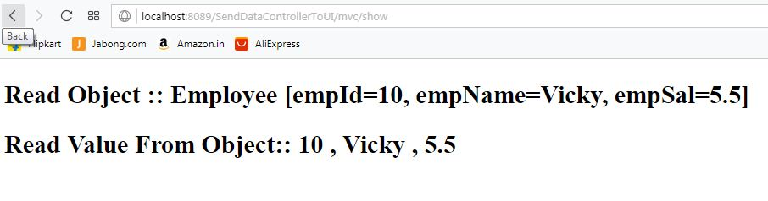

**Sending Collection Data From Controller To UI Using XML.**

**Setup**

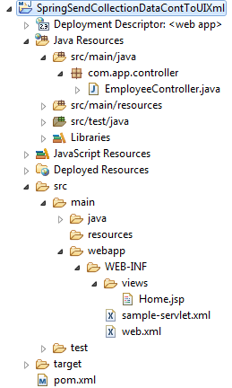

1. **pom.xml**

<projectxmlns=*"http://maven.apache.org/POM/4.0.0"*

xmlns:xsi=*"http://www.w3.org/2001/XMLSchema-instance"*

xsi:schemaLocation=*"http://maven.apache.org/POM/4.0.0 http://maven.apache.org/maven-v4_0_0.xsd"*>

<modelVersion>4.0.0</modelVersion>

<groupId>com.sathyatech</groupId>

<artifactId>SpringSendCollectionDataContToUIXml</artifactId>

<packaging>war</packaging>

<version>0.0.1-SNAPSHOT</version>

<name>SpringSendCollectionDataContToUIXml MavenWebapp</name>

<url>http://maven.apache.org</url>

<dependencies>

<dependency>

<groupId>org.springframework</groupId>

<artifactId>spring-webmvc</artifactId>

<version>5.0.3.RELEASE</version>

</dependency>

<dependency>

<groupId>javax.servlet</groupId>

<artifactId>jstl</artifactId>

<version>1.2</version>

</dependency>

</dependencies>

<build>

<plugins>

<plugin>

<groupId>org.apache.maven.plugins</groupId>

<artifactId>maven-compiler-plugin</artifactId>

<version>3.7.0</version>

<configuration>

<source>1.8</source>

<target>1.8</target>

</configuration>

</plugin>

<plugin>

<artifactId>maven-war-plugin</artifactId>

<version>2.4</version>

<configuration>

<failOnMissingWebXml>false</failOnMissingWebXml>

</configuration>

</plugin>

</plugins>

</build>

</project>

1. **EmployeeController.java**

**package** com.app.controller;

**import** java.util.Arrays;

**import** java.util.List;

**import** org.springframework.stereotype.Controller;

**import** org.springframework.web.bind.annotation.RequestMapping;

**import** org.springframework.web.servlet.ModelAndView;

@Controller

**publicclass** EmployeeController {

@RequestMapping("/show")

**public** ModelAndView showMsg() {

ModelAndView mav = **new** ModelAndView();

mav.setViewName("Home");

List<Object>list =

Arrays.*asList*(10 , "vicky raj" , 5.5);

mav.addObject("data" , list);

**return**mav;

}

}

**3)web.xml**

<!DOCTYPEweb-appPUBLIC

"-//Sun Microsystems, Inc.//DTD Web Application 2.3//EN"

"http://java.sun.com/dtd/web-app_2_3.dtd">

<web-app>

<servlet>

<servlet-name>sample</servlet-name>

<servlet-class>

org.springframework.web.servlet.DispatcherServlet

</servlet-class>

</servlet>

<servlet-mapping>

<servlet-name>sample</servlet-name>

<url-pattern>/mvc/*</url-pattern>

</servlet-mapping>

</web-app>

**4)sample-servlet.xml**

<?xmlversion=*"1.0"*encoding=*"UTF-8"*?>

<beansxmlns=*"http://www.springframework.org/schema/beans"*

xmlns:p=*"http://www.springframework.org/schema/p"*

xmlns:context=*"http://www.springframework.org/schema/context"*

xmlns:xsi=*"http://www.w3.org/2001/XMLSchema-instance"*

xsi:schemaLocation=*"*

*http://www.springframework.org/schema/beans*

*http://www.springframework.org/schema/beans/spring-beans.xsd*

*http://www.springframework.org/schema/context*

*http://www.springframework.org/schema/context/spring-context.xsd*

*"*>

<!-- Activation of annotation -->

<context:component-scanbase-package=*"com.app"*/>

<!-- View Resolver -->

<beanclass=*"org.springframework.web.servlet.view.InternalResourceViewResolver"*

p:prefix=*"/WEB-INF/views/"*

p:suffix=*".jsp"*/>

</beans>

**5)Home.jsp**

<%@pagelanguage=*"java"* isELIgnored=*"false"* contentType=*"text/html; charset=ISO-8859-1"*

pageEncoding=*"ISO-8859-1"*%>

<%@taglibprefix=*"c"* uri=*"http://java.sun.com/jsp/jstl/core"*%>

<!DOCTYPEhtmlPUBLIC"-//W3C//DTD HTML 4.01 Transitional//EN""http://www.w3.org/TR/html4/loose.dtd">

<html>

<head>

<metahttp-equiv=*"Content-Type"*content=*"text/html; charset=ISO-8859-1"*>

<title>Insert title here</title>

</head>

<body>

<h1>${data}</h1>

<c:forEachitems=*"*${data}*"*var=*"ob"*>

<c:outvalue=*"*${ob}*"*/><br>

</c:forEach>

</body>

</html>

**Sending Collection Data From Controller To UI Using Java Config:**

**Setup**

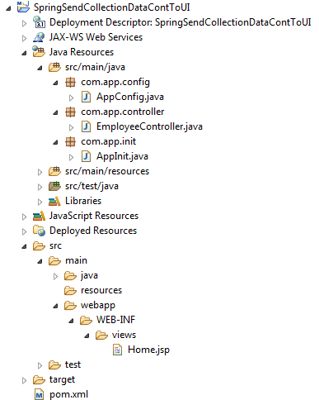

1. **pom.xml**

<projectxmlns=*"http://maven.apache.org/POM/4.0.0"*

xmlns:xsi=*"http://www.w3.org/2001/XMLSchema-instance"*

xsi:schemaLocation=*"http://maven.apache.org/POM/4.0.0 http://maven.apache.org/maven-v4_0_0.xsd"*>

<modelVersion>4.0.0</modelVersion>

<groupId>com.sathyatech</groupId>

<artifactId>SpringSendCollectionDataContToUI</artifactId>

<packaging>war</packaging>

<version>1.1</version>

<name>SpringSendCollectionDataContToUI MavenWebapp</name>

<url>http://maven.apache.org</url>

<dependencies>

<dependency>

<groupId>org.springframework</groupId>

<artifactId>spring-webmvc</artifactId>

<version>5.0.3.RELEASE</version>

</dependency>

<dependency>

<groupId>javax.servlet</groupId>

<artifactId>jstl</artifactId>

<version>1.2</version>

</dependency>

</dependencies>

<build>

<plugins>

<plugin>

<groupId>org.apache.maven.plugins</groupId>

<artifactId>maven-compiler-plugin</artifactId>

<version>3.7.0</version>

<configuration>

<source>1.8</source>

<target>1.8</target>

</configuration>

</plugin>

<plugin>

<artifactId>maven-war-plugin</artifactId>

<version>2.4</version>

<configuration>

<failOnMissingWebXml>false</failOnMissingWebXml>

</configuration>

</plugin>

</plugins>

</build>

</project>

**2)EmployeeController.java**

**package** com.app.controller;

**import** java.util.Arrays;

**import** java.util.List;

**import** org.springframework.stereotype.Controller;

**import** org.springframework.web.bind.annotation.RequestMapping;

**import** org.springframework.web.servlet.ModelAndView;

@Controller

**publicclass** EmployeeController {

@RequestMapping("/show")

**public** ModelAndView showMsg() {

ModelAndView mav = **new** ModelAndView();

mav.setViewName("Home");

List<String>str =

Arrays.*asList*("vicky" , "Raj" , "Kumar" );

mav.addObject("data" , str);

**return**mav;

}

}

**3)AppConfig.java**

**package** com.app.config;

**import** org.springframework.context.annotation.Bean;

**import** org.springframework.context.annotation.ComponentScan;

**import** org.springframework.context.annotation.Configuration;

**import** org.springframework.web.servlet.config.annotation.EnableWebMvc;

**import** org.springframework.web.servlet.view.InternalResourceViewResolver;

@EnableWebMvc

@Configuration

@ComponentScan(basePackages = "com.app")

**publicclass**AppConfig {

@Bean

**public** InternalResourceViewResolver ivr() {

InternalResourceViewResolver ivr =

**new** InternalResourceViewResolver();

ivr.setPrefix("/WEB-INF/views/");

ivr.setSuffix(".jsp");

**return**ivr;

}

}

**4)AppInit.java**

**package** com.app.init;

**import** org.springframework.web.servlet.support.AbstractAnnotationConfigDispatcherServletInitializer;

**import** com.app.config.AppConfig;

**publicclass** AppInit **extends**AbstractAnnotationConfigDispatcherServletInitializer{

@Override

**protected** Class<?>[] getRootConfigClasses() {

**returnnew** Class[] {AppConfig.**class**};

}

@Override

**protected** Class<?>[] getServletConfigClasses() {

**returnnull**;

}

@Override

**protected** String[] getServletMappings() {

**returnnew** String[] {"/mvc/*"};

}

}

**5)Home.jsp**

<%@pagelanguage=*"java"*contentType=*"text/html; charset=ISO-8859-1"*pageEncoding=*"ISO-8859-1"*%>

<%@taglibprefix=*"c"*uri=*"http://java.sun.com/jsp/jstl/core"*%>

<!DOCTYPEhtmlPUBLIC"-//W3C//DTD HTML 4.01 Transitional//EN""http://www.w3.org/TR/html4/loose.dtd">

<html>

<head>

<metahttp-equiv=*"Content-Type"*content=*"text/html; charset=ISO-8859-1"*>

<title>Insert title here</title>

</head>

<body>

<h1>${data }</h1>

<h1>

<c:forEachitems=*"*${data }*"*var=*"ob"*>

<c:outvalue=*"*${ob}*"*/><br>

</c:forEach>

</h1>

</body>

</html>

1. **Sending data from UI To Controller**
2. ***HTML Form (ModelAttribure):***

This concept is used to send data from UI to controller one complete HTML form in single read an object.

* Here Spring container converts from data to object format on click submit after entering data in below steps.
  + - 1. Container create the object to model class [here object name is Class Name , first letter small case.
      2. Container read data from HTML from inputs [request .getParameter..].
      3. Container parse data if required.
      4. Finally set data to ModelAttribute.
* For this object creation , programmer has to do below steps

1. Write one model class with any name.
2. Write variable in class

No of variable in class = no of form input (in html form)

1. Variable name must match with form input.

(<input name = “_____” | <select name = “___” | <textarea name = “_______”)

1. Finally read this object in controller class using below code:

**Syntax**

@ModelAttribute(“classname”)ClassName localVarName

**Example**

@ModelAttibute(“employee”) Employee emp

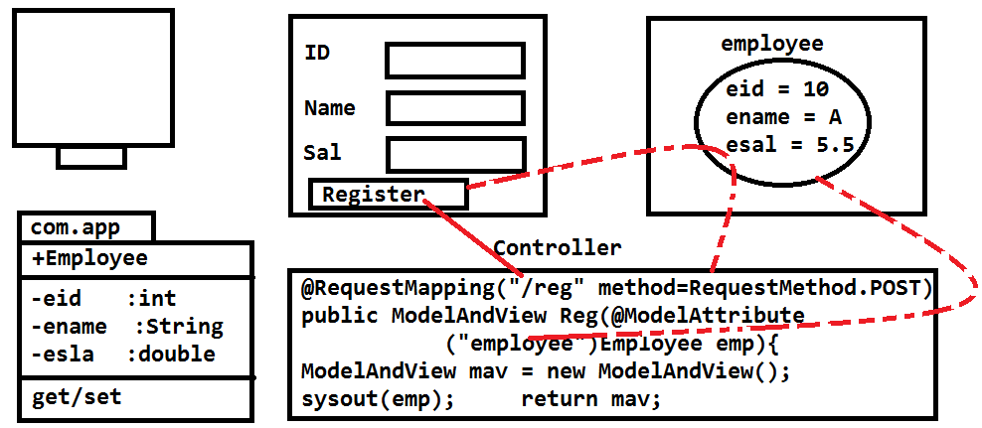

**Example Of Sending Data Form UI To Controller Using XML:**

**Setup**

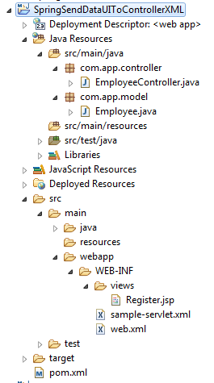

1. **pom.xml**

<projectxmlns=*"http://maven.apache.org/POM/4.0.0"*

xmlns:xsi=*"http://www.w3.org/2001/XMLSchema-instance"*

xsi:schemaLocation=*"http://maven.apache.org/POM/4.0.0 http://maven.apache.org/maven-v4_0_0.xsd"*>

<modelVersion>4.0.0</modelVersion>

<groupId>com.sathyatech</groupId>

<artifactId>SpringSendDataUIToControllerXML</artifactId>

<packaging>war</packaging>

<version>1.1</version>

<name>SpringSendDataUIToControllerXML MavenWebapp</name>

<url>http://maven.apache.org</url>

<dependencies>

<dependency>

<groupId>org.springframework</groupId>

<artifactId>spring-webmvc</artifactId>

<version>5.0.3.RELEASE</version>

</dependency>

<dependency>

<groupId>javax.servlet</groupId>

<artifactId>jstl</artifactId>

<version>1.2</version>

</dependency>

</dependencies>

<build>

<plugins>

<plugin>

<groupId>org.apache.maven.plugins</groupId>

<artifactId>maven-compiler-plugin</artifactId>

<version>3.7.0</version>

<configuration>

<source>1.8</source>

<target>1.8</target>

</configuration>

</plugin>

<plugin>

<artifactId>maven-war-plugin</artifactId>

<version>2.4</version>

</plugin>

</plugins>

</build>

</project>

1. **web.xml**

<!DOCTYPEweb-appPUBLIC

"-//Sun Microsystems, Inc.//DTD Web Application 2.3//EN"

"http://java.sun.com/dtd/web-app_2_3.dtd">

<web-app>

<servlet>

<servlet-name>sample</servlet-name>

<servlet-class>org.springframework.web.servlet.DispatcherServlet</servlet-class>

</servlet>

<servlet-mapping>

<servlet-name>sample</servlet-name>

<url-pattern>/mvc/*</url-pattern>

</servlet-mapping>

</web-app>

1. **sample-servlet.xml**

<?xmlversion=*"1.0"*encoding=*"UTF-8"*?>

<beansxmlns=*"http://www.springframework.org/schema/beans"*

xmlns:p=*"http://www.springframework.org/schema/p"*

xmlns:context=*"http://www.springframework.org/schema/context"*

xmlns:xsi=*"http://www.w3.org/2001/XMLSchema-instance"*

xsi:schemaLocation=*"*

*http://www.springframework.org/schema/beans*

*http://www.springframework.org/schema/beans/spring-beans.xsd*

*http://www.springframework.org/schema/context*

*http://www.springframework.org/schema/context/spring-context.xsd*

*"*>

<!-- Activation Of Annotation -->

<context:component-scanbase-package=*"com.app"*/>

<!-- View Resolver -->

<beanclass=*"org.springframework.web.servlet.view.InternalResourceViewResolver"*

p:prefix=*"/WEB-INF/views/"*

p:suffix=*".jsp"*/>

</beans>

1. **Employee.java**

**package** com.app.model;

**publicclass** Employee {

**privateint**empId;

**private** String empName;

**private** String empPwd;

**private** String empGen;

**private** String empAddr;

**private** String empCountry;

**public** Employee() {

**super**();

}

**publicint** getEmpId() {

**return**empId;

}

**publicvoid** setEmpId(**int**empId) {

**this**.empId = empId;

}

**public** String getEmpName() {

**return**empName;

}

**publicvoid** setEmpName(String empName) {

**this**.empName = empName;

}

**public** String getEmpPwd() {

**return**empPwd;

}

**publicvoid** setEmpPwd(String empPwd) {

**this**.empPwd = empPwd;

}

**public** String getEmpGen() {

**return**empGen;

}

**publicvoid** setEmpGen(String empGen) {

**this**.empGen = empGen;

}

**public** String getEmpAddr() {

**return**empAddr;

}

**publicvoid** setEmpAddr(String empAddr) {

**this**.empAddr = empAddr;

}

**public** String getEmpCountry() {

**return**empCountry;

}

**publicvoid** setEmpCountry(String empCountry) {

**this**.empCountry = empCountry;

}

}

1. **EmployeeController.java**

**package** com.app.controller;

**import** org.springframework.stereotype.Controller;

**import** org.springframework.web.bind.annotation.ModelAttribute;

**import** org.springframework.web.bind.annotation.RequestMapping;

**import** org.springframework.web.servlet.ModelAndView;

**import** com.app.model.Employee;

@Controller

**publicclass** EmployeeController {

@RequestMapping("/show")

**public** ModelAndView show() {

ModelAndView mav = **new** ModelAndView();

mav.setViewName("Register");

**return**mav;

}

@RequestMapping("/reg")

**public**ModelAndViewRegister

(@ModelAttribute("employee")Employee emp) {

ModelAndView mav = **new** ModelAndView();

mav.setViewName("Register");

mav.addObject("emp" , emp);

**return**mav;

}

}

1. **Register.jsp**

<%@pagelanguage=*"java"*isELIgnored=*"false"*contentType=*"text/html; charset=ISO-8859-1"*

pageEncoding=*"ISO-8859-1"*%>

<%@taglibprefix=*"c"*uri=*"http://java.sun.com/jsp/jstl/core"*%>

<!DOCTYPEhtmlPUBLIC"-//W3C//DTD HTML 4.01 Transitional//EN""http://www.w3.org/TR/html4/loose.dtd">

<html>

<head>

<metahttp-equiv=*"Content-Type"*content=*"text/html; charset=ISO-8859-1"*>

<title>Insert title here</title>

<styletype=*"text/css"*>

**td**{

color: *blue*;

}

*#formDiv*{

width:*30%*;

border:*2px solid green*;

float:*left*;

}

*#data*{

width:*30%*;

height:*200px*;

float:*left*;

margin-left:*30px*;

border:*2px solid green*;

}

</style>

</head>

<body>

<divid=*"formDiv"*>

<formaction=*"reg"*method=*"POST"*id=*"form"*>

<tableborder=*"1"*>

<tr>

<td>Employee ID ::</td>

<td><inputtype=*"text"*name=*"empId"*></td>

</tr>

<tr>

<td>Employee Name :: </td>

<td><inputtype=*"text"*name=*"empName"*/></td>

</tr>

<tr>

<td>Employee Password :: </td>

<td><inputtype=*"password"*name=*"empPwd"*/></td>

<tr>

<td>Employee Gender :: </td>

<td><inputtype=*"radio"*name=*"empGen"*value=*"MALE"*/> MALE

<inputtype=*"radio"*name=*"empGen"*value=*"FEMALE"*/> FEMALE</td>

</tr>

<tr>

<td>Employee Address :: </td>

<td><textarearows=*"3"*cols=*"19"*name=*"empAddr"*></textarea></td>

</tr>

<tr>

<td>Employee Country :: </td>

<td><selectname=*"empCountry"*>

<option> INDIA </option>

<option> RUSIA </option>

<option>ISRIAL </option>

<option> AMERICA </option>

</select></td>

</tr>

<tr>

<td><inputtype=*"submit"*value=*"Register"*/></td>

</tr>

</table>

</form>

</div>

<divid=*"data"*>

&nbsp;&nbsp;Employee ID :: ${emp.empId } <br>

&nbsp;&nbsp;Employee Name :: ${emp.empName }<br>

&nbsp;&nbsp;Employee Pwd :: <br>

&nbsp;&nbsp;Employee Gender :: ${emp.empGen }<br>

&nbsp;&nbsp;Employee Address:: ${emp.empAddr }<br>

&nbsp;&nbsp;Employee Country:: ${emp.empCountry }<br>

</div>

</body>

</html>

1. **Output**

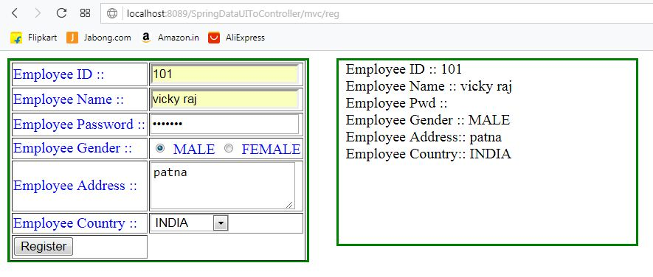

**Example Of Sending Data Form UI To Controller Using Java Config:**

**Setup**

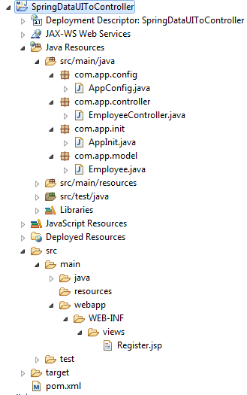

1. **pom.xml**

Same as above XML Example

1. **Employee.java**

Same as above XML Example

1. **EmployeeController.java**

Same as above XML Example

1. **AppConfig.java**

**package** com.app.config;

**import** org.springframework.context.annotation.Bean;

**import** org.springframework.context.annotation.ComponentScan;

**import**org.springframework.context.annotation.Configuration;

**import** org.springframework.web.servlet.config.annotation.EnableWebMvc;

**import** org.springframework.web.servlet.view.InternalResourceViewResolver;

@EnableWebMvc

@Configuration

@ComponentScan(basePackages = "com.app")

**publicclass** AppConfig {

@Bean

**public** InternalResourceViewResolver ivr() {

InternalResourceViewResolver ivr =

**new** InternalResourceViewResolver();

ivr.setPrefix("/WEB-INF/views/");

ivr.setSuffix(".jsp");

**return**ivr;

}

}

1. **AppInit.java**

**package** com.app.init;

**import** org.springframework.web.servlet.support.AbstractAnnotationConfigDispatcherServletInitializer;

**import** com.app.config.AppConfig;

**publicclass** AppInit **extends** AbstractAnnotationConfigDispatcherServletInitializer{

@Override

**protected** Class<?>[] getRootConfigClasses() {

**returnnew** Class[] {AppConfig.**class**};

}

@Override

**protected** Class<?>[] getServletConfigClasses() {

**returnnull**;

}

@Override

**protected** String[] getServletMappings() {

**returnnew** String[] {"/mvc/*"};

}

}

1. **Register.jsp**

Same as above XML Example

1. **Query Parameter (Request Parameters)**

Html form is used to send large data (multiple value) to send few values (Just like one or two inputs) use query parameters concept given by servlets API also supported by spring web mvc framework.

* Data will be sent along with URL in key = value format.
* Here both (key , value) are String type by default.
* This data is given as input as input to (request) method in controller.
* To read this syntax is:

**@RequstParam(“key”)DataType localVariableName;**

EX: URL Is:

[**http://localhost:8089/mvc/show?sid=20**](http://localhost:8089/mvc/show?sid=20)

* Equal servlet meaning is:

String sid = request.getParameter(“sid”)

Int id = Integer.parseInt(sid);

**Example:**

**Setup**

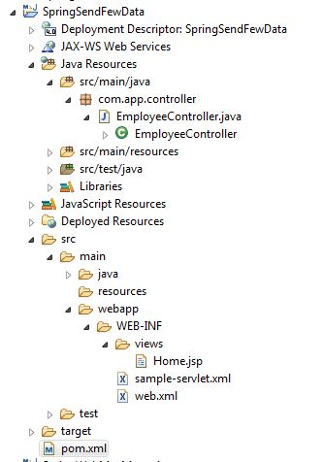

1. **pom.xml**

<projectxmlns=*"http://maven.apache.org/POM/4.0.0"*

xmlns:xsi=*"http://www.w3.org/2001/XMLSchema-instance"*

xsi:schemaLocation=*"http://maven.apache.org/POM/4.0.0 http://maven.apache.org/maven-v4_0_0.xsd"*>

<modelVersion>4.0.0</modelVersion>

<groupId>org.sathyatech</groupId>

<artifactId>SpringSendFewData</artifactId>

<packaging>war</packaging>

<version>0.0.1-SNAPSHOT</version>

<name>SpringSendFewData MavenWebapp</name>

<url>http://maven.apache.org</url>

<dependencies>

<dependency>

<groupId>org.springframework</groupId>

<artifactId>spring-webmvc</artifactId>

<version>5.0.3.RELEASE</version>

</dependency>

</dependencies>

<build>

<plugins>

<plugin> <groupId>org.apache.maven.plugins</groupId>

<artifactId>maven-compiler-plugin</artifactId>

<version>3.7.0</version>

<configuration>

<source>1.8</source>

<target>1.8</target>

</configuration>

</plugin>

<plugin>

<artifactId>maven-war-plugin</artifactId>

<version>2.4</version>

<configuration> <failOnMissingWebXml>false</failOnMissingWebXml>

</configuration>

</plugin>

</plugins>

</build>

</project>

1. **web.xml**

<!DOCTYPEweb-appPUBLIC

"-//Sun Microsystems, Inc.//DTD Web Application 2.3//EN"

"http://java.sun.com/dtd/web-app_2_3.dtd">

<web-app>

<servlet>

<servlet-name>sample</servlet-name>

<servlet-class>

org.springframework.web.servlet.DispatcherServlet

</servlet-class>

</servlet>

<servlet-mapping>

<servlet-name>sample</servlet-name>

<url-pattern>/mvc/*</url-pattern>

</servlet-mapping>

</web-app>

1. **sample-servlet.xml**

<?xmlversion=*"1.0"*encoding=*"UTF-8"*?>

<beansxmlns=*"http://www.springframework.org/schema/beans"*

xmlns:p=*"http://www.springframework.org/schema/p"*

xmlns:context=*"http://www.springframework.org/schema/context"*

xmlns:xsi=*"http://www.w3.org/2001/XMLSchema-instance"*

xsi:schemaLocation=*"*

*http://www.springframework.org/schema/beans*

*http://www.springframework.org/schema/beans/spring-beans.xsd*

*http://www.springframework.org/schema/context*

*http://www.springframework.org/schema/context/spring-context.xsd*

*"*>

<!-- Activation of annotation -->

<context:component-scanbase-package=*"com.app"*/>

<!-- View Resolver -->

<beanclass=*"org.springframework.web.servlet.view.InternalResourceViewResolver"*

p:prefix=*"/WEB-INF/views/"*

p:suffix=*".jsp"*/>

</beans>

1. **Home.jsp**

<%@pagelanguage=*"java"*isELIgnored=*"false"* contentType=*"text/html; charset=ISO-8859-1"*

pageEncoding=*"ISO-8859-1"*%>

<!DOCTYPEhtmlPUBLIC"-//W3C//DTD HTML 4.01 Transitional//EN""http://www.w3.org/TR/html4/loose.dtd">

<html>

<head>

<metahttp-equiv=*"Content-Type"*content=*"text/html; charset=ISO-8859-1"*>

<title>Insert title here</title>

</head>

<body>

<h1>${data }</h1>

</body>

</html>

**Special concept in request param for String DataType**

Case#1.

If key is not present in URL , then FC throws HTTP status – 400 Bad request with message required String parameter ‘sname’ is not present in URL.

**Syntax is:**

**@RequestParam(“key”)DataType localVarName**

Case#2

Making key as optional in code. If no key = value is provided in URL to avoid error and have default value as ‘null’

**Syntax is:**

**@RequestParam(name = “key” , required = false)DataType localVarName**

**Code is:**

**@RequestParam(name = “sname” , required = false)String sn**

Case#3

When key is optional , we can change default value null to other value

**Syntax is:**

**@RequestParam(name = “key” , required = false , defaultValue = “value”) DataType localVariableName**

**Example:**

**@RequestParam(name = “sname”, required = false , defaultValue = “No Value “) String sn**

* If URL contains no key ‘sname’ then value printed is : No Value.
* If value data is not matched with data type in code then FC throws Http Status 400-Bad request.

Ex:

<http://localhost:8089/show?sid=AA>

Code:

@RequestParam(“sid”)int sn

Here AA can not be converted to int type.

* Non-String DataType (int) if we make it as optional.

Code like

@RequestParam(name = “sid” , required = false)int sn

If key is not present then default value null is assigned to sid which can not be converted to int type.

So FC throws **Http-Status 500 internal server error**

**Sol1:**

Change DataType int to Integer(primitive to wrapper).

**Code is:**

**@RequestParam(name = “sid” , required = false)Integer sn**

**Sol2:**

Change default value from null to any other int value.

**@RequestParam(name = “sid” , required = false ,**

**defaultValue = “5”)int sn**

* If same key provided with different value in URL , FC considers this is a problem it throws error as:

**Http status 400-bad request**

ModelAndView

* It is a shared memory between controller and UI (view) pages.
* It must be used as method return type in controller.
* It creates two memory parts those are view (controller) and models.
* Same times , controller is not sharing data with view , in this case also memory will be allocated to model even not used by application [memory wasted].
* To avoid this performance degrade use new concept like.

1. ModelMap for model.
2. String for view name

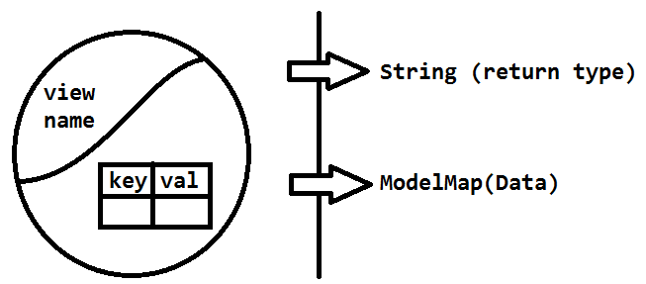

**Ex for old and new formats**

* Consider below controller method with using ModelAndView and without using ModelAndView.
* Here new format are faster compared to ModelAndView

***Case#1 No Data***

***Old: Using ModelAndView***

@RequestMapping(“/show”)

public ModelAndView showPage(){

ModelAndView mav = new ModelAndView();

mva.setViewName(“Home”);

return mav;

***New: Using String for view name***

@RequestMapping(“/show”)

public String showPage(){

peturn “Home”;

}

***Case#2 Sending Data***

***Old: Using ModelAndView***

@RequestMapping(“/show”)

public ModelAndView showPage(){

ModelAndView mav = new ModelAndView();

mav.setViewName(“Home”);

mav.addObject(“eid” , 10);

return mav;

}

***New: Using String view name and model map for data***

@RequestMapping(“/show”)

public String showPage(ModelMap map){

map.addAttribure(“eid” , 10);

return map;

}

**ExampleCode**

**Setup**

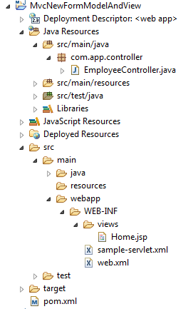

1. **pom.xml**

<projectxmlns=*"http://maven.apache.org/POM/4.0.0"*

xmlns:xsi=*"http://www.w3.org/2001/XMLSchema-instance"*

xsi:schemaLocation=*"http://maven.apache.org/POM/4.0.0 http://maven.apache.org/maven-v4_0_0.xsd"*>

<modelVersion>4.0.0</modelVersion>

<groupId>org.sathyatech</groupId>

<artifactId>MvcNewFormModelAndView</artifactId>

<packaging>war</packaging>

<version>1.1</version>

<name>MvcNewFormModelAndView MavenWebapp</name>

<url>http://maven.apache.org</url>

<dependencies>

<dependency>

<groupId>org.springframework</groupId>

<artifactId>spring-webmvc</artifactId>

<version>5.0.3.RELEASE</version>

</dependency>

</dependencies>

<build>

<plugins>

<plugin>

<groupId>org.apache.maven.plugins</groupId>

<artifactId>maven-compiler-plugin</artifactId>

<version>3.7.0</version>

<configuration>

<source>1.8</source>

<target>1.8</target>

</configuration>

</plugin>

<plugin>

<artifactId>maven-war-plugin</artifactId>

<version>2.4</version>

<configuration>

<failOnMissingWebXml>false</failOnMissingWebXml>

</configuration>

</plugin>

</plugins>

</build>

</project>

1. **web.xml**

<!DOCTYPEweb-appPUBLIC

"-//Sun Microsystems, Inc.//DTD Web Application 2.3//EN"

"http://java.sun.com/dtd/web-app_2_3.dtd">

<web-app>

<servlet>

<servlet-name>sample</servlet-name>

<servlet-class>

org.springframework.web.servlet.DispatcherServlet

</servlet-class>

</servlet>

<servlet-mapping>

<servlet-name>sample</servlet-name>

<url-pattern>/mvc/*</url-pattern>

</servlet-mapping>

</web-app>

1. **sample-servlet.xml**

<?xmlversion=*"1.0"*encoding=*"UTF-8"*?>

<beans

xmlns=[*http://www.springframework.org/schema/beans*](http://www.springframework.org/schema/beans)

xmlns:p=*"http://www.springframework.org/schema/p"*

xmlns:context=*"http://www.springframework.org/schema/context"*

xmlns:xsi=*"http://www.w3.org/2001/XMLSchema-instance"*

xsi:schemaLocation=*"*

*http://www.springframework.org/schema/beans*

*http://www.springframework.org/schema/beans/spring-beans.xsd*

*http://www.springframework.org/schema/context http://www.springframework.org/schema/context/spring-context.xsd*

*"*>

<!-- Activation of annotation -->

<context:component-scanbase-package=*"com.app"*/>

<!-- View Resolver -->

<beanclass=*"org.springframework.web.servlet.view.InternalResourceViewResolver"*

p:prefix=*"/WEB-INF/views/"*

p:suffix=*".jsp"*/>

</beans>

1. **EmployeeController.java**

**package** com.app.controller;

**import** org.springframework.stereotype.Controller;

**import** org.springframework.ui.ModelMap;

**import** org.springframework.web.bind.annotation.RequestMapping;

@Controller

**publicclass** EmployeeController {

@RequestMapping("/show")

**public**String showPage(ModelMap map) {

map.addAttribute("data" , "Hello");

**return**"Home";

}

}

1. **Home.jsp**

<%@pagelanguage=*"java"*isELIgnored=*"false"* contentType=*"text/html; charset=ISO-8859-1"*

pageEncoding=*"ISO-8859-1"*%>

<!DOCTYPEhtmlPUBLIC"-//W3C//DTD HTML 4.01 Transitional//EN""http://www.w3.org/TR/html4/loose.dtd">

<html>

<head>

<metahttp-equiv=*"Content-Type"*content=*"text/html; charset=ISO-8859-1"*>

<title>Insert title here</title>

</head>

<body>

<h1>${data }</h1>

</body>

</html>

**Spring tag library**

**Tag Library**

Writing java code in tag format , which makes easy to apply css/javascript/.. any UI Technology

**JSTL (Jsp Standard Tag Library)**

Spring tag library provide below concept.

1. **Form Binding**

Spring form can be converted to model class object and even model class object can be converted to spring form.

**Spring Form <=> Model Object

**HTML Form => Model Object

1. **Validation Binding**

STL support server sid validations on Model Object those will be auto-bound to UI component.

1. **Mult-Language Support: (II8n =Internationalization)**

Write application in one display output in multiple language (Hindi , Tamil , Kannada , Telgu…).

1. **Dynamic Input Compnent.**

STL support List<java.util> will be converted to dynamic drop dow | radio buttons | checkbox

Spring Form Tags Components and their equal HTML code.

1. **Creating form**

***HTML***

<form action = “ ” method = “ “></form>

***STL***

*<form:from action = “ “ method = “ “ modelAttribute = “ “></form>*

1. **Text Input**

***HTML***

<input type = “text” name = “empId” id = “empId”/>

***STL***

<form:input path = “empId”/>

1. **Password Input**

***HTML***

<input type = “password” name = “empPwd” id = “empId” />

**STL**

<form:password path = “empPwd”/>

1. **Radio Button Input**

***HTML***

<input type = “radio” name = “empGen” id = “empGen”/>

***STL***

<form:radioButton path = “empGen”/>

1. **Text Area Input**

***Html***

<textarea name = “addr” id =”addr”></textarea>

***STL***

<from: textarea path = “addr”/>

1. **Checkbox Input**

***HTML***

<input type = “checkbox” name = “lang” id = “lang” />

***STL***

<form: checkbox path = “lang”/>

1. **Dropdown Input**

***HTML***

<select name = “country”>

<option value = “IND”>IND </option>

<option value = “Aus”>AUS </option>

</select>

***STL***

<form:select name = “country>

<form:option value = “IN”>IND </form:option>

<form:option value = “US”>US</form:option>

</form:select>

1. **Hidden Input**

***HTML***

<input type = “hidden” name = “eid” id = “eid”/>

***STL***

<from:hidden path = “eid”/>

* Submit button are same as HTML Code.

**Spring Validation API**

Spring has provided “form validation API” to validate input modelAttriburte [form data].

* On model validation , Spring returns errors class object with all list of errors. To check errors. To check errors are exist or not use method hasError() : bollean type
* Validator class must be defined by programmer and link with controller.
* Controller should provide modelAttribute as input to validate class, here validator class returns error object to controller object.

**UML DESING FOR VALIDATOR**

* Spring has provided one predefine interface Validation(I)[ given in package: org.springFramework.validation ]
* Programmer should implement this interface and define one implementations class which returns finally Error object.
* Create has a between Controller and Validation, given as

EmployeeController Has-A EmployeeValidation

* Display error at UI using tag

<form:error path=”key”/ >

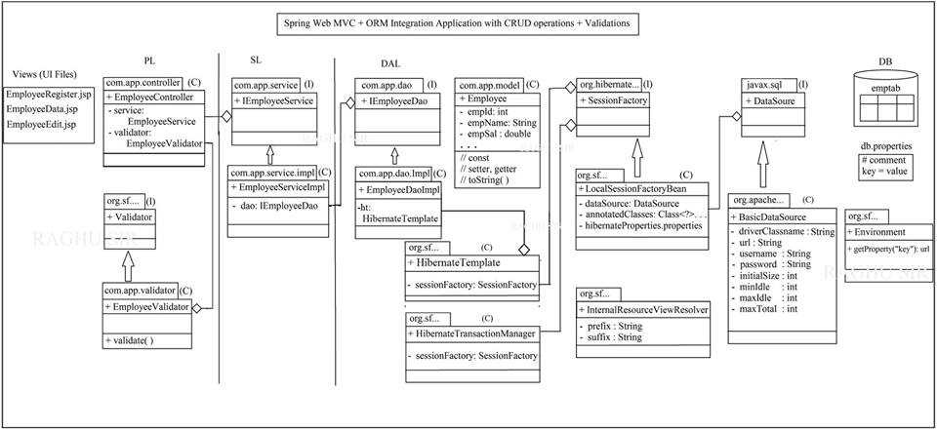

**Pattern API:**

It is a (core) java API to validate input String (data) matched with given pattern [Regular Expression] or not? If matched true else false.

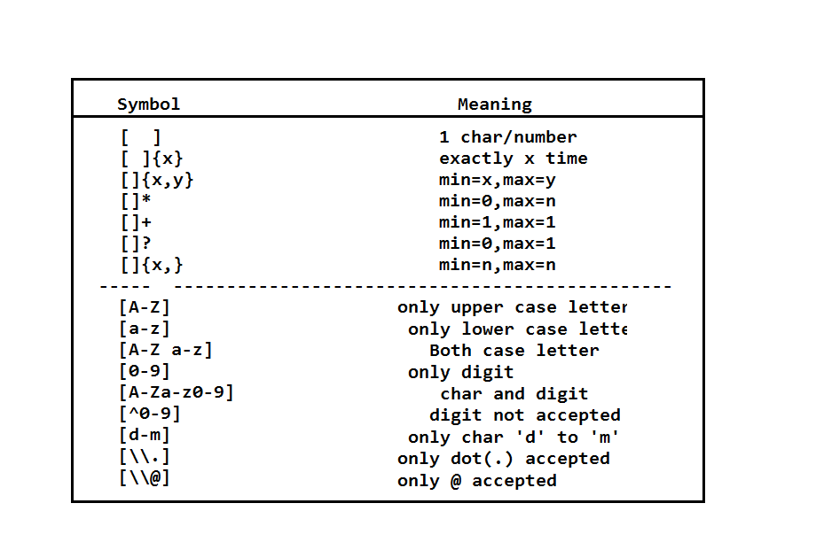

1. **Accept only 3 upper case chars.**

Expression#1 [A-Z][A-z][A-Z]

Expression#2 [A-Z]{3}

Expression#3 [A-Z][A-Z]{2}

1. **Accepts uppercase chars min = 4 , max = 25.**

Excpression# [A-Z]{4 , 25}

1. **Start with uppercase char , letter both case accepted , min 4 and max = 25.**

Expression# [A-Z][A-Z a-z]{3 , 24}

1. **Start with uppercase , ends with digit min =4 , max = 10**

**Middle any character or digit**

Expression# [A-Z][A-Z a-z o-9]{2 , 8}{0-9}

1. **Accept exactly 10 digits only.**

Expression# [0-9]{10}

1. **Starts with 1 to 9 letter any digit min = max = 10.**

Expression# [1-9][0-9]{9}

**Locale (Multi-language) Concept in java:**

It is also called as Internationalization [I18n] i.e. showing java application output in multiple languages

* For every symbol in word has been assigned with one unique number is called as Unicode system.
* It is a hexa-decimal number example

\u0905 = aa

\U0co5 = telgu symbol

* Go to google.com
* Type “hindi Unicode pdf”
* Click on first link

1. Replace all static message (hard coded message) in jsp , controller and validation using their respected keys which are placed in .properties file in jsp.

<spring : message code = “key”/>

To get this add spring tag library:

[%@taglib prefix = “spirng” uri = “http://www.springframework.org/tags”%](mailto:%25@taglib%20prefix%20=%20)

**In Validator:**

Provide key for message read and remove default message

1. Errors.rejectValue(“variable” , “key”)
2. ValidationUtils.rejectIfEmptyOnWhiteSpace(errors , “variable” , “key”)

**In Controller:**

Make controller class HAS-A with MessageResource(Spring F/W) and use locale as method parameter then code is :

@Controller

Public class _____Controller{

@Autowired

Private MessageSource message;

Public String method (___ , Locale locale){

String m = message.getMessage(“key” , Object[] , locale);

}

}

**One Time Setup Code is:**

1. **MessageSource obj:**

It indicates properties file details i.e. baseName for all properties file and encoding type (UTF-8 = Unicode)

1. **LocaleResolver:**

It is used to store language code is system (browser side : Cookie: server side : Session)

1. **HandlerIntercepter:**

On change language code (made by request ) “reloaded new properties file “

1. **Adding Interceptor to AppConfig:**

Register interceptor details with java config file

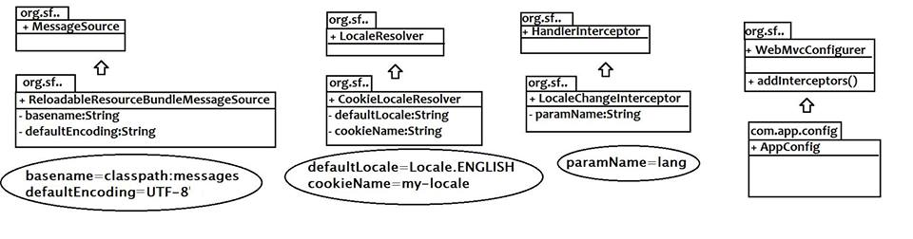

**CODE:**

**Setup**

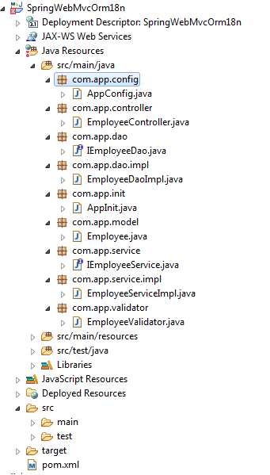

1. **Model Class (Employee.java)**

**package**com.app.model;

**import** java.util.List;

**import**javax.persistence.CollectionTable;

**import**javax.persistence.Column;

**import**javax.persistence.ElementCollection;

**import**javax.persistence.Entity;

**import**javax.persistence.GeneratedValue;

**import**javax.persistence.Id;

**import**javax.persistence.JoinColumn;

**import**javax.persistence.OrderColumn;

**import**javax.persistence.Table;

**import**org.hibernate.annotations.GenericGenerator;

@Entity

@Table(name="emptab")

**publicclass** Employee {

@Id

@Column(name="eid")

@GeneratedValue(generator="mygen")

@GenericGenerator(name="mygen",strategy="increment")

**private** Integer empId;

@Column(name="ename")

**private** String empName;

@Column(name="epwd")

**private** String empPwd;

@Column(name="egen")

**private** String empGen;

@Column(name="addr")

**private** String empAddr;

@Column(name="cntry")

**private** String empCntry;

@ElementCollection

@CollectionTable(name="emplangtab", //table name

joinColumns=@JoinColumn(name="eid") //key column

)

@OrderColumn(name="pos") //index column

@Column(name="lang") //element column

**private** List<String>empLang;

**public** Employee() {

**super**();

}

**public** Employee(Integer empId) {

**super**();

**this**.empId = empId;

}

**public** Integer getEmpId() {

**return**empId;

}

**publicvoid** setEmpId(Integer empId) {

**this**.empId = empId;

}

**public** String getEmpName() {

**return**empName;

}

**publicvoid** setEmpName(String empName) {

**this**.empName = empName;

}

**public** String getEmpPwd() {

**return**empPwd;

}

**publicvoid** setEmpPwd(String empPwd) {

**this**.empPwd = empPwd;

}

**public** String getEmpGen() {

**return**empGen;

}

**publicvoid** setEmpGen(String empGen) {

**this**.empGen = empGen;

}

**public** String getEmpAddr() {

**return**empAddr;

}

**publicvoid** setEmpAddr(String empAddr) {

**this**.empAddr = empAddr;

}

**public** String getEmpCntry() {

**return**empCntry;

}

**publicvoid** setEmpCntry(String empCntry) {

**this**.empCntry = empCntry;

}

**public** List<String> getEmpLang() {

**return**empLang;

}

**publicvoid** setEmpLang(List<String>empLang) {

**this**.empLang = empLang;

}

@Override

**public** String toString() {

**return**"Employee [empId=" + empId + ", empName=" + empName + ", empPwd=" + empPwd + ", empGen=" + empGen

+ ", empAddr=" + empAddr + ", empCntry=" + empCntry + ", empLang=" + empLang + "]";

}

}

1. **IEmployeeDao**

**package**com.app.dao;

**import** java.util.List;

**import**com.app.model.Employee;

**publicinterface** IEmployeeDao {

**publicint** saveEmployee(Employeeemp);

**publicvoid** updateEmployee(Employeeemp);

**publicvoid** deleteEmployee(**int**empId);

**public**Employee getEmployeeById(**int**empId);

**public** List<Employee> getAllEmployees();

}

1. **EmployeeDaoImpl.java**

**package**com.app.dao.impl;

**import** java.util.List;

**import** org.springframework.beans.factory.annotation.Autowired;

**import**org.springframework.orm.hibernate5.HibernateTemplate;

**import** org.springframework.stereotype.Repository;

**import**com.app.dao.IEmployeeDao;

**import**com.app.model.Employee;

@Repository

**publicclass** EmployeeDaoImpl **implements**IEmployeeDao {

@Autowired

**private**HibernateTemplateht;

@Override

**publicint** saveEmployee(Employeeemp) {

**return** (Integer)ht.save(emp);

}

@Override

**publicvoid** updateEmployee(Employeeemp) {

ht.update(emp);

}

@Override

**publicvoid**deleteEmployee(**int**empId) {

ht.delete(**new**Employee(empId));

}

@Override

**public**EmployeegetEmployeeById(**int**empId) {

**return**ht.get(Employee.**class**, empId);

}

@Override

**public** List<Employee>getAllEmployees() {

**return**ht.loadAll(Employee.**class**);

}

}

1. **IEmployeeService.java**

**package**com.app.service;

**import** java.util.List;

**import**com.app.model.Employee;

**publicinterface** IEmployeeService {

**publicint** saveEmployee(Employeeemp);

**publicvoid** updateEmployee(Employeeemp);

**publicvoid** deleteEmployee(**int**empId);

**public**Employee getEmployeeById(**int**empId);

**public** List<Employee> getAllEmployees();

}

1. **EmployeeServiceImpl**

**package**com.app.service.impl;

**import** java.util.List;

**import** org.springframework.beans.factory.annotation.Autowired;

**import** org.springframework.stereotype.Service;

**import**org.springframework.transaction.annotation.Transactional;

**import**com.app.dao.IEmployeeDao;

**import**com.app.model.Employee;

**import**com.app.service.IEmployeeService;

@Service

**publicclass** EmployeeServiceImpl **implements**IEmployeeService {

@Autowired

**private**IEmployeeDaodao;

@Transactional

**publicint** saveEmployee(Employeeemp) {

**return**dao.saveEmployee(emp);

}

@Transactional

**publicvoid** updateEmployee(Employeeemp) {

dao.updateEmployee(emp);

}

@Transactional

**publicvoid** deleteEmployee(**int**empId) {

dao.deleteEmployee(empId);

}

@Transactional(readOnly=**true**)

**public**Employee getEmployeeById(**int**empId) {

**return**dao.getEmployeeById(empId);

}

@Transactional(readOnly=**true**)

**public** List<Employee> getAllEmployees() {

**return**dao.getAllEmployees();

}

}

1. **AppInit.java**

**package**com.app.init;

**import** org.springframework.web.servlet.support.AbstractAnnotationConfigDispatcherServletInitializer;

**import**com.app.config.AppConfig;

**publicclass** AppInit **extends** AbstractAnnotationConfigDispatcherServletInitializer{

@Override

**protected** Class<?>[] getRootConfigClasses() {

**returnnew** Class[] {AppConfig.**class**};

}

@Override

**protected** Class<?>[] getServletConfigClasses() {

**returnnull**;

}

@Override

**protected** String[] getServletMappings() {

**returnnew** String[] {"/"};

}

}

1. **AppConfig.java**

**package**com.app.config;

**import** java.util.Locale;

**import** java.util.Properties;

**import**org.apache.commons.dbcp2.BasicDataSource;

**import** org.springframework.beans.factory.annotation.Autowired;

**import** org.springframework.context.annotation.Bean;

**import** org.springframework.context.annotation.ComponentScan;

**import** org.springframework.context.annotation.Configuration;

**import** org.springframework.context.annotation.PropertySource;

**import** org.springframework.context.support.ReloadableResourceBundleMessageSource;

**import** org.springframework.core.env.Environment;

**import**org.springframework.orm.hibernate5.HibernateTemplate;

**import**org.springframework.orm.hibernate5.HibernateTransactionManager;

**import**org.springframework.orm.hibernate5.LocalSessionFactoryBean;

**import**org.springframework.transaction.annotation.EnableTransactionManagement;

**import** org.springframework.web.servlet.config.annotation.EnableWebMvc;

**import** org.springframework.web.servlet.config.annotation.InterceptorRegistry;

**import** org.springframework.web.servlet.config.annotation.WebMvcConfigurer;

**import** org.springframework.web.servlet.i18n.CookieLocaleResolver;

**import** org.springframework.web.servlet.i18n.LocaleChangeInterceptor;

**import** org.springframework.web.servlet.view.InternalResourceViewResolver;

**import**com.app.model.Employee;

@Configuration

@EnableWebMvc//MVC

@EnableTransactionManagement//Tx

@PropertySource("classpath:db.properties")

@ComponentScan(basePackages="com.app")

**publicclass** AppConfig **implements** WebMvcConfigurer {

//load properties

@Autowired

**private** Environment env;

//DataSource

@Bean

**public**BasicDataSource dsObj() {

BasicDataSourceds=**new**BasicDataSource();

ds.setDriverClassName(env.getProperty("dc"));

ds.setUrl(env.getProperty("url"));

ds.setUsername(env.getProperty("un"));

ds.setPassword(env.getProperty("pwd"));

ds.setInitialSize(1);

ds.setMaxIdle(10);

ds.setMinIdle(5);

ds.setMaxTotal(10);

**return**ds;

}

//SessionFactory

@Bean

**public**LocalSessionFactoryBean sfObj() {

LocalSessionFactoryBeansf=**new**LocalSessionFactoryBean();

sf.setDataSource(dsObj());

sf.setAnnotatedClasses(Employee.**class**);

sf.setHibernateProperties(props());

**return**sf;

}

**private** Properties props() {

Properties p=**new** Properties();

p.put("hibernate.dialect", env.getProperty("dialect"));

p.put("hibernate.show_sql", env.getProperty("showsql"));

p.put("hibernate.format_sql", env.getProperty("fmtsql"));

p.put("hibernate.hbm2ddl.auto", env.getProperty("ddlauto"));

**return**p;

}

//HT

@Bean

**public**HibernateTemplate htObj() {

HibernateTemplateht=**new**HibernateTemplate();

ht.setSessionFactory(sfObj().getObject());

**return**ht;

}

//Tx manager

@Bean

**public**HibernateTransactionManager httx() {

HibernateTransactionManagerhtm=**new**HibernateTransactionManager();

htm.setSessionFactory(sfObj().getObject());

**return**htm;

}

//view resolver

@Bean

**public** InternalResourceViewResolver ivr() {

InternalResourceViewResolver v=**new** InternalResourceViewResolver();

v.setPrefix("/WEB-INF/views/");

v.setSuffix(".jsp");

**return**v;

}

/**multi-language configuration**/

//1. Message Source : .properties file name and data storing

@Bean

**public** ReloadableResourceBundleMessageSource messageSource() {

ReloadableResourceBundleMessageSource r=**new** ReloadableResourceBundleMessageSource();

r.setBasename("classpath:messages");

r.setDefaultEncoding("UTF-8");

**return**r;

}

@Bean

**public** CookieLocaleResolver localeResolver() {

CookieLocaleResolver c=**new** CookieLocaleResolver();

c.setDefaultLocale(Locale.***ENGLISH***);

c.setCookieName("my-cke");

**return**c;

}

@Bean

**public** LocaleChangeInterceptor interceptor() {

LocaleChangeInterceptor l=**new** LocaleChangeInterceptor();

l.setParamName("lang");

**return**l;

}

@Override

**publicvoid** addInterceptors(InterceptorRegistry registry) {

registry.addInterceptor(interceptor());

}

}

1. **EmployeeController.java**

**package**com.app.controller;

**import** java.util.Locale;

**import** org.springframework.beans.factory.annotation.Autowired;

**import** org.springframework.context.MessageSource;

**import** org.springframework.stereotype.Controller;

**import** org.springframework.ui.ModelMap;

**import** org.springframework.validation.Errors;

**import** org.springframework.web.bind.annotation.ModelAttribute;

**import** org.springframework.web.bind.annotation.RequestMapping;

**import** org.springframework.web.bind.annotation.RequestMethod;

**import**com.app.model.Employee;

**import**com.app.service.IEmployeeService;

**import**com.app.validator.EmployeeValidator;

@Controller

**publicclass** EmployeeController {

@Autowired

**private**IEmployeeServiceservice;

@Autowired

**private**EmployeeValidatorvalidator;

@Autowired

**private** MessageSource message;

/* #1 Show EmployeeRegister JSP,

* when /reg is entered in browser

*/

@RequestMapping("/reg")

**public** String showRegPage(ModelMap map) {

map.addAttribute("employee", **new**Employee());

**return**"EmployeeRegister";

}

/**

* 2. On click submit read ModelAttribute

* validate, if no errors save else

* return to same page

*/

@RequestMapping(value="/insert",method=RequestMethod.***POST***)

//***read modelAttribute, next param must be Errors

**public** String saveEmp(@ModelAttribute("employee")Employeeemp,Errors errors,ModelMap map,Locale locale ) {

//check validation errors

validator.validate(emp, errors);

//if no errors

**if**(!errors.hasErrors()) {

//save data to DB

**int**empId=service.saveEmployee(emp);

//show success message

String msg=message.getMessage("success", **new** Object[] {empId}, locale);

map.addAttribute("message", msg);

//clear form

map.addAttribute("employee", **new**Employee());

}**else** {//if errors exist

String msg=message.getMessage("fail", **null**, locale);

map.addAttribute("message", msg);

}

//finally goto UI page

**return**"EmployeeRegister";

}

}

1. **EmployeeValidator.java**

**package**com.app.validator;

**import** java.util.regex.Pattern;

**import** org.springframework.stereotype.Component;

**import** org.springframework.validation.Errors;

**import** org.springframework.validation.ValidationUtils;

**import** org.springframework.validation.Validator;

**import**com.app.model.Employee;

@Component

**publicclass** EmployeeValidator **implements** Validator {

@Override

**publicboolean** supports(Class<?>clz) {

**return**Employee.**class**.equals(clz);

}

@Override

**publicvoid** validate(Object target, Errors errors) {

//data validations

Employeee=(Employee)target;

//name accept only 4-6 chars

**if**(!Pattern.*compile*("[A-Za-z]{4,6}").matcher(e.getEmpName()).matches()) {

errors.rejectValue("empName", "empNameErr" );

}

//pwd 2-6 upper or lower and digitis

**if**(!Pattern.*compile*("[A-Za-z0-9]{2,6}").matcher(e.getEmpPwd()).matches()) {

errors.rejectValue("empPwd", "empPwdErr");

}

//please choose one gender

ValidationUtils.*rejectIfEmptyOrWhitespace*(errors, "empGen", "empGenErr");

//enter address

ValidationUtils.*rejectIfEmptyOrWhitespace*(errors, "empAddr", "empAddErr");

//choose country

ValidationUtils.*rejectIfEmptyOrWhitespace*(errors, "empCntry", "empCntrErr");

//langs

**if**(e.getEmpLang()==**null** || e.getEmpLang().isEmpty()) {

errors.rejectValue("empLang", "empLangErr" );

}

}

}

**Properties File:**

1. **db.properties**

#Connection Properties

dc=com.mysql.jdbc.Driver

url=jdbc:mysql://localhost:3306/test

un=root

pwd=root

#Hibernate Properties

dialect=org.hibernate.dialect.MySQL5Dialect

showsql=true

fmtsql=true

ddlauto=create

1. **message_hi.properties**

title=\u0915\u0930\u094D\u092E\u091A\u093E\u0930\u0940\u0930\u091C\u093F\u0938\u094D\u091F\u0930\u092A\u0947\u091C\u092E\u0947\u0902\u0906\u092A\u0915\u093E\u0938\u094D\u0935\u093E\u0917\u0924\u0939\u0948

ename=\u0915\u0930\u094D\u092E\u091A\u093E\u0930\u0940\u0915\u093E\u0928\u093E\u092E

epwd=\u0915\u0930\u094D\u092E\u091A\u093E\u0930\u0940\u092A\u093E\u0938\u0935\u0930\u094D\u0921

egen=\u0915\u0930\u094D\u092E\u091A\u093E\u0930\u0940\u0932\u093F\u0902\u0917

eaddr=\u0915\u0930\u094D\u092E\u091A\u093E\u0930\u0940\u092A\u0924\u093E

ecntry=\u0915\u0930\u094D\u092E\u091A\u093E\u0930\u0940\u0926\u0947\u0936

elang=\u0915\u0930\u094D\u092E\u091A\u093E\u0930\u0940\u092D\u093E\u0937\u093E\u090F\u0902

empNameErr=\u0915\u0943\u092A\u092F\u093E\u092E\u093E\u0928\u094D\u092F\u0915\u0930\u094D\u092E\u091A\u093E\u0930\u0940\u0928\u093E\u092E\u0926\u0930\u094D\u091C\u0915\u0930\u0947\u0902

empPwdErr=\u0915\u0943\u092A\u092F\u093E\u092E\u093E\u0928\u094D\u092F\u0915\u0930\u094D\u092E\u091A\u093E\u0930\u0940\u092A\u093E\u0938\u0935\u0930\u094D\u0921\u0926\u0930\u094D\u091C\u0915\u0930\u0947\u0902

empGenErr=\u0915\u0943\u092A\u092F\u093E\u090F\u0915\u0935\u093F\u0915\u0932\u094D\u092A\u091A\u0941\u0928\u0947\u0902

empAddErr=\u0915\u0943\u092A\u092F\u093E\u092A\u0924\u093E\u0926\u0930\u094D\u091C\u0915\u0930\u0947\u0902

empCntrErr=\u0915\u0943\u092A\u092F\u093E\u090F\u0915\u0935\u093F\u0915\u0932\u094D\u092A\u091A\u0941\u0928\u0947\u0902

empLangErr=\u0915\u0943\u092A\u092F\u093E\u0915\u092E\u0938\u0947\u0915\u092E\u090F\u0915\u092D\u093E\u0937\u093E\u0915\u093E\u091A\u092F\u0928\u0915\u0930\u0947\u0902

success=\u0915\u0930\u094D\u092E\u091A\u093E\u0930\u0940**{0}**\u0938\u0939\u0947\u091C\u093E\u0917\u092F\u093E

fail=\u0915\u0943\u092A\u092F\u093E\u0938\u092D\u0940\u0924\u094D\u0930\u0941\u091F\u093F\u092F\u094B\u0902\u0915\u0940\u091C\u093E\u0902\u091A\u0915\u0930\u0947\u0902

1. **message_te.properties**

title=\u0C09\u0C26\u0C4D\u0C2F\u0C4B\u0C17\u0C41\u0C32\u0C28\u0C2E\u0C4B\u0C26\u0C41\u0C2A\u0C47\u0C1C\u0C40\u0C15\u0C3F\u0C38\u0C4D\u0C35\u0C3E\u0C17\u0C24\u0C02

ename=\u0C09\u0C26\u0C4D\u0C2F\u0C4B\u0C17\u0C3F\u0C2A\u0C47\u0C30\u0C41

epwd=\u0C09\u0C26\u0C4D\u0C2F\u0C4B\u0C17\u0C3F\u0C2A\u0C3E\u0C38\u0C4D\u0C35\u0C30\u0C4D\u0C21\u0C4D

egen=\u0C09\u0C26\u0C4D\u0C2F\u0C4B\u0C17\u0C3F\u0C32\u0C3F\u0C02\u0C17\u0C02

eaddr=\u0C09\u0C26\u0C4D\u0C2F\u0C4B\u0C17\u0C3F\u0C1A\u0C3F\u0C30\u0C41\u0C28\u0C3E\u0C2E\u0C3E

ecntry=\u0C09\u0C26\u0C4D\u0C2F\u0C4B\u0C17\u0C3F\u0C26\u0C47\u0C36\u0C02

elang=\u0C09\u0C26\u0C4D\u0C2F\u0C4B\u0C17\u0C3F\u0C2D\u0C3E\u0C37\u0C32\u0C41

empNameErr=\u0C1A\u0C46\u0C32\u0C4D\u0C32\u0C41\u0C2C\u0C3E\u0C1F\u0C41\u0C05\u0C2F\u0C4D\u0C2F\u0C47\u0C09\u0C26\u0C4D\u0C2F\u0C4B\u0C17\u0C3F\u0C2A\u0C47\u0C30\u0C41\u0C28\u0C41\u0C28\u0C2E\u0C4B\u0C26\u0C41\u0C1A\u0C47\u0C2F\u0C02\u0C21\u0C3F

empPwdErr=\u0C26\u0C2F\u0C1A\u0C47\u0C38\u0C3F\u0C1A\u0C46\u0C32\u0C4D\u0C32\u0C41\u0C2C\u0C3E\u0C1F\u0C41\u0C05\u0C2F\u0C4D\u0C2F\u0C47\u0C09\u0C26\u0C4D\u0C2F\u0C4B\u0C17\u0C41\u0C32\u0C2A\u0C3E\u0C38\u0C4D\u0C35\u0C30\u0C4D\u0C21\u0C4D\u0C28\u0C41\u0C28\u0C2E\u0C4B\u0C26\u0C41\u0C1A\u0C47\u0C2F\u0C02\u0C21\u0C3F

empGenErr=\u0C26\u0C2F\u0C1A\u0C47\u0C38\u0C3F\u0C12\u0C15\u0C0E\u0C02\u0C2A\u0C3F\u0C15\u0C28\u0C41\u0C0E\u0C02\u0C1A\u0C41\u0C15\u0C4B\u0C02\u0C21\u0C3F

empAddErr=\u0C26\u0C2F\u0C1A\u0C47\u0C38\u0C3F\u0C1A\u0C3F\u0C30\u0C41\u0C28\u0C3E\u0C2E\u0C3E\u0C28\u0C41\u0C28\u0C2E\u0C4B\u0C26\u0C41\u0C1A\u0C47\u0C2F\u0C02\u0C21\u0C3F

empCntrErr=\u0C26\u0C2F\u0C1A\u0C47\u0C38\u0C3F\u0C12\u0C15\u0C0E\u0C02\u0C2A\u0C3F\u0C15\u0C28\u0C41\u0C0E\u0C02\u0C1A\u0C41\u0C15\u0C4B\u0C02\u0C21\u0C3F

empLangErr=\u0C26\u0C2F\u0C1A\u0C47\u0C38\u0C3F\u0C15\u0C28\u0C40\u0C38\u0C02\u0C12\u0C15\u0C2D\u0C3E\u0C37\u0C28\u0C41\u0C0E\u0C02\u0C1A\u0C41\u0C15\u0C4B\u0C02\u0C21\u0C3F

success=Employee**{0}**saved

fail=PleaseCheckallErrors

1. **message.properties**

title=WelcometoEmployeeRegisterPage

ename=EmployeeName

epwd=EmployeePassword

egen=EmployeeGender

eaddr=EmployeeAddress

ecntry=EmployeeCountry

elang=EmployeeLanguages

empNameErr=PleaseEnterValidEmployeeName

empPwdErr=PleaseEnterValidEmployeePassword

empGenErr=Pleasechooseoneoption

empAddErr=PleaseEnterAddress

empCntrErr=PleaseChooseoneOption

empLangErr=PleasechooseatleastoneLanguage

success=\u0C09\u0C26\u0C4D\u0C2F\u0C4B\u0C17\u0C3F**{0}**\u0C38\u0C47\u0C35\u0C4D\u0C05\u0C2F\u0C4D\u0C2F\u0C3E\u0C30\u0C41

fail=\u0C26\u0C2F\u0C1A\u0C47\u0C38\u0C3F\u0C05\u0C28\u0C4D\u0C28\u0C3F\u0C32\u0C4B\u0C2A\u0C3E\u0C32\u0C28\u0C41\u0C24\u0C28\u0C3F\u0C16\u0C40\u0C1A\u0C47\u0C2F\u0C02\u0C21\u0C3F

**JSP PAGE**

**(EmployeeRegister.jsp)**

<%@pagelanguage=*"java"*contentType=*"text/html; charset=UTF-8"*

pageEncoding=*"UTF-8"*%>

<%@taglibprefix=*"form"*uri=*"http://www.springframework.org/tags/form"*%>

<%@taglibprefix=*"spring"*uri=*"http://www.springframework.org/tags"*%>

<html>

<head>

<title>Insert title here</title>

<styletype=*"text/css"*>

*.errors* {

color: *red*;

}

</style>

</head>

<body>

<ahref=*"?lang=en"*>ENGLISH</a>

<ahref=*"?lang=hi"*>HINDI</a>

<ahref=*"?lang=te"*>TELUGU</a>

<ahref=*"?lang=kn"*>KANNADA</a>

<h2><spring:messagecode=*"title"*/></h2>

<form:formaction=*"insert"*method=*"post"*modelAttribute=*"employee"*>

<pre>

<spring:messagecode=*"ename"*/> : <form:inputpath=*"empName"*/>

<form:errorspath=*"empName"*cssClass=*"errors"*/>

<spring:messagecode=*"epwd"*/> : <form:passwordpath=*"empPwd"*/>

<form:errorspath=*"empPwd"*cssClass=*"errors"*/>

<spring:messagecode=*"egen"*/> : <form:radiobuttonpath=*"empGen"*value=*"Male"*/> Male <form:radiobuttonpath=*"empGen"*value=*"Female"*/> Female

<form:errorspath=*"empGen"*cssClass=*"errors"*/>

<spring:messagecode=*"eaddr"*/> : <form:textareapath=*"empAddr"*/>

<form:errorspath=*"empAddr"*cssClass=*"errors"*/>

<spring:messagecode=*"ecntry"*/> : <form:selectpath=*"empCntry"*>

<form:optionvalue=*""*>-SELECT-</form:option>

<form:optionvalue=*"IND"*>IND</form:option>

<form:optionvalue=*"AUS"*>AUS</form:option>

<form:optionvalue=*"DNR"*>DNR</form:option>

</form:select>

<form:errorspath=*"empCntry"*cssClass=*"errors"*/>

<spring:messagecode=*"elang"*/>:

<form:checkboxpath=*"empLang"*value=*"ENG"*/> ENG

<form:checkboxpath=*"empLang"*value=*"HIN"*/> HIN

<form:checkboxpath=*"empLang"*value=*"TEL"*/> TEL

<form:checkboxpath=*"empLang"*value=*"TAM"*/> TAM

<form:errorspath=*"empLang"*cssClass=*"errors"*/>

<inputtype=*"submit"*value=*"Register"*/>

</pre>

</form:form>

${message}

</body>

</html>

**CHAPTER ## 5. SPRING EMAIL**

* Spring Email API has been created by Spring Framework using java-mail API and POJI-POJO Design Pattern.
* Spring Email API is a simplified email service which can be implemented and integrated with any spring application easily.
* By using Java mail API (given by Sun MicroSystem) coding and setup is lengthy, it is simplified with POJI-POJO given below :

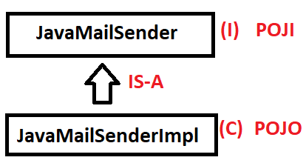

* Spring Email API supports MIME Type Email Sending (Multipurpose Internet Mail Extension). It means “Any kind of file as attachment”,

**EX**: Video, Audio, Text, Document, Images etc…

I.e shown as :

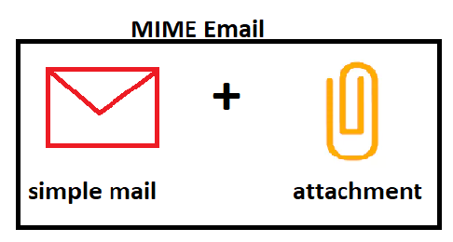

* Spring Email API also provided one Helper class **“MIMEMessageHelper”**tocreate message(writing code) in less lines of code.
* To provide attachment details use MultiPartFile Concept SystemResource.

**(EX: FileSystemResource).**

**SPRING EMAIL DESIGN:**

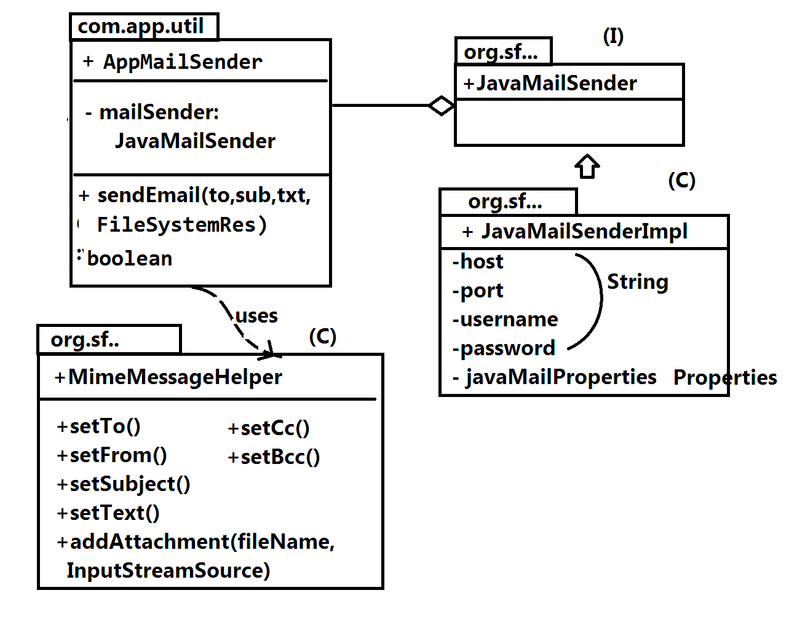

**# STEP TO CREATE SPRING EMAIL PROJECT IN ECLIPSE OR STS:-**

**Step#1:**create simple maven project

> File >new > Maven Project > click on checkbox

[v] create simple project (skip archtype……)

> next button > enter details like:

groupId : org.sathyatech

artifectId : Spring5EmailApp

version : 1.0

> Finish

**Step#2:**Add <dependencies> and build plugins in pom.xml

<dependency>

<groupId>org.springframework</groupId>

<artifectId>spring-context</artifectId>

<version>5.0.6.RELEASE</version>

</dependency>

<dependency>

<groupId>org.springframework</groupId>

<artifectId>spring-context-support</artifectId>

<version>5.0.6.RELEASE</version>

</dependency>

<dependency>

<groupId>javax.mail</groupId>

<artifectId>mail</artifectId>

<version>1.4</version>

</dependency>

**Step#3:** Update Maven Project

>Right click on Project > Maven

>Update Project (or alt + F5)

**EXAMPLE PROGRAM:-**

**FOLDER SYSTEM STRUCTURE:-**

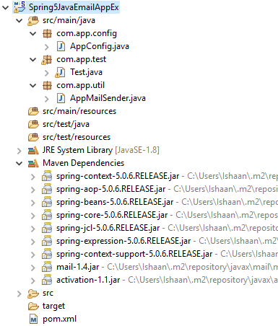

**CODE:**

1. **Spring Java Configuration File:-**

**package com.app.config;**

**import java.util.Properties;**

**import org.springframework.context.annotation.Bean;**

**import org.springframework.context.annotation.ComponentScan;**

**import org.springframework.context.annotation.Configuration;**

**import org.springframework.mail.javamail.JavaMailSenderImpl;**

**@Configuration**

**@ComponentScan(basePackages="com.app")**

**publicclass AppConfig {**

**//JavaMail Sender Impl**

**@Bean**

**public JavaMailSenderImpl mail() {**

**JavaMailSenderImpl mail = new JavaMailSenderImpl();**

**mail.setHost("smtp.gmail.com");**

**mail.setPort(587);**

**mail.setUsername("abc@gamil.com");//enter your**

**emailId.**

**mail.setPassword("12345");//enter ur password.**

**mail.setJavaMailProperties(props());**

**returnmail;**

**}**

**private Properties props() {**

**Properties p = new Properties();**

**p.put("mail.smtp.auth", "true");**

**p.put("mail.smtp.starttls.enable", "true");**

**returnp;**

**}**

**}**

1. **Mail Sender Util Class:-**

**package com.app.util;**

**import javax.mail.internet.MimeMessage;**

**import org.springframework.beans.factory.annotation.Autowired;**

**import org.springframework.core.io.FileSystemResource;**

**import org.springframework.mail.javamail.JavaMailSender;**

**import org.springframework.mail.javamail.MimeMessageHelper;**

**import org.springframework.stereotype.Component;**

**@Component**

**publicclass AppMailSender {**

**@Autowired**

**private JavaMailSender mailsender;**

**publicboolean sendEmail(String to, String sub, String text, FileSystemResource file) {**

**booleanstatus = false;**

**try {**

**// 1. Create Message Object**

**MimeMessage message = mailsender.createMimeMessage();**

**// 2. Create helper class Object**

**MimeMessageHelper helper = new MimeMessageHelper(message, file!=null?true:false);**

**// 3. Compose Message**

**helper.setTo(to);**

**helper.setFrom("abc@gamil.com");**

**helper.setSubject(sub);**

**helper.setText(text);**

**helper.addAttachment(file.getFilename(), file);**

**// 4. Send Email**

**mailsender.send(message);**

**status=true;**

**}**

**catch (Exception e) {**

**status=false;**

**e.printStackTrace();**

**System.*out*.println(e);**

**}**

**returnstatus;**

**}**

**}**

1. **Test Class:-**

**package com.app.test;**

**import org.springframework.context.ApplicationContext;**

**import org.springframework.context.annotation.AnnotationConfigApplicationContext;**

**import org.springframework.core.io.FileSystemResource;**

**import com.app.config.AppConfig;**

**import com.app.util.AppMailSender;**

**publicclass Test {**

**publicstaticvoid main(String[] args) {**

**//ApplicationContext ac = new ClassPathXmlApplicationContext(AppConfig.class);**

**ApplicationContext act = new AnnotationConfigApplicationContext(AppConfig.class);**

**AppMailSender mail = act.getBean("appMailSender", AppMailSender.class);**

**FileSystemResource file = new FileSystemResource("C:/Users/Ishaan/Desktop/ashu.jpg");**

**booleanflag = mail.sendEmail("ashuptn92@gmail.com", "Hello", "Welcome To Spring Email", file);**

**if(flag) {**

**System.*out*.println("Done!!!");**

**}else {**

**System.*out*.println("Sorry!!!!");**

**}**

**}**

**}**

1. **pom.xml:-**

**<projectxmlns=*"http://maven.apache.org/POM/4.0.0"*xmlns:xsi=*"http://www.w3.org/2001/XMLSchema-instance"*xsi:schemaLocation=*"http://maven.apache.org/POM/4.0.0 http://maven.apache.org/xsd/maven-4.0.0.xsd"*>**

**<modelVersion>4.0.0</modelVersion>**

**<groupId>org.sathyatech</groupId>**

**<artifactId>Spring5JavaEmailAppEx</artifactId>**

**<version>1.0</version>**

**<dependencies>**

**<dependency>**

**<groupId>org.springframework</groupId>**

**<artifactId>spring-context</artifactId>**

**<version>5.0.6.RELEASE</version>**

**</dependency>**

**<dependency>**

**<groupId>org.springframework</groupId>**

**<artifactId>spring-context-support</artifactId>**

**<version>5.0.6.RELEASE</version>**

**</dependency>**

**<dependency>**

**<groupId>javax.mail</groupId>**

**<artifactId>mail</artifactId>**

**<version>1.4</version>**

**</dependency>**

**</dependencies>**

**<build>**

**<plugins>**

**<plugin>**

**<groupId>org.apache.maven.plugins</groupId>**

**<artifactId>maven-compiler-plugin</artifactId>**

**<version>3.8.0</version>**

**<configuration>**

**<source>1.8</source>**

**<target>1.8</target>**

**</configuration>**

**</plugin>**

**</plugins>**

**</build>**

**</project>**

**OUTPUT:-**

**Successfully done….**

**NOTE:-**

* **Before running above application.**

1. **Disable your antivirus for few minutes.**
2. **Enable less secure App in your gmail account.**

* **Login to gmail account.**
* **Top right corner click on your name.**
* **Choose google account settings options.**
* **Click on “ sign in add security”.**
* **Scroll down and “ Enable Less Secure App : ON”**

**CHAPTER # 6 SPRING SCHEDULING**

**Spring Scheduler :**

To execute a task simultaneously by container(without user interaction) based on “Period of time” or ”Point of time ” scheduling are used.

Here period of time indicates hours/days and gap but not starting and ending hours or days and Point of time indicates start and end hours and days.

To do scheduling write one method (public, void, zero param) and apply annotation “@Scheduled” over method. Then this method will be called by container automatically.

To activate this process using

1. XML configuration: <task:@annotaion-driven>

[use task schema in <bean> tag]

1. Java configuration: @EnabledScheduling

[write in AppConfig class]

**Example:---**

Point of Time Period of time

12th JAN 3 days

11:00AM 6 hours

1:32:41PM 14 min

[Exact Date and Time] [Time gap]

**Example Code:-**

1. **fixedDelay:-**

It works based on period of time . Input must be milli seconds[1000mili sec = 1 sec]

On spring container startup, it will call method one , after completing method execution , container wait for give delay then calls one more time. This process is repeated until container is stopped.

Example:-

Consider above method takes 3 sec time to finish work then” time line” is shown below,

**(b)fixedRate:-**

We can write code is

@Scheduled(fixedRate=1000) over method then max waiting time including method execution time is 1sec.

If limit is crossed ,then once last method call is complete then next method call is made without any gap[gap time=0].

If method has taken less time then given fixedRate wait

time is =fixedRate-method execution time.

CRON:-

It is an expression used to specify “Point of Time” or “Period of Time”, provided by Unix Operating System and followed by spring scheduler also.

Formate is:-

**0-59 0-59 0- 23 1-31**  **1-12 SUN-SAT**

Sec min hrs day month weak

* * * * * * *

Possible symbol used in expression are:-

* = any Symbol

? =any day/week

* = range

,=Possible values

/= Period of time

Ex#1 0 0 9 * * *

>> Every day morning 9 AM

Ex#2 0 0 9,21 * * *

>> Every day morning 9:00am and 9:00pm

Ex#3 0 30 8-10 * * *

>> Every day morning 8:30 AM ,10:30

Ex#4 0 0/15 16 * * *

>> Every day 4:00PM, with 15 gaps

4:15:00 pm 4:30:00pm, 4:45:00 (only)

Ex#5 15 * * * * *

>> every minute 15 sec only

>> like 9:10:15, next 9:11:15

Ex#6 */15 * * *

>> like 9:10:15, next 9:10:30>9:10:45

Ex#7 0 * 6,7 * * *

>> invalid expression

Ex#8 0 0 9 19 *

>>Sep(9th month) 1st - 9:00:00am

Ex#9 59 59 23 31 12 ?

>> 31 DEC mid-night 11:59:59PM

Ex10 9 9 9 ? 6 ?

>> 6th month every day 09:09:09AM

Ex#11 0 0 6,19 * * *

>> 6:00AM and 7:00PM every day

Ex#12 0 0/30 8-10 * * *

>> 8:00, 8:30 , 9:00, 9:30, 10:00 and 10:30 every day

Ex#13 0 0 9-17 * * MON-FRI

>> on the hour nine-to-five week-days

**EXAMPLE PROGRAM:-**

**Folder Structure:-**

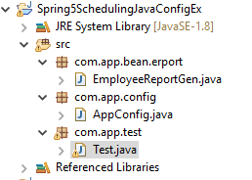

**-----------------------------------CODE------------------------------------**

1. **AppConfig.java**

**package com.app.config;**

**import org.springframework.context.annotation.ComponentScan;**

**import org.springframework.context.annotation.Configuration;**

**import org.springframework.scheduling.annotation.EnableScheduling;**

**@Configuration**

**@EnableScheduling**

**@ComponentScan(basePackages="com.app")**

**publicclass AppConfig {**

**}**

1. **EmployeeReportGen.java**

**package com.app.bean.erport;**

**import java.util.Date;**

**import org.springframework.scheduling.annotation.Scheduled;**

**import org.springframework.stereotype.Component;**

**@Component**

**publicclass EmployeeReportGen {**

**// 1000 milli Second = 1 Second**

**@Scheduled(fixedDelay=5000)**

**publicvoid genReport() {**

**System.*out*.println(new Date());**

**}**

**}**

1. **TestClass.java**

**package com.app.test;**

**import org.springframework.context.ApplicationContext;**

**import org.springframework.context.annotation.AnnotationConfigApplicationContext;**

**import com.app.config.AppConfig;**

**publicclass Test {**

**publicstaticvoid main(String[] args) {**

**ApplicationContext c = new AnnotationConfigApplicationContext(AppConfig.class);**

**}**

**}**

**# RUN TEST CLASS THEN OUTPUT IS:**

**Sun Oct 07 19:16:12 IST 2018**

**Sun Oct 07 19:16:17 IST 2018**

**Sun Oct 07 19:16:22 IST 2018**

**Sun Oct 07 19:16:27 IST 2018**

**.**

**.**

**.**

**CHAPTER # 7** **SPRING AOP**

**AOP (Aspect Oriented Programming):-**

* It is used for “Cross-cutting-concern ” . It means separate business logic and external services.
* External service must behave as plug-in-code, that is without modifying exited application, programmer, should able to add/remove external services Example are :- Log4j,UnitTest,security,JMS,Crytography,Encode and decode request/response ,filter management, request identity process, etc………………………..

**AOP Terms**

1. Aspect:- It is a class, which indicates external services logic.
2. Advice:- It is a method inside Aspect (class). It is also called as implementation of Aspect.
3. Pointcut: It is an expression which select the business class method to connect with advice. But it will not tell which advice it is
4. Joinpoint:- It is a combination of Advice and Pointcut expression . It means “joinpoint says which business class method need what and how many advice.
5. Target :- It is a pure business class object (before adding/without external services logic).
6. Weaving :- It is process done by weaver (sub component of spring container ).It will add advice logic to target based on join points.
7. Proxy:- It is a final output of weaving which contains business class logic and selected advices logic.

** ie Code linked at object level, not at class level.

**EXAMPLE DESIGN:-**

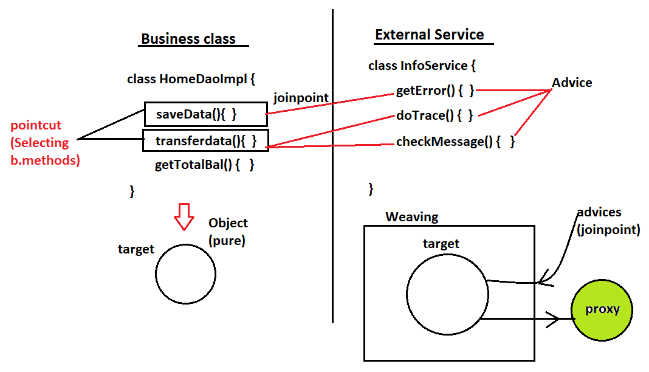

--------------**Types of Advices in AOP**--------------

Every method defined in Aspect class must have signed with one of below advice are;-----

1. Before Advice:- Execute advice before business method.

Execution order:

Advice- method ();

b. method (); // Business Method.

1. After Advice:- Execute advice before business method.

Execution order:

b. method ();

Advice- method ();

1. Around advice:- Advice first part is called before business method and second part of advice is called after business method line “Proceed” calls business method from advice.

Execution order:

Advice- method (); --1st part

b. method ();

Advice- method (); 2nd part

1. After Returning:- This is after advice type but it is only called on successful execution of b.method () only.

Execution order:-

b. method (); (if execution succesfully)

Advice- method ();

1. AfterThrowing Advices:This is after advice type but it is only called on fail/exception execution of b.method () only.

Execution order:-

b. method (); (if throw execution)

Advice- method ();

**Example:-**

**Folder Structure :-**

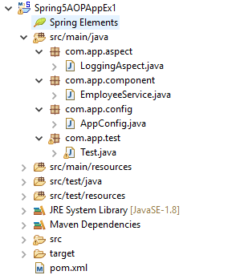

**CODE :-**

1. **LoggingAspect.java:-**

**package com.app.aspect;**

**import org.aspectj.lang.annotation.Aspect;**

**import org.aspectj.lang.annotation.Before;**

**import org.aspectj.lang.annotation.Pointcut;**

**import org.springframework.stereotype.Component;**

**@Component**

**@Aspect**

**publicclass LoggingAspect {**

**@Pointcut("execution(public * sh*(..))") // joinpoint**

**publicvoid point1() {**

**}**

**@Before("point1()")**

**publicvoid showLog() {**

**System.*out*.println("I m from Before Advice()");**

**}**

**}**

1. **EmployeeService.java:-**

**package com.app.component;**

**import org.springframework.stereotype.Service;**

**@Service**

**publicclass EmployeeService {**

**publicvoid showMsg() {**

**System.*out*.println("Hello I m from Business Methos()");**

**}**

**}**

1. **AppConfig.java:-**

**package com.app.config;**

**import org.springframework.context.annotation.ComponentScan;**

**import org.springframework.context.annotation.Configuration;**

**import org.springframework.context.annotation.EnableAspectJAutoProxy;**

**@Configuration**

**@EnableAspectJAutoProxy**

**@ComponentScan(basePackages="com.app")**

**publicclass AppConfig {**

**}**

1. **Test.java:-**

**package com.app.test;**

**import org.springframework.context.ApplicationContext;**

**import org.springframework.context.annotation.AnnotationConfigApplicationContext;**

**import com.app.component.EmployeeService;**

**import com.app.config.AppConfig;**

**publicclass Test {**

**publicstaticvoid main(String[] args) {**

**ApplicationContext ac = new AnnotationConfigApplicationContext(AppConfig.class);**

**EmployeeService e = ac.getBean("employeeService",EmployeeService.class);**

**e.showMsg();**

**}**

**}**

**# RUN TEST CLASS THEN OUTPUT IS :-**

I m from Before Advice()

Hello I m from Business Methos()

**# Diff between After, AfterReturning and AfterThrowing Advices:---**

After advice is executed either success or failure of b.method(), but AfterReturning advice is executed only if b.method() is executed successfully and AfterThrowing advice is executed only on exception thoown by b.method()

Q. >>Can we join one b.method() with multiple advice:--

->Yes possible ,even one advice can also be linked with multiple b.method()

Q.>> Who will create target object:--

->Spring container ,before weaving process

Q.>> Why BeforeReturning/throwing advice are not available in AOP?

-> Containe/JVM can never guess what happens before execution of b.method() , So it is not possible to write those.

Q.> Why pointcut is expression are used?

-> To select business(), which are connected to advice next,

Point cut never provides advices details to b.method().

**Pointcut:-**

It is an expression used to select business class methods which needs advices. But it will not provide details of advices.

**Point cut follows below format:--**

AS RT PACK.CLS.MN(PARAMETERS)

All are optional in this , we can use wild card character like *(star).dot-dot(..), dot(.) only.

AS (access specifier)

MN(method name)

RT(Return type)

PMTRS(Parameters)

* Consider below business class method

1. +getData(int): void
2. +get(): void
3. +get(double): String
4. +getModel():String
5. +getFormate(int): void
6. +set(): void
7. +setData(int): void
8. +set (double): String
9. +setModel():String
10. +setFormat(int): void

-------------------Point Cut Expression------------

1>>Public * get(..)

Result:🡪Here two dots(..) indicates any number of parameters in any order and * in place of return type indicates any return type is accepted.

Selected method:-- 2,3

2>> public void * t*()

Result :-- method name should contain one letter ’t’ nay place (starting/ending/middle ) and must have zero param and void type method

Selected method :------> 5,6,7,2

3>> public * *()

Selected method:--> 2,4,7,9

4>> public String *Data(..)

Selected method--> No method selected

5>> public * get *()

Selected method-->2,4

6>> public * get(..)

Selected method-->2

Selected method-->2,3

7>> public int *et(..)

Selected method-->not matched

8>>public void *o*()

Selected method-->

9>>public String *(..)

Selected method-->3,4,8,9

10>>public * *(..)

Selected method-->All method are selected.

**AOP Programming using Aspect:---**

Spring has provided AOP basic model and implement by vender “Aspect” (3rd party) using AOP annotations. Given few example :--@Aspect,@befpre,@After,@Around,@AfterReturning,@AfterThrowing, @Pointcut…….. etc

To enable these annotation in case of

**1>>XML:--><aop:aspect-autoproxy>**

**2>>JAVA:-- @EnableAspectjAutoProxy**

**## Steps to write AOP Example :-**

**#1:** define one component (Service / controller / Repository / RestController) class which behaves like business class.

**#2:**Define Aspect (class) which indicates External Services.

**#3:** Define Spring Configuration file (XML / JAVA) To Enable AOP Program.

**#4:**  Write one Test class to call only Business Method .

\*\*\***Expected output :Advice must be called automatically.**

**# EXAMPLE CODE :-**

**#1:**Create one simple maven project.

Details:

Group-Id : org.sathyatech

Artifect-Id : Spring5AOPEx1

Version : 1.0

**#2:**AddSpring and Aspects Dependencies for jars download.

**<dependency>**

**<groupId>org.springframework</groupId>**

**<artifactId>spring-context</artifactId>**

**<version>5.0.6.RELEASE</version>**

**</dependency>**

**<dependency>**

**<groupId>org.aspectj</groupId>**

**<artifactId>aspectjrt</artifactId>**

**<version>1.8.7</version>**

**</dependency>**

**<dependency>**

**<groupId>org.aspectj</groupId>**

**<artifactId>aspectjweaver</artifactId>**

**<version>1.8.7</version>**

**</dependency>**

**#3:**Update Maven Project (alt+F5)

**#4:** Create one java config file under src/main/java folder.

**----------------AppConfig.java------------------**

**Package com.app.config;**

**//ctrl+shift+o(imports)**

**@EnableAspectJAutoProxy**

**@Configuration**

**@ComponentScan(basePackages="com.app")**

**publicclass AppConfig { }**

**#5: Create one Business class.**

**----------------EmployeeService.java------------------**

**Package com.app.component;**

**//ctrl+shift+o(imports)**

**@Service**

**publicclass EmployeeService {**

**publicvoid showMsg() {**

**System.*out*.println("Hello I M from Business Method...");**

**}**

**}**

**#6: Write one Aspect with Advices and Pointcut.**

**----------------LoggingAspect.java------------------**

**Package com.app.aspect;**

**//ctrl+shift+o(imports)**

**@Aspect**

**@Component**

**publicclass LoggingAspectA {**

**@Pointcut("execution(public * s*(..))")**

**publicvoid point1() {**

**System.*out*.println("Hello LoggingA Pointcut");**

**}**

**@Before("point1()")**

**publicvoid showLogA() {**

**System.*out*.println("From Before Advice");**

**}**

**@After("point1()")**

**publicvoid showLogB() {**

**System.*out*.println("From After Advice");**

**}**

**}**

**#7: Test class**

**----------------------------Test.java--------------------------------------**

**Package com.app.test;**

**//ctrl+shift+o(imports)**

**publicclass Test {**

**publicstaticvoid main(String[] args) {**

**ApplicationContext ac = new AnnotationConfigApplicationContext(AppConfig.class);**

**EmployeeService emp = ac.getBean("employeeService",EmployeeService.class);**

**emp.showMessage();**

**}**

**}**

**Example #2:- Types of Advices Example**

* **All files are same as above example only aspect is different.**

**CASE #1Before , After Advice Types:**

package com.app.aspect;

// ctrl+shift+o (imports)

@Aspect

@Component

Public class LoggingAspect {

@Pointcut (“execution(public * s*(..))”)

public void point1() { }

@Before(“point1()”)

public vod showLogA(){

System.out.println(“From Before Advice”)

}

@After(“point1()”)

public void showLogB(){

System.out.println(“From After Advice”)

}

}

**CASE#2: Around Advice**

Here use ProceedingJoinPoint to call proceed() method. It throws checked exception , must handle using try – catch.

package com.app.aspect;

// ctrl+shift+o(imports)

@Aspect

@Component

Public class LoggingAspectB {

@Pointcut (“execution(public * sh*(..))”)

public void point1() { }

@Around(“point1()”)

public vod getMsg(ProceedingJoinPoint jp){

System.out.println(“From 1st part of Around”);

Try{ // b.method call

Object ob = jp.proceed();

} catch(Throwable t) {

System.out.println(t);

}

System.out.println(“From 2nd  part of Around”);

}

}

**CASE#3: After Returning and Throwaing:**

* For Returning we should provide pointcut, return type and Throwing provide pointcut , throw (execution) type.

package com.app.aspect;

// ctrl+shift+o(imports)

@Aspect

@Component

Public class LoggingAspectC {

@Pointcut (“execution(public * s*(..))”)

public void point1() { }

@AfterReturning(pointcut=”point1()”, returning=”ob”)

public vod onSuccess(Object ob){

System.out.println(“After Success : : ”+ob);

}

@AfterThrowing(pointcut=”point1()”, throwing=”th”)

public void onFail(Throwable th) {

System.out.println(“After Failure :: ”+th.getMessage());

}

}

**##**In above any one advice is executed , to see onFail advice output add below code in b.method.

**Int x = 9;**

**If(x > 0) throw new RuntimeException (“Test Exception”);**

* If we don’t specify any package and class name then expression considers all packages and all classes. To sort required classes and packages provide expression as :

**AS RT PACK.CLS.MN(PARAMETER)**

**NOTE :-**

1. In expression beside parameters next (right to left) is method name, next dot position is class name, next all dots positions are package name.

**EX Format :-**

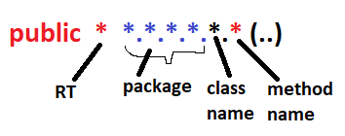

1. Always consider last level package for finding classes.

**EX: *.*.*.*.*.*(..) Here it is 4th level package is considered.**

**EX: com.app.one.two.*.*(..)**

**Consider classes only from two package.**

1. For last level package if we provide two dots **“pack..”** then it indicates current package and all it’s sub package classes are selected.

**EX: com.app..*.*()**

Here app package classes and all it’s sub package classes. (not super package)

1. Symbol **‘*’**indicates any (package, class,method or return type).
2. Symbol **‘ .. ’** (dot dot) can be used for current and sub package classes and any parameter type.

**## Consider below Tree for Expression :-**

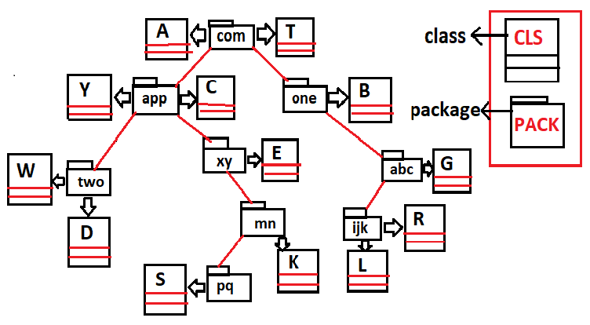

**## Consider above all classes having below all methods (methods in every classes).**

1. **+getData(int):void**
2. **+get():void**
3. **+getModel():String**
4. **+getCode():String**
5. **+get(double):int**
6. **+getModel(int):int**
7. **+set():void**
8. **+setModel():String**
9. **+setCode(int):String**
10. **+set(double):int**

**#1. Expression**

public * com.*.*.*.*()

classes(4) X method(4)

W,D,E,G | 2,3,7,8

Total = 16.

**#2. Expression**

public void com.app..*.*()

classes(7) X method (2)

Y,C,W,D,E,S,K | 2,7

Total = 14.

**#3. Expression**

public String com.one.*.*.get*()

classes(1) X method(1)

D | 3

Total = 1.

**#4. Expression**

public int com.*.*..*.set()

classes (8) X method (0)

W,D,E,F,R,S,K,L | 0

Total = 0.

**#5. Expression**

public * com.*.*.*.*.*.*et()

classes (3) X method (2)

K,L,R | 2,7

Total = 6.

**#7. Expression**

public void com..*.set()

classes (13) X method (1)

All classes | 7

Total = 13.

**#8. Expression**

public * *..*.*(..)

classes (13) X method (10)

All classes | 10

Total = 130;

**## SPECIAL EXPRESSION IN AOP :**

1. **within() expression:**

* This is used to write one pointcut expression which indicates select all methods in given package classes or given classes.

EX:- expression and equal meaning is :

1. **within(com.app.*)**

equal meaning is all classes in com.app package (and all methods in that).

1. **within (com.app.Employee)**

only Employee class method**.**

1. **within (com.app..*)**

app package classes and all sub – package classes (all methods in those).

1. **args () expression:**

* To indicate only parameters not other thing in pointcut use this expression.

**EX :-**

1. **args(int) -->**all classes methods having int type parameter is selected.
2. **args(..) -->**method having any parameter is **OK.**
3. **args(String, ..) -->**First parameter of method must be String, 2nd onward anything is **OK.**
4. **this() expression:**

* To specify exact class methods (not multiple classes).

**EX:-**

1. **this(com.app.Employee) -->**means only Employee class methods are selected.

**# Pointcut Joins:-**

* One advice can be connected to multiple pointcuts using AND AND(&&) OR OR (||) symbols.

**EX#1:-**

**@Pointcut (“execution (_________)”)**

**public void p1() { }**

**@Pointcut(“execution (_________)”)**

**Public void p2() { }**

Here p1, p2 are two Pointcuts then we can write as p1() && p2().

P1() || p2() for a JoinPoint (Advice)

**EX#2:-**

P1() -----🡪 within (com.app..*)

P2() -----🡪 args(int)

Advice --🡪 p1() && p2()

* A method which exist in class that is available in app package and method must have int param is selected and connected with advice.

**# SPECIAL CASE IN ACCESS SPECIFIER :-**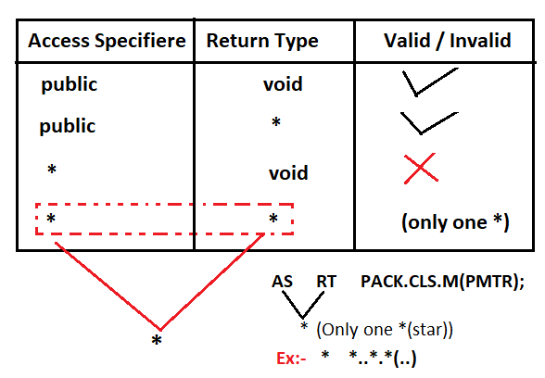

**CHAPTER # 8 SPRING REST WEBSERVICES**

**# Spring 5.x Rest Webservice :-**

* Spring 5.x provides ReST Webservices implementation using spring ReST light weight Design, which can be implemented in RAD model (Rapid Application Development) using Template Design Pattern.
* Spring ReST API contains classes, interfaces, anootations and enums (pre-defined).
* To implement Spring ReST Application we should create two projects.

Those are :

1. Spring ReST Provider Application
2. Spring ReST Consumer Application

Both communicates using Http Protocol

(HttpRequest / HttpResponse).

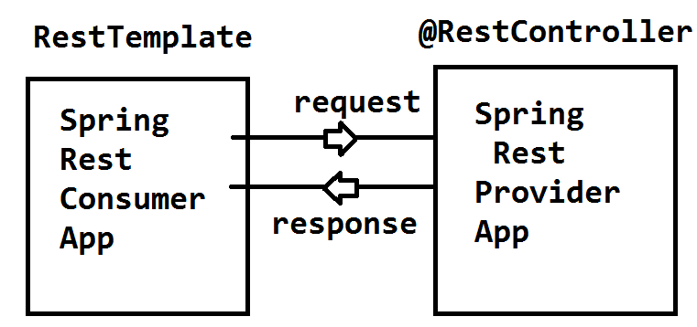

**SPRING REST PROVIDER APPLICATION DESIGN**

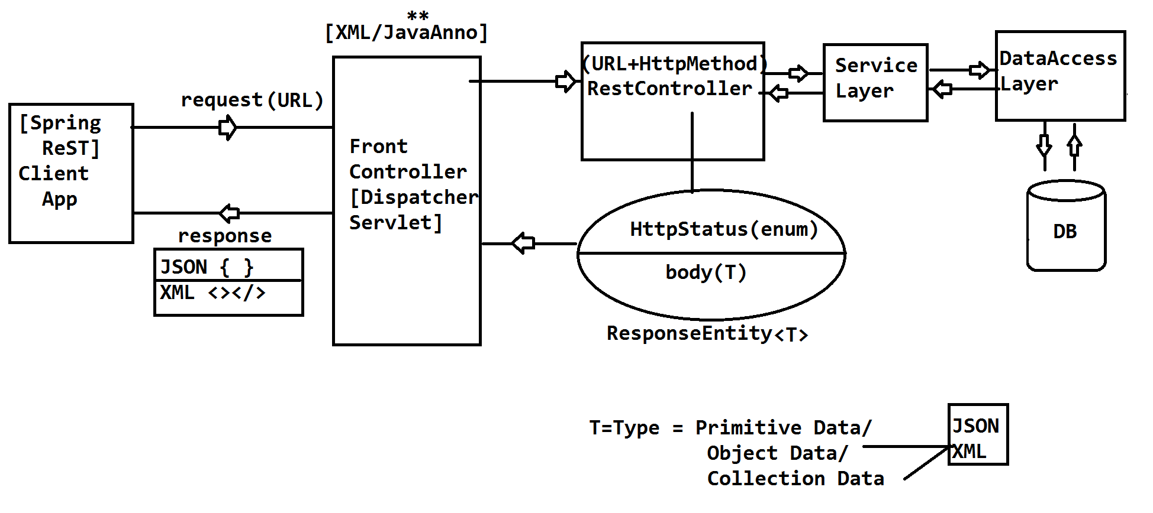

**# RestController class coding :-**

* This is written in IL (Integration Layer) using Spring Annotations and wnums. Every RestController method must be bounded to one HttpMethod Type using it’s equal annotations. Few are given as :

**HttpMethod (enum)** **Spring Annotation**

GET @GetMapping

POST @PostMapping

PUT @PutMapping

DELETE @DeleteMapping

PATCH @PatchMapping

**Format of writing ReST Controller class :-**

package [packageName];

// ctrl+shift+o (imports)

@RestController

@RequestMapping(“/url”) // optional

public class [className] {

// HttpMethod + URL

@GetMapping(“/url”)

public ResponseEntity<?> [methodName] () {

// logic…

return ResponseEntity(Body, HttpStatus);

}

}

**NOTE :-**

1. **@RestController :- [Spring 4.x]**

It is a 5th StereoType Annotation ie which detect the class and creates the object in Spring Container.

It must be applied on class level.

It internally follows @Controller and @RestController

1. **ResponseEntity<T> :-**

It is a class provide by spring ReST API. It is used as method return type which should contain body (GenericType) and HttpStatus (enum).

1. **@RequestMapping :-**

It is used to provide path(URL) at class / method level. class level it is optional.

1. **Method Level,**

Path and HttpMethod Type can be provided using HttpType Annotations using @XXXMapping,

**Ex :-** @GetMapping, @PostMapping … etc.

**# Spring Provider Coding Steps Part # 1:-**

**Step#1:-**

Create One Maven Project (webapp)

File > New > Maven Project

** do not select any checkbox > next> search for “webapp” and choose

“maven-archtype-webapp” > next > Enter Details:

groupId : org.sathyatech.app

artifectId : Spring5ProviderApp

version : 1.0

>Finish.

**Step#2:-**

Provide dependencies, build plugins in pom.xml

Spring WebMVC, fasterxml(JSON, XML)

Using JACKSON, maven compiler plugin,

Maven war plugin.

**Step#3:-**

Assign one webserver to Application

>Right click on project > build path…

>Configure Buildpath > Library Tab

>Add Library > Server runtime

>choose Apache Tomcat(7.x/8.x/ 9.x) > Apply > Apply and close

**Step#4:-**

Update maven project (alt+F5)

>Right click on project > maven

>update project.

**Step#5:-**

Write code in below order under src/main/java folder, also delete web.xml and index.jsp file.

-------------------------------**Folder Structure**-----------------------------

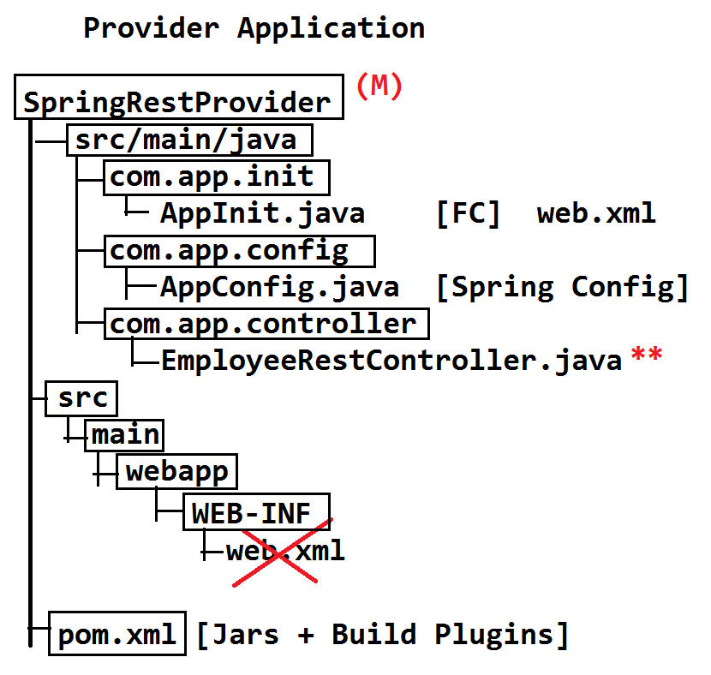

**---------------------------IN ECLIPSE OR STS FOLDER STRUCTURE-----------------------------**

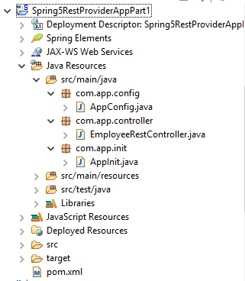

**----------------------JAVA CODE PART #1-----------------------------------------**

1. **Pom.xml:**

**<projectxmlns=*"http://maven.apache.org/POM/4.0.0"***

**xmlns:xsi=*"http://www.w3.org/2001/XMLSchema-instance"***

**xsi:schemaLocation=*"http://maven.apache.org/POM/4.0.0 http://maven.apache.org/maven-v4_0_0.xsd"*>**

**<modelVersion>4.0.0</modelVersion>**

**<groupId>org.sathyatech.app</groupId>**

**<artifactId>Spring5RestControllerApp1</artifactId>**

**<packaging>war</packaging>**

**<version>1.0</version>**

**<name>Spring5RestControllerApp1 MavenWebapp</name>**

**<url>http://maven.apache.org</url>**

**<dependencies>**

**<dependency>**

**<groupId>org.springframework</groupId>**

**<artifactId>spring-webmvc</artifactId>**

**<version>5.0.6.RELEASE</version>**

**</dependency>**

**<dependency>**

**<groupId>com.fasterxml.jackson.core</groupId>**

**<artifactId>jackson-databind</artifactId>**

**<version>2.9.5</version>**

**</dependency>**

**<dependency>**

**<groupId>com.fasterxml.jackson.dataformat</groupId>**

**<artifactId>jackson-dataformat-xml</artifactId>**

**<version>2.9.5</version>**

**</dependency>**

**</dependencies>**

**<build>**

**<plugins>**

**<plugin>**

**<groupId>org.apache.maven.plugins</groupId>**

**<artifactId>maven-compiler-plugin</artifactId>**

**<version>3.7.0</version>**

**<configuration>**

**<source>1.8</source>**

**<target>1.8</target>**

**</configuration>**

**</plugin>**

**<plugin>**

**<groupId>org.apache.maven.plugins</groupId>**

**<artifactId>maven-war-plugin</artifactId>**

**<version>2.6</version>**

**<configuration>**

**<failOnMissingWebXml>false</failOnMissingWebXml>**

**</configuration>**

**</plugin>**

**</plugins>**

**</build>**

**</project>**

1. **AppConfig.java:-**

package com.app.config;

import org.springframework.context.annotation.ComponentScan;

import org.springframework.context.annotation.Configuration;

import org.springframework.web.servlet.config.annotation.EnableWebMvc;

@Configuration

@EnableWebMvc

@ComponentScan(basePackages="com.app")

publicclass AppConfig {

}

1. **AppInit.java:-**

package com.app.init;

import org.springframework.web.servlet.support.AbstractAnnotationConfigDispatcherServletInitializer;

import com.app.config.AppConfig;

publicclass AppInit extends AbstractAnnotationConfigDispatcherServletInitializer {

@Override

protected Class<?>[] getRootConfigClasses() {

returnnew Class[] {AppConfig.class};

}

@Override

protected Class<?>[] getServletConfigClasses() {

returnnull;

}

@Override

protected String[] getServletMappings() {

returnnew String[] {"/*"};

}}

1. **EmployeeRestController.java:-**

package com.app.controller;

import org.springframework.http.HttpStatus;

import org.springframework.http.ResponseEntity;

import org.springframework.web.bind.annotation.DeleteMapping;

import org.springframework.web.bind.annotation.GetMapping;

import org.springframework.web.bind.annotation.PostMapping;

import org.springframework.web.bind.annotation.PutMapping;

import org.springframework.web.bind.annotation.RequestMapping;

import org.springframework.web.bind.annotation.RestController;

@RestController

@RequestMapping("/employee") // Optional

publicclass EmployeeRestController {

// Method

// HttpMethod + Method URL

@GetMapping("/show")

public ResponseEntity<String> showMsgA(){

String body = "Welcome To GET Method Spring Rest Appication!!";

HttpStatus status = HttpStatus.*OK*;

ResponseEntity<String>entity = new ResponseEntity<String>(body,status);

returnentity;

}

@PostMapping("/show")

public ResponseEntity<String> showMsgB(){

String body = "Welcome To POST Method Spring Rest Appication!!";

HttpStatus status = HttpStatus.*OK*;

ResponseEntity<String>entity = new ResponseEntity<String>(body,status);

returnentity;

}

@PutMapping("/show")

public ResponseEntity<String> showMsgC(){

String body = "Welcome To PUT Method Spring Rest Appication!!";

HttpStatus status = HttpStatus.*OK*;

ResponseEntity<String>entity = new ResponseEntity<String>(body,status);

returnentity;

}

@DeleteMapping("/show")

public ResponseEntity<String> showMsgD(){

String body = "Welcome To DELETE Method Spring Rest Appication!!";

HttpStatus status = HttpStatus.*OK*;

ResponseEntity<String>entity = new ResponseEntity<String>(body,status);

returnentity;

}

}

**# Running on server:**

Run as > run on server

<http://localhost:2022/Spring5RestConsumerAppPart1/employee/show>

**OUTPUT ON BROWSER:-**

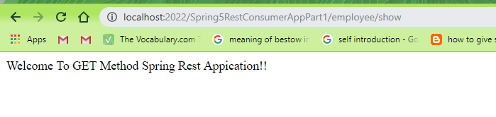

-------------------------POSTMAN SCREEN----------------------------------

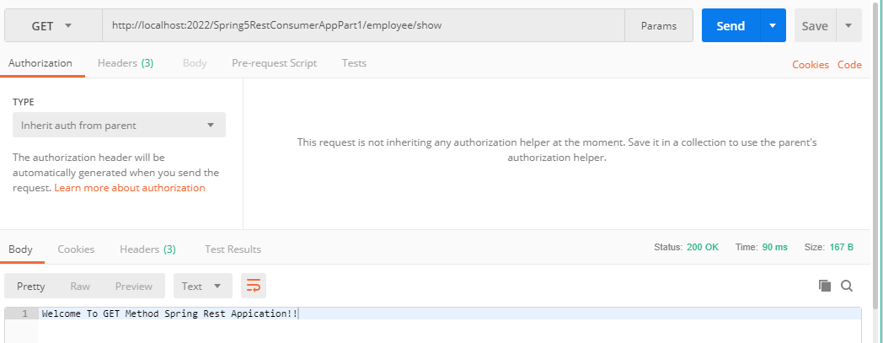

**# SPRING REST CONSUMER APPLICATION:-**

* Use RestTemplate to make HTTP Request calls to provider application from consumer application.
* Template is a Design Pattern used to reduce common lines of code (duplicate code/ boiler plate code...).

**RestTemplate takes care of :**

**>Creating client objects**

**>web resources object**

**> Default HTTP methods with Header**

**> Making call to Provider**

**> Auto conversion of response to ResponseEntity<T>**

**-----------------------Client Application Steps------------------------------------------------**

1. Create simple maven project

> File > New > Maven Project

> Choose checkbox *** > next

> Enter Details like:

groupId : org.sathyatech.app

artifectId : Spring5ConsumerApp

version : 1.0

>Finish.

2. Open pom.xml and provide jars and build plugins.

3. Update Maven Project (alt+F5)

> Right click on project > Maven

> update project.

4. Create one class “ClientTest” under src/main/java Folder.

**Coding Steps are:-**

1. **Create object to RestTemplate**
2. **Create String (Provider) URL**
3. **Make call (as HTTPRequest)**
4. **Get Response in ResponseEntity**
5. **Print or use result (body / status)**

**FOLDER STRUCTURE:-**

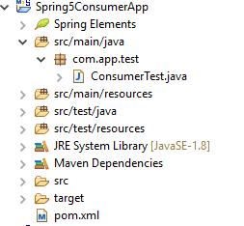

**Example Code:**

1. **pom.xml**

**<projectxmlns=*"http://maven.apache.org/POM/4.0.0"***

**xmlns:xsi=*"http://www.w3.org/2001/XMLSchema-instance"***

**xsi:schemaLocation=*"http://maven.apache.org/POM/4.0.0 http://maven.apache.org/xsd/maven-4.0.0.xsd"*>**

**<modelVersion>4.0.0</modelVersion>**

**<groupId>org.sathyatech.app</groupId>**

**<artifactId>Spring5ConsumerApp</artifactId>**

**<version>1.0</version>**

**<dependencies>**

**<dependency>**

**<groupId>org.springframework</groupId>**

**<artifactId>spring-webmvc</artifactId>**

**<version>5.0.6.RELEASE</version>**

**</dependency>**

**<dependency>**

**<groupId>com.fasterxml.jackson.core</groupId>**

**<artifactId>jackson-databind</artifactId>**

**<version>2.9.5</version>**

**</dependency>**

**<dependency>**

**<groupId>com.fasterxml.jackson.dataformat</groupId>**

**<artifactId>jackson-dataformat-xml</artifactId>**

**<version>2.9.5</version>**

**</dependency>**

**</dependencies>**

**<build>**

**<plugins>**

**<plugin>**

**<groupId>org.apache.maven.plugins</groupId>**

**<artifactId>maven-compiler-plugin</artifactId>**

**<version>3.7.0</version>**

**<configuration>**

**<source>1.8</source>**

**<target>1.8</target>**

**</configuration>**

**</plugin>**

**</plugins>**

**<finalName>SpringRestProvider</finalName>**

**</build>**

**</project>**

1. **ConsumerTest.java**

package com.app.test;

import org.springframework.http.ResponseEntity;

import org.springframework.web.client.RestTemplate;

publicclass ConsumerTest {

publicstaticvoid main(String[] args) {

//1.create object to RestTemplate

RestTemplate rt =new RestTemplate();

//2.Provider URL

String url="http://localhost:2022/Spring5RestProviderAppPart1/employee/show";

//3.make call (http request)

//4.get Response in ResponseEntity

ResponseEntity<String>entity=rt.getForEntity(url, String.class);

//5.Print or use result

System.*out*.println(entity.getBody());

System.*out*.println(entity.getStatusCode().name());

System.*out*.println(entity.getStatusCodeValue());

}

}

**OUTPUT:-**

Welcome To GET Method Spring Rest Appication!!

OK

200

**# SPRING REST-PROVIDER USING XML CONFIGURATION PART- #2**

* Here FC (FrontController) must be configured in web.xml using directory match url pattern.

**Ex: /rest/* , /* , / (only slash) , a/b/c/\***

**Code look likes : (web.xml)**

**<web-app>**

**<servlet>**

**<servlet-name>sample</servlet-name>**

**<servlet-class>**

**org.springframework.web.servlet.DispatcherServlet**

**</servlet-class>**

**</servlet>**

**<servlet-mapping>**

**<servlet-name>sample</servlet-name>**

**<url-pattern>/rest/*</url-pattern>**

**</servlet-mapping>**

**</web-app>**

* Spring xml configuration must be created under /WEB-INF/ with naming rule : [<servlet-name>]-servlet.xml in above ex:<servlet-name> = sample,

Then File name : **sample-servlet.xml**

It should contain code for:

1. **Activation of annotations**
2. **Activation of MVC/ReST process.**

Code looks like:

<beans…>

<context:component-scan base-package=”com.app” />

<mvc:annotation-driven />

</beans>

**# Working with MediaType (Global Format):-**

**MediaType:-**

It is a concept for data representation, language data (object) can be convert to global format and reverse using MediaType Annotations.

Those are:

**@RequestBody :**Must be applied at method parameter by programmer.

**@ResponseBody:** Autoapplied by RestController for every method return type.

* HttpRequest/Response holds data in global format in body area at same time we should add Header key **“Content-Type”** to indicate what type of data Body holds.
* **For JSON Content-Type : application/json**
* **For XML Content-Type : application/xml**
* Request Header should also have Header key **“Accept”** (with JSON/XML) which indicates what type of response Body is expected by consumer.
* To enable JSON conversion in ReST in pom.xml

Add dependency :

**Artifect-Id : Jackson-databind**

**(or any it’s equal )**

To enable XML conversion in ReST,

In pom.xml add dependency :

**Artifect-Id : Jackson-dataformat-xml**

**(or any it’s equal)**

* If both are added then default **“Accept : application/xml”**

(with high priority) , if any one is added JSON/XML , then that is only default “Accept”.

**CASE#1:-**

Provider supports both XML,JSON and request Body is JSON, Content-Type is application/xml. Then HttpStatus **400 Bad Request.**

**CASE#2:-**

Provider supports XML only. Request Body JSON. Then HttpStatus **415Unsupported MediaType.**

**CASE#3:-**

Provider supports JSON only Request Body JSON. Then HttpStatus **200 OK.**

**----------------WORKING FLOW OF MEDIATYPE-------------------------**

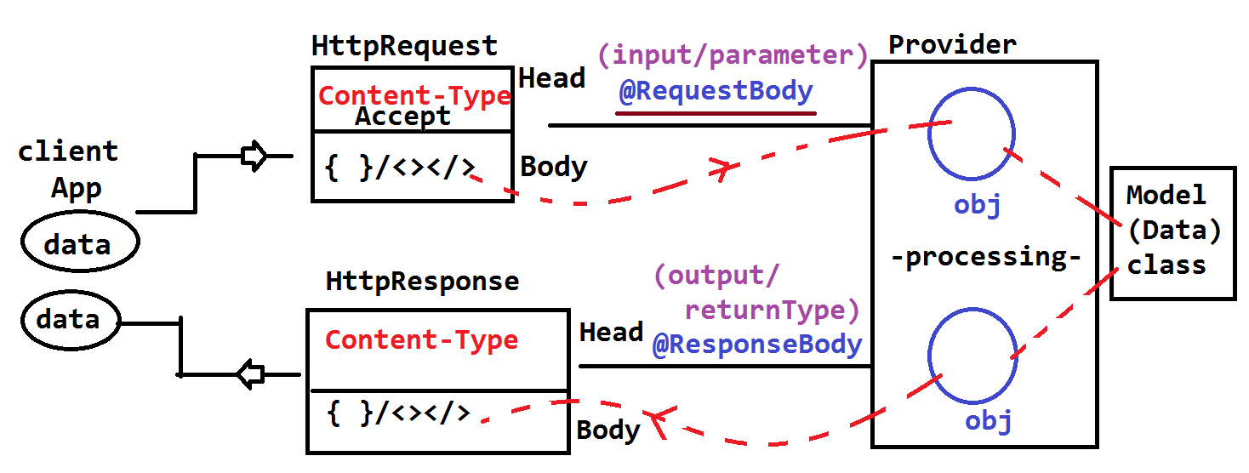

**PROGRAM EXAMPLE CODE :-**

**# Folder Structure Maven Project:-**

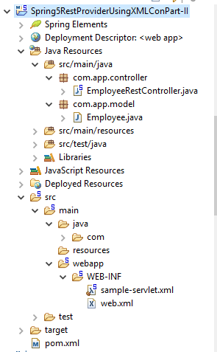

**Example Code:-**

1. **Pom.xml**

<projectxmlns="http://maven.apache.org/POM/4.0.0" xmlns:xsi="http://www.w3.org/2001/XMLSchema-instance"

xsi:schemaLocation="http://maven.apache.org/POM/4.0.0 http://maven.apache.org/maven-v4_0_0.xsd">

<modelVersion>4.0.0</modelVersion>

<groupId>org.sathyatech.app</groupId>

<artifactId>Spring5RestProviderUsingXMLConPart-II</artifactId>

<packaging>war</packaging>

<version>1.0</version>

<name>Spring5RestProviderUsingXMLConPart-II MavenWebapp</name>

<url>http://maven.apache.org</url>

<dependencies>

<dependency>

<groupId>org.springframework</groupId>

<artifactId>spring-webmvc</artifactId>

<version>5.0.6.RELEASE</version>

</dependency>

<dependency>

<groupId>com.fasterxml.jackson.core</groupId>

<artifactId>jackson-databind</artifactId>

<version>2.9.5</version>

</dependency>

<dependency>

<groupId>com.fasterxml.jackson.dataformat</groupId>

<artifactId>jackson-dataformat-xml</artifactId>

<version>2.9.5</version>

</dependency>

</dependencies>

<build>

<plugins>

<plugin>

<groupId>org.apache.maven.plugins</groupId>

<artifactId>maven-compiler-plugin</artifactId>

<version>3.7.0</version>

<configuration>

<source>1.8</source>

<target>1.8</target>

</configuration>

</plugin>

<plugin>

<groupId>org.apache.maven.plugins</groupId>

<artifactId>maven-war-plugin</artifactId>

<version>2.6</version>

<configuration>

<failOnMissingWebXml>false</failOnMissingWebXml>

</configuration>

</plugin>

</plugins>

</build>

</project>

1. **Employee Model Class**

**package com.app.model;**

**publicclass Employee {**

**privateintempId;**

**private String empName;**

**privatedoubleempSal;**

**public Employee() {**

**super();**

**}**

**publicint getEmpId() {**

**returnempId;**

**}**

**publicvoid setEmpId(intempId) {**

**this.empId = empId;**

**}**

**public String getEmpName() {**

**returnempName;**

**}**

**publicvoid setEmpName(String empName) {**

**this.empName = empName;**

**}**

**publicdouble getEmpSal() {**

**returnempSal;**

**}**

**publicvoid setEmpSal(doubleempSal) {**

**this.empSal = empSal;**

**}**

**@Override**

**public String toString() {**

**return"Employee [empId=" + empId + ", empName=" + empName + ", empSal=" + empSal + "]";**

**}**

**}**

1. **EmployeeRestController class:**

package com.app.controller;

import org.springframework.http.HttpStatus;

import org.springframework.http.ResponseEntity;

import org.springframework.web.bind.annotation.PostMapping;

import org.springframework.web.bind.annotation.RequestBody;

import org.springframework.web.bind.annotation.RequestMapping;

import org.springframework.web.bind.annotation.RestController;

import com.app.model.Employee;

**@RestController**

**@RequestMapping("/employee")**

public class EmployeeRestController {

@PostMapping("/data")

public ResponseEntity<Employee> processData(@RequestBody Employee emp){

emp.setEmpSal(emp.getEmpSal()*4);

ResponseEntity<Employee> entity = new ResponseEntity<Employee>(emp, HttpStatus.OK);

return entity;

}

}

1. **Web.xml file:**

**<?xmlversion=*"1.0"*encoding=*"UTF-8"*?>**

**<web-appxmlns:xsi=*"http://www.w3.org/2001/XMLSchema-instance"***

**xmlns=*"http://xmlns.jcp.org/xml/ns/javaee"***

**xsi:schemaLocation=*"http://xmlns.jcp.org/xml/ns/javaee http://xmlns.jcp.org/xml/ns/javaee/web-app_3_1.xsd"*id=*"WebApp_ID"*version=*"3.1"*>**

**<servlet>**

**<servlet-name>sample</servlet-name>**

**<servlet-class>org.springframework.web.servlet.DispatcherServlet</servlet-class>**

**</servlet>**

**<servlet-mapping>**

**<servlet-name>sample</servlet-name>**

**<url-pattern>/rest/*</url-pattern>**

**</servlet-mapping>**

**</web-app>**

1. **Sample-servlet.xml:**

**<?xmlversion=*"1.0"*encoding=*"UTF-8"*?>**

**<beansxmlns=*"http://www.springframework.org/schema/beans"***

**xmlns:context=*"http://www.springframework.org/schema/context"***

**xmlns:mvc=*"http://www.springframework.org/schema/mvc"***

**xmlns:p=*"http://www.springframework.org/schema/p"***

**xmlns:xsi=*"http://www.w3.org/2001/XMLSchema-instance"***

**xsi:schemaLocation=*"http://www.springframework.org/schema/beans***

***http://www.springframework.org/schema/beans/spring-beans.xsd***

***http://www.springframework.org/schema/context***

***http://www.springframework.org/schema/context/spring-context.xsd***

***http://www.springframework.org/schema/mvc***

***http://www.springframework.org/schema/mvc/spring-mvc.xsd "*>**

**<!-- 1. Activation of Annotations -->**

**<context:component-scanbase-package=*"com.app"*/>**

**<!-- 1. MVC of Annotations -->**

**<mvc:annotation-driven/>**

**</beans>**

**## Run on server add make Request Using POSTMAN**

**POSTMAN SCREEN #1 BODY DETAILS**

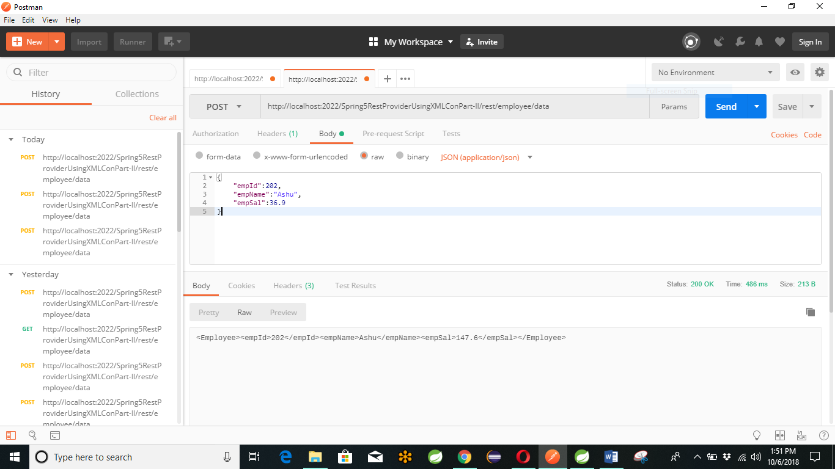

**## Run on server add make Request Using POSTMAN**

**POSTMAN SCREEN #2 HEADER DETAILS**

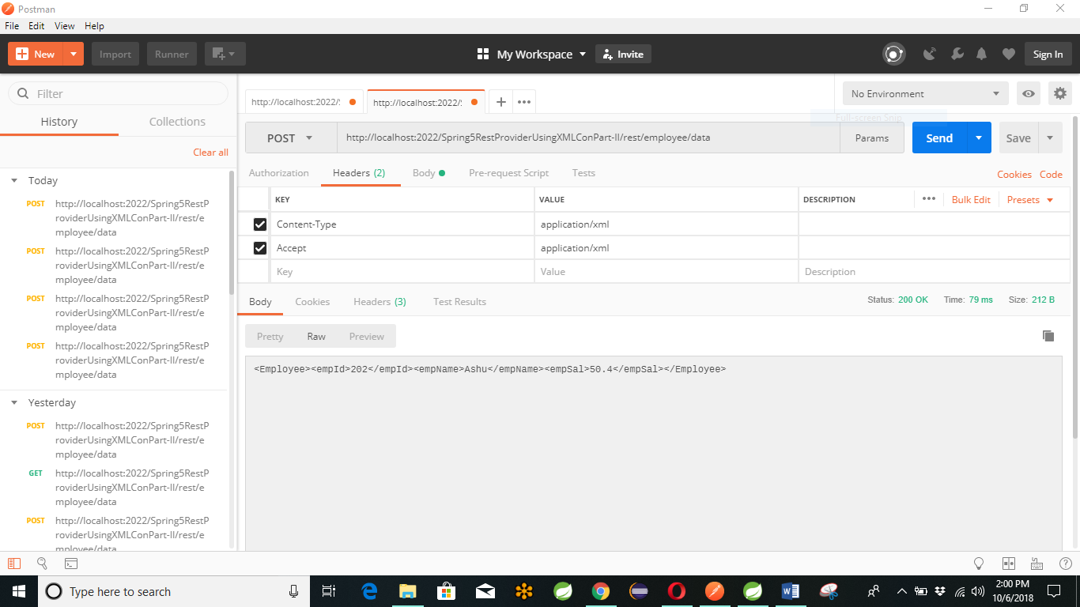

**# MAKING REQUEST USING SPRING REST CLIENT**

1. Create HttpHeaders with 2 header params. Those are Content-Type , Accept.

**Code Sample :-**

**HttpHeaders headers = new HttpHeaders();**

**Headers.add(“Content-Type”, “__________”);**

**Headers.add(“Accept”, “__________”);**

1. Create HttpEntity with two parts Body(String) and headers(HttpHeaders).

**Code Sample :-**

**HttpEntity<String> entity = new HttpEntity<String>();**

1. Create RestTemplate Object.

**RestTemplate template = new RestTemplate();**

1. Make Request call (get()/post()/put()…..) with inputs like URL, Entity, ResponseType.
2. Store Response data back into ResponseEntity<T> Object.

**Code Sample :-**

**ResponseEntity<String> re = template.postForEntity(url, entity, String.class);**

1. Print HttpStatus and Body

System.out.println(re.getStatusCodeValue());

System.out.println(re.getStatusCode().name());

System.out.println(re.getBody());

**--------------------------------DESIGN----------------------------------**

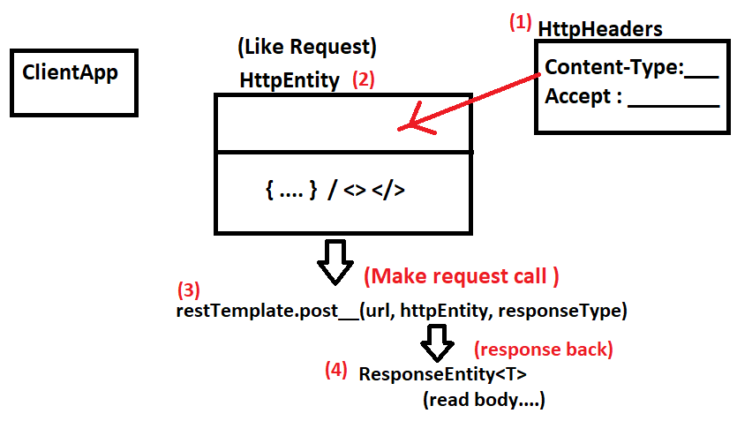

**Example Program :-**

**Folder Structure :-**

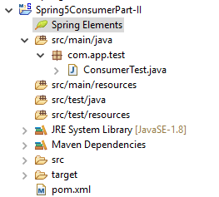

**CODE :-**

1. **Pom.xml :-**

**<projectxmlns=*"http://maven.apache.org/POM/4.0.0"***

**xmlns:xsi=*"http://www.w3.org/2001/XMLSchema-instance"***

**xsi:schemaLocation=*"http://maven.apache.org/POM/4.0.0 http://maven.apache.org/xsd/maven-4.0.0.xsd"*>**

**<modelVersion>4.0.0</modelVersion>**

**<groupId>org.sathyatech.app</groupId>**

**<artifactId>Spring5ConsumerPart-II</artifactId>**

**<version>1.0</version>**

**<dependencies>**

**<dependency>**

**<groupId>org.springframework</groupId>**

**<artifactId>spring-webmvc</artifactId>**

**<version>5.0.6.RELEASE</version>**

**</dependency>**

**<dependency>**

**<groupId>com.fasterxml.jackson.core</groupId>**

**<artifactId>jackson-databind</artifactId>**

**<version>2.9.5</version>**

**</dependency>**

**<dependency>**

**<groupId>com.fasterxml.jackson.dataformat</groupId>**

**<artifactId>jackson-dataformat-xml</artifactId>**

**<version>2.9.5</version>**

**</dependency>**

**</dependencies>**

**<build>**

**<plugins>**

**<plugin>**

**<groupId>org.apache.maven.plugins</groupId>**

**<artifactId>maven-compiler-plugin</artifactId>**

**<version>3.7.0</version>**

**<configuration>**

**<source>1.8</source>**

**<target>1.8</target>**

**</configuration>**

**</plugin>**

**</plugins>**

**<finalName>Spring5RestProviderUsingXMLConPart-II</finalName>**

**</build>**

**</project>**

1. **ConsumerTest.java :-**

**package com.app.test;**

**import org.springframework.http.HttpEntity;**

**importorg.springframework.http.HttpHeaders;**

**import org.springframework.http.ResponseEntity;**

**import org.springframework.web.client.RestTemplate;**

**publicclass ConsumerTest {**

**publicstaticvoid main(String[] args) {**

**//String body = "{\"empId\":202,\"empName\":\"Ashu\",\"empSal\":36.9}";**

**String body = "<Employee><empId>999</empId><empName>Ashutosh</empName><empSal>88.99</empSal></Employee>";**

**String url = "http://localhost:2022/Spring5RestProviderUsingXMLConPart-II/rest/employee/data";**

**// 1. Add Header**

**HttpHeadersheaders = newHttpHeaders();**

**//headers.add("Content-Type", "application/json");**

**headers.add("Content-Type", "application/xml");**

**headers.add("Accept", "application/json");**

**// 2. Entity**

**HttpEntity<String>he = new HttpEntity<String>(body, headers);**

**// 3. Make Request call**

**RestTemplate template = new RestTemplate();**

**// 4. Get Response back also**

**ResponseEntity<String>re = template.postForEntity(url, he, String.class);**

**System.*out*.println(re.getStatusCodeValue());**

**System.*out*.println(re.getStatusCode().name());**

**System.*out*.println(re.getBody());**

**}**

**}**

**CHAPTER # 9** **SPRING JMS (JAVA MESSAGE SERVICE)**

* J**MS** : Java Message Service.

This concept is used to exchange (send / receive) messages (data) between two (or more) java applications.

* These java application can run in same computer (same vm) or different computers (different vms).

**[VM = Virtual Machine]**

* JMS is applicable only for java applications (any type web, stand alone, mobile , etc…).
* One java application is called asclient which can be acting as consumer or producer.
* Two clients communicates using **MOM (Message Oriented Middleware).**
  + - * **Ex : Apache ActiveMQ , WebLogic MQs.**
* MOM contains special memory to hold messages called as **“Destination”**. It is like a storage location for messages.

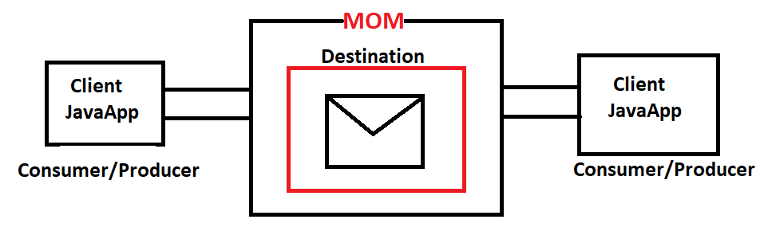

**# Types of JMS Communication:-**

1. **P2P (Peer-To-Peer) Communication:-**

* If message is taken (read) by only one Consumer (Client) then it is known as P2P Communication.

1. **Pub/Sub (Publish-and-Subscribe) Communication :-**

* If one message is taken (read) by multiple Consumer (Clients) [Same copy] then it is known as Pub/Sub Communication.

**##Destination :-**

* It is a memory created in MOM to hold messages. It is two types based on Communications.

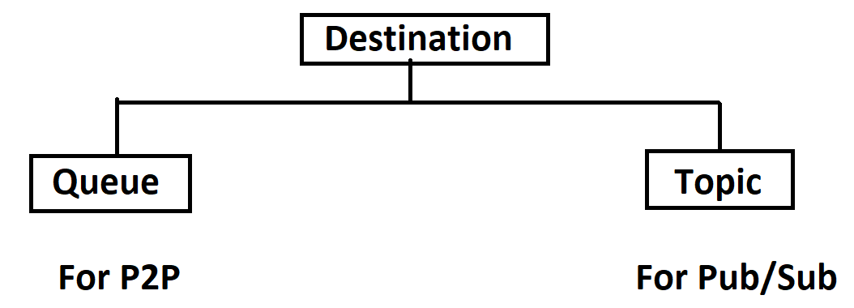

**#) Queue :-**

* It is used to hold message in case of P2P Communication. It must be identified using one name **Ex: myqueue12.**

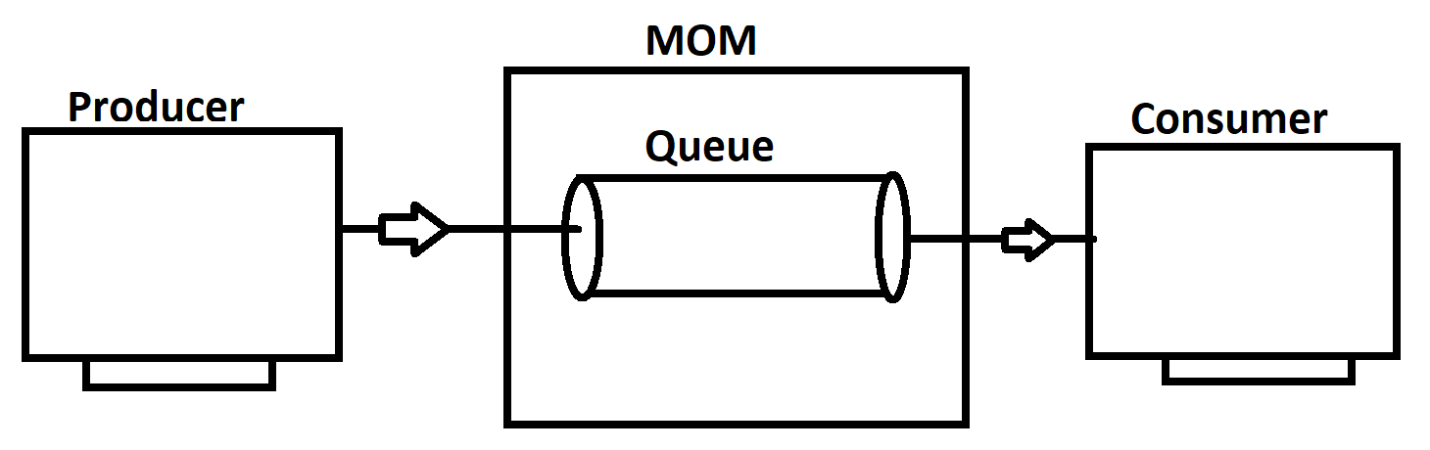

**#) Topic :-**

* It is used to hold message given by Producer, this message will be broadcasted to (given to multiple) Consumers . one message multiple copies are created in memory.

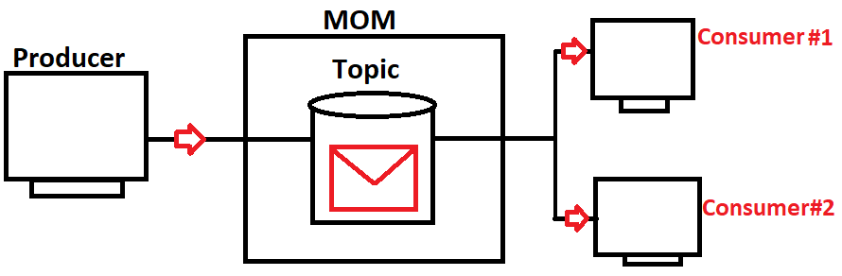

**#JMS DESIGN PROVIDED BY SUNMICROSYSTEM :-**

**#1:**Download and setup MOM

(Ex: Apache ActiveMQ Software)

**#2**: Identify http port and tcp port:

Ex: Http port = **8161**

Tcp port = **61616**

* Http port is used to view admin console of MOM, to see “how many Topic and Queue are created and their status” Tcp port is used to send/receive messages to/from MOM using Java JMS Application.

**#3:** Writecode for client (Message Producer) and for client (Message

Consumer).

*** Create multiple message Consumer in case of Pub/Sub (Topic).

**---------------------------Coding Steps------------------------------------------------**

**#a:**Create Connection Factory Object using MOM URL.

(BROKER URL)

For ActiveMQ: tcp://localhost:61616

**#b:**Create Connection between JMS App and MOM.

**#c:** Create Session to do operations (send/recieve) and at same time

Destination also (any order).

**#d:** Destination must be Queue for P2P and Topic for Pub/Sub.

**#e:** Use session to create send message to destination for producer app.

**#f:** Use Session toread message from destination for Consumer Application.

**-------------------------GENERIC JMS DESIGN BY SUN-----------------------------**

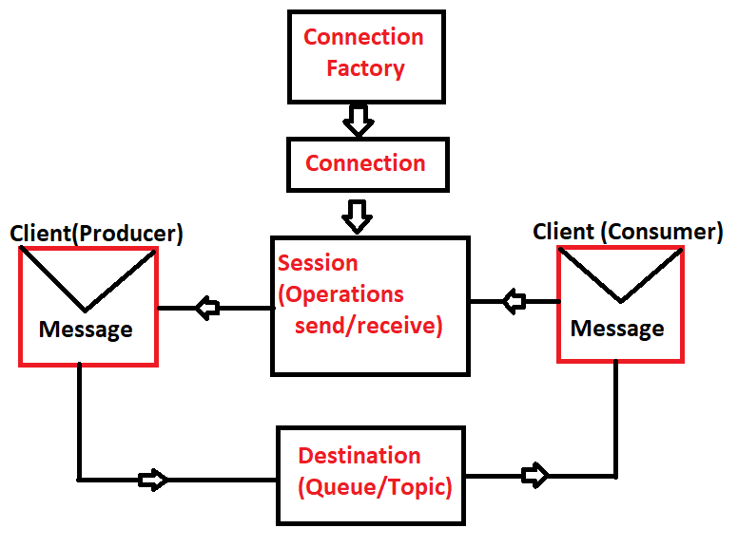

**# Spring JMS :-**

* Spring JMS reduces coding lines provided by SUN JMS, using Template Design Pattern given as JMSTemplate.

**# JmsTemplate :-**

* Auto Creates Connection, Session, Destination and manages application link with MOM.
* This Template supports for both Consumer and Producer but mainly used for Producer.

------------------------JMS Template Design--------------------

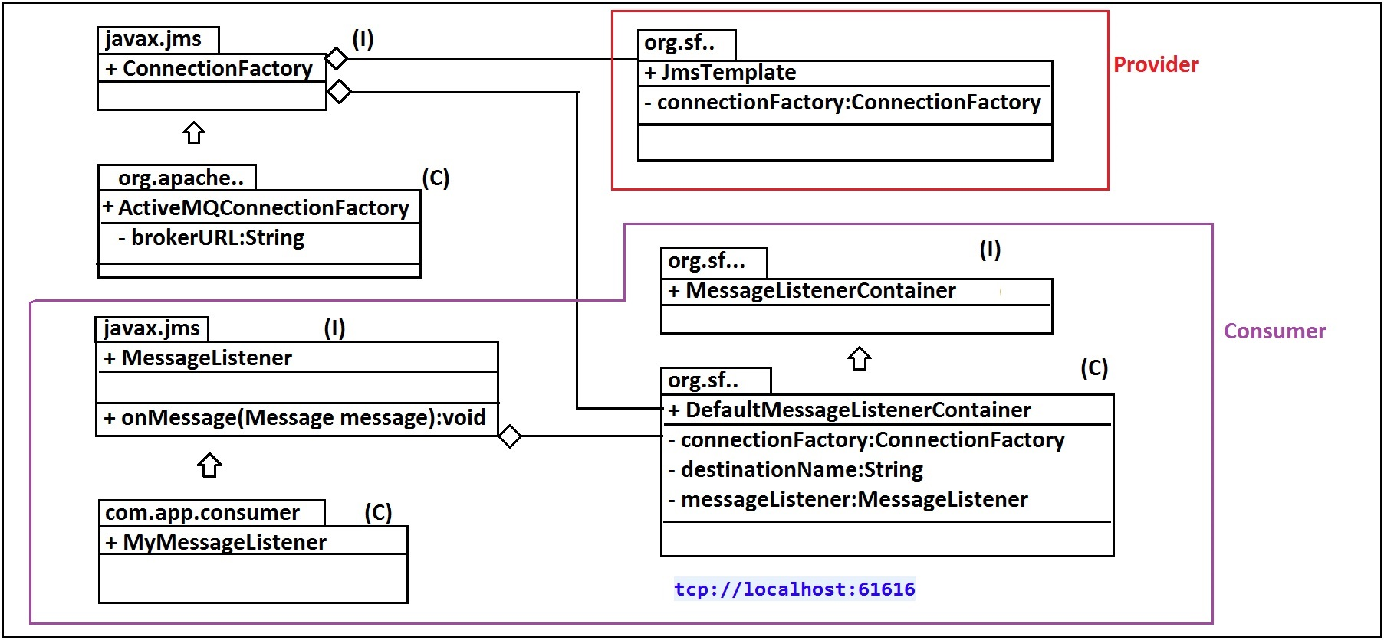

STEPS TO IMPLEMENT JMS PRODUCER CLIENT:-

**#1:** Create One Maven Project

> File > New > Maven Project

> Click checkbox

[v] Create Simple Project

> next > enter details:

groupId : org.sathyatech

artifectId : Spring5JMSProviderApp

version : 1.0

> Finish

**#2:**in pom.xml add dependencies for spring context, spring jms, spring ActiveMQ and build plugins for maven compiler.

**#3:**Update Maven Project (alt+F5)

> Right click on Project > Maven

> Update Project

**#4:**Write AppConfig.java folder under src/main/java folder

*) Configure 2 Beans here, Those are :

**a. ActiveMQConnectionFactory**

**b. JmsTemplate**

**#5:**Use JmsTemplate in Test class and send Message using method

|  |
| --- |
| **send(String destination, messageCreate)** |

**Here Default Destination type is Queue messageCreator is Functional interface (having only one abstract method) , so we can write lambda expression.**

**#6:send() method code looks like :-**

**JmsTemp.send(“my-test-queue” , (ses)-> ses.createTextMessage(“Hello Ashu!!!”));**

**Example Program:-**

**Folder System:-**

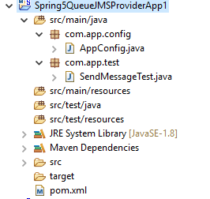

**CODE :-**

1. **Pom.xml:**

**<project xmlns="http://maven.apache.org/POM/4.0.0" xmlns:xsi="http://www.w3.org/2001/XMLSchema-instance"**

**xsi:schemaLocation="http://maven.apache.org/POM/4.0.0 http://maven.apache.org/xsd/maven-4.0.0.xsd">**

**<modelVersion>4.0.0</modelVersion>**

**<groupId>org.sathyatech</groupId>**

**<artifactId>Spring5JMSProvider</artifactId>**

**<version>1.0</version>**

**<dependencies>**

**<dependency>**

**<groupId>org.springframework</groupId>**

**<artifactId>spring-jms</artifactId>**

**<version>5.0.6.RELEASE</version>**

**</dependency>**

**<dependency>**

**<groupId>org.springframework</groupId>**

**<artifactId>spring-context</artifactId>**

**<version>5.0.6.RELEASE</version>**

**</dependency>**

**<dependency>**

**<groupId>org.springframework</groupId>**

**<artifactId>spring-core</artifactId>**

**<version>5.0.6.RELEASE</version>**

**</dependency>**

**<dependency>**

**<groupId>org.apache.activemq</groupId>**

**<artifactId>activemq-spring</artifactId>**

**<version>5.15.4</version>**

**</dependency>**

**</dependencies>**

**<build>**

**<plugins>**

**<plugin>**

**<groupId>org.apache.maven.plugins</groupId>**

**<artifactId>maven-compiler-plugin</artifactId>**

**<version>3.7.0</version>**

**<configuration>**

**<source>1.8</source>**

**<target>1.8</target>**

**</configuration>**

**</plugin>**

**</plugins>**

**</build>**

**</project>**

1. **AppConfig:-**

**package org.sathyatech.app.config;**

**import javax.jms.ConnectionFactory;**

**import org.apache.activemq.ActiveMQConnectionFactory;**

**import org.springframework.context.annotation.Bean;**

**import org.springframework.context.annotation.Configuration;**

**import org.springframework.jms.core.JmsTemplate;**

**@Configuration**

**public class AppConfig {**

**@Bean**

**public ConnectionFactory connectionFactory() {**

**ActiveMQConnectionFactory cf=new ActiveMQConnectionFactory();**

**cf.setBrokerURL("tcp://localhost:61616");**

**return cf;**

**}**

**@Bean**

**public JmsTemplate jmsTemplate() {**

**JmsTemplate jt=new JmsTemplate();**

**jt.setConnectionFactory(connectionFactory());**

**return jt;**

**}**

**}**

1. **Test class:-**

**package org.sathyatech.app.test;**

**import javax.jms.JMSException;**

**import javax.jms.Message;**

**import javax.jms.Session;**

**import org.sathyatech.app.config.AppConfig;**

**import org.springframework.context.annotation.AnnotationConfigApplicationContext;**

**import org.springframework.jms.core.JmsTemplate;**

**import org.springframework.jms.core.MessageCreator;**

**public class SendMessageTest {**

**public static void main(String[] args) {**

**AnnotationConfigApplicationContext c=new AnnotationConfigApplicationContext(AppConfig.class);**

**JmsTemplate jt=c.getBean(JmsTemplate.class);**

**jt.send("my-test-spring", new MessageCreator() {**

**@Override**

**public Message createMessage(Session ses) throws JMSException {**

**return ses.createTextMessage("SAMPLE ONE");**

**}**

**});**

**c.close();**

**}**

**}**

**#*** Start ActiveMQ before run above application :-**

**Steps are:-**

**>Goto Folder Apache-activemq-5.15.4**

**> bin folder**

**> choose os version win32/win64**

**> click on bat file active.bat**

**> ** wait for 3 minutes**

**> Goto browser and enter URL**

[**http://localhost:8161/admin**](http://localhost:8161/admin)

**username, password : admin**

**> click on menu option : Queues**

**> observe details**

* To Convert above client (Producer) code from **P2P (Queue)** concept to **pub/sub (Topic)** use below code in AppConfig over JmsTemplate Object.

**JmsTemplate jt = new JmsTemplate();**

**Jt.setPubSubDomain(true); [or]**

**Jt.setPubSubDomain(Boolean.TRUE);**

**#CONSUMER APPLICATION USING SPRING JMS:-**

* Here (Client) Consumer Application make call to MOM (using schedulers with gap of 5000 mili sec = 5 sec by default).

This call gets executed in below order :-

**#1:** Identify MOM using ConnectionFactory.

**#2:** Identify Destination in MOM and read Message if exist.

**#3:** Copy Message into Consumer App memory known as

**“MessageListenerContainer”.**

**#4:** Once copied from MOM to Consumer hand over to **“MessageListener” (I).**

**#5: onMessage() method** executed task by taking Message as Input.

--------------------------------------**Execution Flow**-----------------------------------

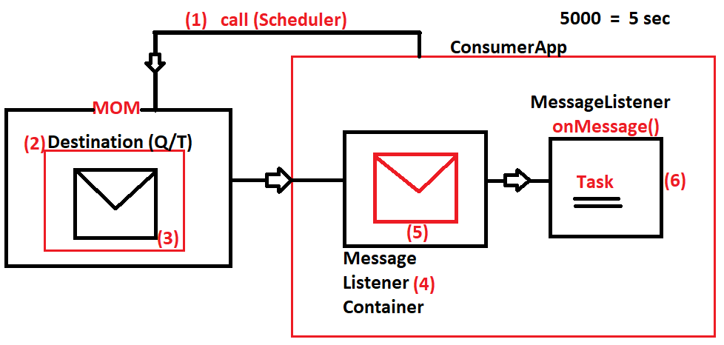

* If Message is received , then after executing onMessage() again Consumer makes a call with 5 sec gap (default).

**# UML DESIGN FOR CONSUMER APPLICATION #**

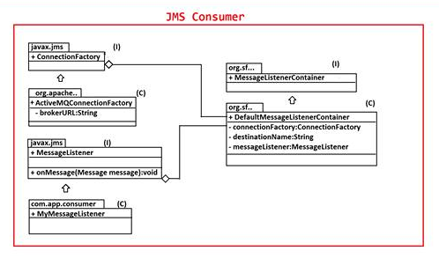

**Example Program :-**

**Folder System Structure:-**

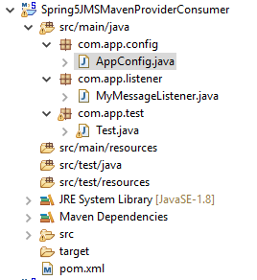

1. **Pom.xml:-**

**<projectxmlns=*"http://maven.apache.org/POM/4.0.0"***

**xmlns:xsi=*"http://www.w3.org/2001/XMLSchema-instance"***

**xsi:schemaLocation=*"http://maven.apache.org/POM/4.0.0 http://maven.apache.org/xsd/maven-4.0.0.xsd"*>**

**<modelVersion>4.0.0</modelVersion>**

**<groupId>org.sathyatech.app</groupId>**

**<artifactId>Spring5JMSMavenProviderConsumer</artifactId>**

**<version>1.0</version>**

**<dependencies>**

**<dependency>**

**<groupId>org.springframework</groupId>**

**<artifactId>spring-jms</artifactId>**

**<version>5.0.6.RELEASE</version>**

**</dependency>**

**<dependency>**

**<groupId>org.springframework</groupId>**

**<artifactId>spring-context</artifactId>**

**<version>5.0.6.RELEASE</version>**

**</dependency>**

**<dependency>**

**<groupId>org.springframework</groupId>**

**<artifactId>spring-core</artifactId>**

**<version>5.0.6.RELEASE</version>**

**</dependency>**

**<dependency>**

**<groupId>org.apache.activemq</groupId>**

**<artifactId>activemq-all</artifactId>**

**<version>5.15.4</version>**

**</dependency>**

**</dependencies>**

**<build>**

**<plugins>**

**<plugin>**

**<groupId>org.apache.maven.plugins</groupId>**

**<artifactId>maven-compiler-plugin</artifactId>**

**<version>3.7.0</version>**

**<configuration>**

**<source>1.8</source>**

**<target>1.8</target>**

**</configuration>**

**</plugin>**

**</plugins>**

**</build>**

**</project>**

1. **AppConfig.java:-**

package com.app.config;

import javax.jms.ConnectionFactory;

import javax.jms.MessageListener;

import org.apache.activemq.ActiveMQConnectionFactory;

import org.springframework.beans.factory.annotation.Autowired;

import org.springframework.context.annotation.Bean;

import org.springframework.context.annotation.ComponentScan;

import org.springframework.context.annotation.Configuration;

import org.springframework.jms.annotation.EnableJms;

import org.springframework.jms.listener.DefaultMessageListenerContainer;

import org.springframework.jms.listener.MessageListenerContainer;

@Configuration

@EnableJms

@ComponentScan(basePackages="com.app")

publicclass AppConfig {

@Autowired

private MessageListener messageListener;

@Bean

public ConnectionFactory connectionFactory() {

ActiveMQConnectionFactory c=new ActiveMQConnectionFactory();

c.setBrokerURL("tcp://localhost:61616");

returnc;

}

@Bean

public MessageListenerContainer listenerContainer() {

DefaultMessageListenerContainer m=new DefaultMessageListenerContainer();

m.setConnectionFactory(connectionFactory());

m.setDestinationName("my-test-spring");

m.setMessageListener(messageListener);

returnm;

}

}

1. **MyMessageListener.java:-**

**package com.app.listener;**

**import javax.jms.JMSException;**

**import javax.jms.Message;**

**import javax.jms.MessageListener;**

**import javax.jms.TextMessage;**

**import org.springframework.stereotype.Component;**

**@Component**

**publicclass MyMessageListener implements MessageListener{**

**@Override**

**publicvoid onMessage(Message message) {**

**TextMessage tm=(TextMessage) message;**

**try {**

**System.*out*.println(tm.getText());**

**} catch (JMSException e) {**

**e.printStackTrace();**

**}**

**}**

**}**

1. **Test.java:-**

package com.app.test;

import org.springframework.context.annotation.AnnotationConfigApplicationContext;

import com.app.config.AppConfig;

import com.app.listener.MyMessageListener;

publicclass Test {

publicstaticvoid main(String[] args) {

AnnotationConfigApplicationContext ac=new AnnotationConfigApplicationContext(AppConfig.class);

MyMessageListener ms=ac.getBean(MyMessageListener.class);

}

}

**# EXECUTION STEPS #:**

**#1:** Start Apache ActiveMQ

URL : <http://localhost:8161/admin>

Username/password : admin/admin

**#2:** Run Consumer Application

(Create multiple Consumers in multiple work spaces, just modify

oneMessage() method data )

**#3:** Run Provider Application.

** Make sure that Consumer Destination name must match with Provider

Destination name Else no output.

**Chapter#10 Spring Security (JAAS)**

**JAAS: ( Java Authentication and Authorization Service )**

* It is a concept used to secure application URL’s
* It will secure URL’s in 2 level

1. User Identity [un , pwd]
2. Role verification

**Authentication :**

Work on store and retrieve use identity details like username , password , role it will compare only name and password not role with end user input.

**Authorization :**

It will security work on login and role management of application using JAAS.

* Spring security works on login and role management of application using JAAS.
* Security is provided to URL using managers.

1. Authentication Manager.
2. Authorization Manager.
3. **Authentication Manager:**

It will store details of user in RAM on DB and verifies when user try to login.

**Types of Authentication**

1. **InMemoryAuthentication**

Storing details in RAM.

1. **JdbcAuthentication**

Storing details (un ,pwd , role) in DB using JDBC.

1. **UserDetailsService:**

Storing details (un ,pwd , role) in DB using ORM.

1. **AuthorizationManager:**

It will provide details of URL’s “who can access what URL? “ provided types as:

1. **permitAll**

everyone can access no login & no role required.

1. **hasAuthority**

URL can be accessed by users who must login and should have expected role. If login/role failed cannot access URL.

1. **authentication**

URL can be accessed by users who must login only. Role check not require

**Spring Security Design**

**Level 1:** Enable Security Filter

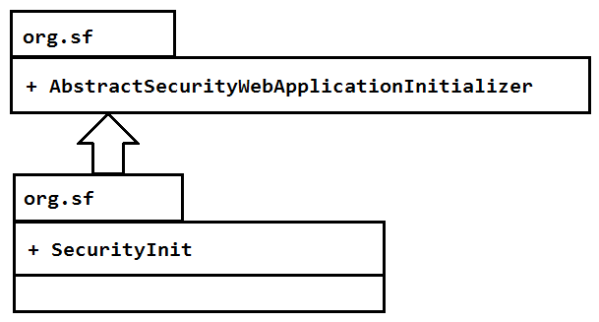

**Level 2:** Configure Authentication / Authorization manager.

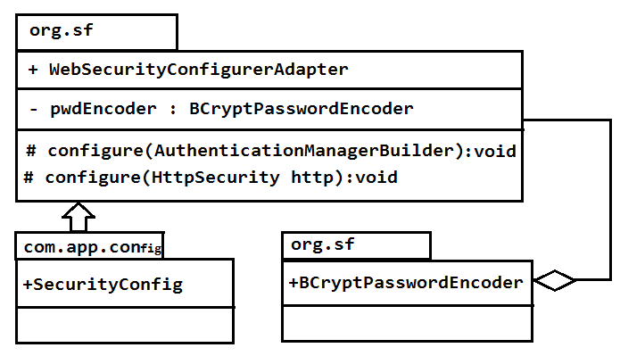

**Step 1:**write one web application using WEB-MVC with multiple URL method.

**Step 2:**write on spring config file to provide authentication and authorization manager details

**EX:**SpringSecurity which should extends class WebSecurityConfigurerAdapter and

Override 2 method.

**Step 3:**use any password encoder for securing password

1. NoOperationPwdEncoder
2. BCryptPasswordEncoder. (Binary Cryptography) etc.

**Step 4:**Enable security filter by writing one class. That extends “AbstractSecurityWebApplicationInitializer”

**Spring Security#1 :InMemoryAuthentication**

Create one web application using spring WEB-MVC in below format.

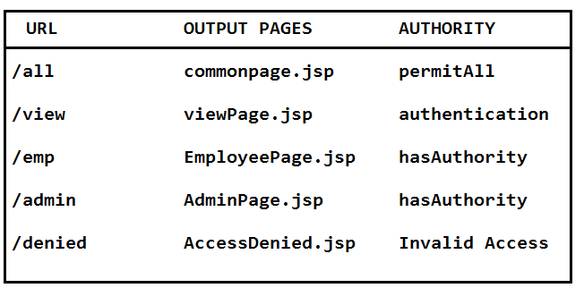

**SETUP**

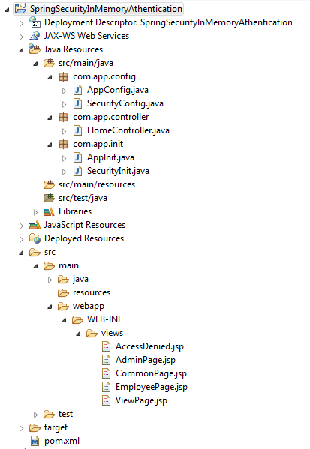

1. **pom.xml**

<projectxmlns=*"http://maven.apache.org/POM/4.0.0"*

xmlns:xsi=*"http://www.w3.org/2001/XMLSchema-instance"*

xsi:schemaLocation=*"http://maven.apache.org/POM/4.0.0 http://maven.apache.org/maven-v4_0_0.xsd"*>

<modelVersion>4.0.0</modelVersion>

<groupId>org.sathyatech</groupId>

<artifactId>SpringSecurityInMemoryAthentication</artifactId>

<packaging>war</packaging>

<version>0.0.1-SNAPSHOT</version>

<name>SpringSecurityInMemoryAthenticationMavenWebapp</name>

<url>http://maven.apache.org</url>

<dependencies>

<dependency>

<groupId>org.springframework.security</groupId>

<artifactId>spring-security-web</artifactId>

<version>5.0.2.RELEASE</version>

</dependency>

<dependency>

<groupId>org.springframework</groupId>

<artifactId>spring-webmvc</artifactId>

<version>5.0.3.RELEASE</version>

</dependency>

<dependency>

<groupId>org.springframework.security</groupId>

<artifactId>spring-security-config</artifactId>

<version>5.0.2.RELEASE</version>

</dependency>

</dependencies>

<build>

<plugins>

<plugin>

<groupId>org.apache.maven.plugins</groupId>

<artifactId>maven-compiler-plugin</artifactId>

<version>3.7.0</version>

<configuration>

<source>1.8</source>

<target>1.8</target>

</configuration>

</plugin>

<plugin>

<artifactId>maven-war-plugin</artifactId>

<version>2.4</version>

<configuration>

<failOnMissingWebXml>false</failOnMissingWebXml>

</configuration>

</plugin>

</plugins>

</build>

</project>

1. **Config File (AppConfig.java)**

**package**com.app.config;

**import**org.springframework.context.annotation.Bean;

**import**org.springframework.context.annotation.ComponentScan;

**import**org.springframework.context.annotation.Configuration;

**import**org.springframework.context.annotation.Import;

**import** org.springframework.security.crypto.bcrypt.BCryptPasswordEncoder;

**import**org.springframework.web.servlet.config.annotation.EnableWebMvc;

**import** org.springframework.web.servlet.view.InternalResourceViewResolver;

@Configuration

@ComponentScan(basePackages = "com.app")

@Import(SecurityConfig.**class**)

@EnableWebMvc

**publicclass**AppConfig {

@Bean

**public**BCryptPasswordEncoderpwdEncoder() {

**returnnew**BCryptPasswordEncoder();

}

@Bean

**public**InternalResourceViewResolverivr() {

InternalResourceViewResolverivr = **new**InternalResourceViewResolver();

ivr.setPrefix("/WEB-INF/views/");

ivr.setSuffix(".jsp");

**return**ivr;

}

}

1. **Spring Flie (SecurityConfig.java)**

**package**com.app.config;

**import**org.springframework.beans.factory.annotation.Autowired;

**import**org.springframework.context.annotation.Configuration;

**import** org.springframework.security.config.annotation.authentication.builders.AuthenticationManagerBuilder;

**import** org.springframework.security.config.annotation.web.builders.HttpSecurity;

**import** org.springframework.security.config.annotation.web.configuration.EnableWebSecurity;

**import** org.springframework.security.config.annotation.web.configuration.WebSecurityConfigurerAdapter;

**import** org.springframework.security.crypto.bcrypt.BCryptPasswordEncoder;

**import** org.springframework.security.web.util.matcher.AntPathRequestMatcher;

@EnableWebSecurity

@Configuration

**publicclass**SecurityConfig**extends**WebSecurityConfigurerAdapter{

@Autowired

**private**BCryptPasswordEncoderpwdEnc;

@Override

**protectedvoid** configure(AuthenticationManagerBuilderauth) **throws** Exception {

auth.inMemoryAuthentication().withUser("Sam")

.password(pwdEnc.encode("Sam")).authorities("EMP");

auth.inMemoryAuthentication().withUser("Ram")

.password(pwdEnc.encode("Ram")).authorities("ADMIN");

auth.inMemoryAuthentication().withUser("Vicky")

.password(pwdEnc.encode("Vicky")).authorities("STUDENT" , "MGR");

}

**protectedvoid**configur(HttpSecurityhttp) **throws** Exception {

http.authorizeRequests()

.antMatchers("/all").permitAll()

.antMatchers("/emp").hasAuthority("EMP")

.antMatchers("/admin").hasAuthority("/ADMIN")

.anyRequest().authenticated()

.and().formLogin().defaultSuccessUrl("/view")

.and().logout().logoutRequestMatcher

(**new**AntPathRequestMatcher("/logout"))

.and().exceptionHandling().accessDeniedPage("/denied");

}

}

1. **Init File (AppInit.java)**

**package**com.app.init;

**import** org.springframework.web.servlet.support.AbstractAnnotationConfigDispatcherServletInitializer;

**import**com.app.config.AppConfig;

**publicclass**AppInit**extends**AbstractAnnotationConfigDispatcherServletInitializer{

@Override

**protected** Class<?>[] getRootConfigClasses() {

**returnnew** Class[] {AppConfig.**class**};

}

@Override

**protected** Class<?>[] getServletConfigClasses() {

// **TODO** Auto-generated method stub

**returnnull**;

}

@Override

**protected** String[] getServletMappings() {

**returnnew** String[] {"/"};

}

}

1. **Init File (SecurityInit.java)**

**package**com.app.init;

**import** org.springframework.security.web.context.AbstractSecurityWebApplicationInitializer;

**publicclass**SecurityInit**extends**AbstractSecurityWebApplicationInitializer{ }

1. **HomeController.java**

**package**com.app.controller;

**import**org.springframework.stereotype.Controller;

**import**org.springframework.web.bind.annotation.RequestMapping;

@Controller

**publicclass**HomeController {

@RequestMapping("/all")

**public** String all() {

**return**"CommonPage";

}

@RequestMapping("/emp")

**public** String emp() {

**return**"EmployeePage";

}

@RequestMapping("/view")

**public** String view() {

**return**"ViewPage";

}

@RequestMapping("/admin")

**public** String admin() {

**return**"AdminPage";

}

@RequestMapping("/denied")

**public** String denied() {

**return**"AccessDenied";

}

}

1. **JSP Files**
2. **AccessDenied.jsp**

<%@pagelanguage=*"java"*contentType=*"text/html; charset=ISO-8859-1"*

pageEncoding=*"ISO-8859-1"*%>

<!DOCTYPEhtmlPUBLIC"-//W3C//DTD HTML 4.01 Transitional//EN""http://www.w3.org/TR/html4/loose.dtd">

<html>

<head>

<metahttp-equiv=*"Content-Type"*content=*"text/html; charset=ISO-8859-1"*>

<title>Insert title here</title>

</head>

<body>

<h1>Youcan not access this URL!!</h1>

<ahref=*"logout"*>Goto Home</a>

</body>

</html>

1. **AdminPage.jsp**

<%@pagelanguage=*"java"*contentType=*"text/html; charset=ISO-8859-1"*

pageEncoding=*"ISO-8859-1"*%>

<!DOCTYPEhtmlPUBLIC"-//W3C//DTD HTML 4.01 Transitional//EN""http://www.w3.org/TR/html4/loose.dtd">

<html>

<head>

<metahttp-equiv=*"Content-Type"*content=*"text/html; charset=ISO-8859-1"*>

<title>Insert title here</title>

</head>

<body>

<h1>welcome to Admin page!!</h1>

<ahref=*"logout"*>Goto Home</a>

</body>

</html>

1. **CommonPage.jsp**

<%@pagelanguage=*"java"*contentType=*"text/html; charset=ISO-8859-1"*

pageEncoding=*"ISO-8859-1"*%>

<!DOCTYPEhtmlPUBLIC"-//W3C//DTD HTML 4.01 Transitional//EN""http://www.w3.org/TR/html4/loose.dtd">

<html>

<head>

<metahttp-equiv=*"Content-Type"*content=*"text/html; charset=ISO-8859-1"*>

<title>Insert title here</title>

</head>

<body>

<h1>Welcome to All!!</h1>

</body>

</html>

1. **EmployeePage.jsp**

<%@pagelanguage=*"java"*contentType=*"text/html; charset=ISO-8859-1"*

pageEncoding=*"ISO-8859-1"*%>

<!DOCTYPEhtmlPUBLIC"-//W3C//DTD HTML 4.01 Transitional//EN""http://www.w3.org/TR/html4/loose.dtd">

<html>

<head>

<metahttp-equiv=*"Content-Type"*content=*"text/html; charset=ISO-8859-1"*>

<title>Insert title here</title>

</head>

<body>

<h1>welcome to Employee Page!!</h1>

<ahref=*"logout"*>Goto Home</a>

</body>

</html>

1. **ViewPage.jsp**

<%@pagelanguage=*"java"*contentType=*"text/html; charset=ISO-8859-1"*

pageEncoding=*"ISO-8859-1"*%>

<!DOCTYPEhtmlPUBLIC"-//W3C//DTD HTML 4.01 Transitional//EN""http://www.w3.org/TR/html4/loose.dtd">

<html>

<head>

<metahttp-equiv=*"Content-Type"*content=*"text/html; charset=ISO-8859-1"*>

<title>Insert title here</title>

</head>

<body>

<h1>Welcome to View Page!! </h1>

<ahref=*"logout"*>Goto Home</a>

</body>

</html>

**antMatchers(“/urlPattern”):**

This method is used to provide URL-Patterns and their security levels.

1. Here we can use symbol like

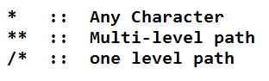

1. Use security level method like:

**.permitAll() ::** every one can access.

**.hasAuthority(“r1”)::**only given role(R1) can view this after login.

**.authenticated() ::**indicates only login , no role required.

**.hasAnyAuthority(“r1” , “r2” , “r3”) ::**user should have any role in given list and can view after.

1. **anyRequest() ::**it is used to provide all URL’s which are not specified in configuration.

**Ex:**IN URL’s only /emp , /admin provided in config , to indicate remaining 198 URL’s use anyRequest()

1. **Every URL can be accessed by everyone.**

Ans) .anyRequest().permitAll()

1. **/emp can be accessed by ADMIN or EMPLOYEE roles after login.**

Ans) .antMatchers(“/emp”).hasAnyAuthority(“ADMIN” , “EMPLOYEE”)

1. **/home can be accessed by everyone.**

Ans) .antMatchers(“/home).permitAll()

1. **All product operations are accessed by Employee only**

**[/product/view , /product/get , /product/edit , /product/save]**

Ans) .antMatchers(“/product**”).hasAuthority(“Employee”)

Or

.antMatchers(“/product/view” , “/product/get” , “/product/edit” , “/product/save”

* Spring provide default login form without writing (JSP / HTML) code by programmer.

**.and().formLogin()**

* To specify “after login , go to default URL “ code is:

**.and().formLogin().defaultSuccessUrl(“/view”)**

* To specify logout URL Pattern

.and().logout.logoutRequestMatcher

( newAntPathRequestMatcher(“/logout”))

* To specify access denied error page.

**.and().exceptionHandling().accessDeniedPage(“/denied”)**

1. **InMemoryAuthentication**

It will store data in RAM , it is used only for testing process , if DB is not installed in system. This is best way to test application.

* At runtime we cannot create new user.
* Again stop server , modify code and start.
* Stores data in RAM , on every re-start of server memory deleted and created again.
* Format look like:

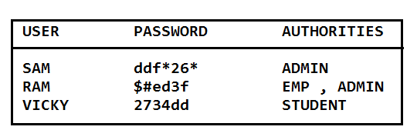

1. **JdbcAuthentication:**

It will store data in DB table(2) table-1 stores user details and table-2 stores authorities.

Communicate to DB table using spring JDBC uses DataSource (javax.sql) interface with two special SQL queries.

SQL#1 load user by username.

SQL#2 load authorities by username.